XV. Christmas Price Mladá Boleslav

Date: Saturday, 22th November 2008
Location: Sportshall - Auto Skoda, Mladá Boleslav, U Stadionu str., Czech Republic

Categories : KATA
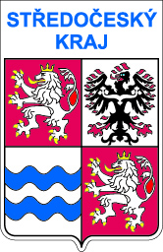
KATA MALE 7 – 11 YEARS 8 th-7 th KYU
KATA FEMALE 7 – 11 YEARS 8 th-7 th KYU
KATA MALE 12 – 14 YEARS 8 th-7 th KYU
KATA FEMALE 12 – 14 YEARS 8 th-7 th KYU
KATA MALE 7 – 11 YEARS +6 th KYU
KATA FEMALE 7 – 11 YEARS +6 th KYU
KATA MALE 12 – 14 YEARS +6th KYU
KATA FEMALE 12 – 14 YEARS +6th KYU

KATA MALE CADETS 15 – 17 YEARS
KATA FEMALE CADETS 15 – 17 YEARS

KATA TEAM
KATA MALE TEAM 7-14 YEARS
KATA FEMALE TEAM 7-14 YEARS

KUMITE
KUMITE MALE 7 – 11 YEARS (- 35 KG, -40 KG, + 40 KG)
KUMITE FEMALE 7 – 11 YEARS OPEN
KUMITE MALE 12 – 14 YEARS (-40 KG, - 50 KG, - 60 KG, + 60 KG)
KUMITE MALE CADETS 15 – 17 YEARS (- 60 KG, - 70 KG, + 70 KG)
KUMITE FEMALE 12 – 14 YEARS (-40 KG, - 50 KG, + 50 KG)
KUMITE FEMALE CADETS 15 – 17 YEARS (-50 KG, - 58 KG, + 58 KG)

System: WKF-Rules – KATA male and female 7-17 years WKF + basic KATA
Deadline: Entry 19th November 2008 at the latest
to: Mr. Ladislav Mareš
Jana Palacha 1215, 293 01 Mladá Boleslav, Czech Republic
Phone : +420 602 252 692
Email: karatemb@seznam.cz Internet: www.karate.jtp.cz

Starting Fee: Individuals: Euro 5,- for competitor
Teams: free start for Team

Registration: Saturday, 22th November 2008,
Sportshall Skoda Mlada Boleslav 7.00 - 8.45 a.m.

Grades: 8th Kyu minimum KATA , 6th Kyu – KUMITE all categories
Referees: Czech Karate Federation

Program: SATURDAY 22th November 2008
7.00 a.m. – 8.45 a.m. Registration for all categories (Sportshall)
0.30 p.m. – 1.30 p.m. Registration fot all categories KUMITE
(Sportshall)
9.00 a.m. Kata Eliminations and finals,
2.15 p.m. Opening Ceremony
3.00 p.m. Kumite individual eliminations
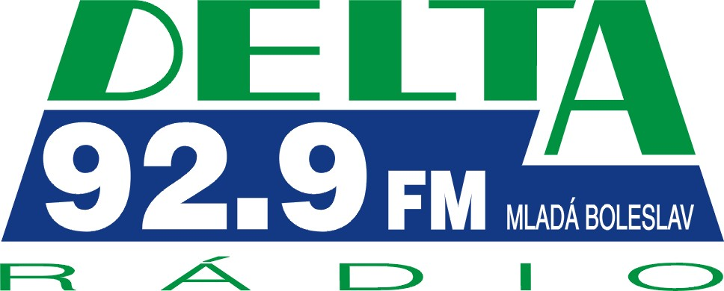

SPONZORS

BOSPOR – Ford Božena Sedláková Mladá Boleslav



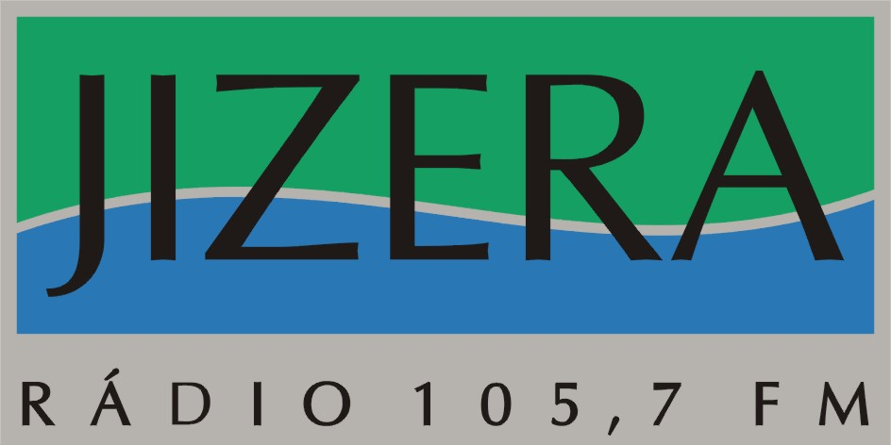
PARTNERS



For example, in the years 2004, 2005, 2006 and 2007 started more than 300 competitors.
We are looking to you.

