Czech Karate Federation
Pilsen Karate Federation



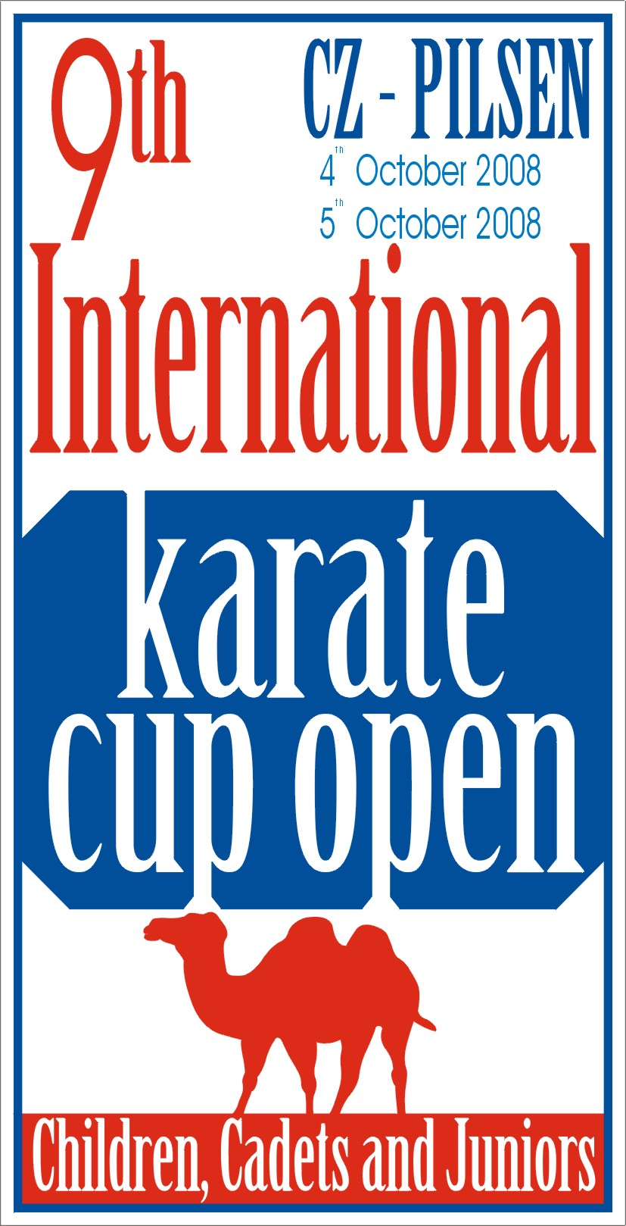

The 9th
Czech Karate Open
Euro Grand Prix
Central-European league

For Children, Youth and Seniors

4th – 5th October, 2008
Pilsen (Plzeň)
Czech Republic
Lokomotiva Sports Hall, Úslavská street

Dear Friends,

We have the pleasure to invite you to participate in our karate competition

The 9th International Karate Cup Open – Foundation for youth
For Children, Youth and Seniors

4th – 5th October, 2008

Information about the tournament:

Organiser:
Czech Karate Federation
Pilsen Karate Federation

Place:
Plzeň (Pilsen), Lokomotiva Sports Hall, Úslavská street

Date of competition:
Saturday, 4th October, 2008 - category cadets, seniors
Sunday, 5th October 2008 – category children, juniors

Time of Competition
9:00

Registration fee:
15 Euros per person per category
20 Euros per team
Invited:
European and World Teams, Clubs and Schools

Closing date:
no later than 1th October, 2008.
Please inform us about the time of your arrival/departure to/from Pilsen and the means of transport.This information are very important for transport.

Technical conference:
Friday, 3th October, 2008

Transport:
Transport Airport Prague- Pilsen- Prague ensure Travel Agency Seko bus
Transport official hotel – sporthall – official hotel is free.

Banquet: For official all international teams will be prepare small refreshment in Restaurant Simsalabim on the Americka street in central Pilsen. Start timer is 9.00 p.m. in Saturday.

Accommodation:

Travel Agency Seko Bus
Šumavská 4
Plzeň
Tel, fax: +420 377 240 995
e-mail: sekobus@volny.cz

Maps road to sport hall

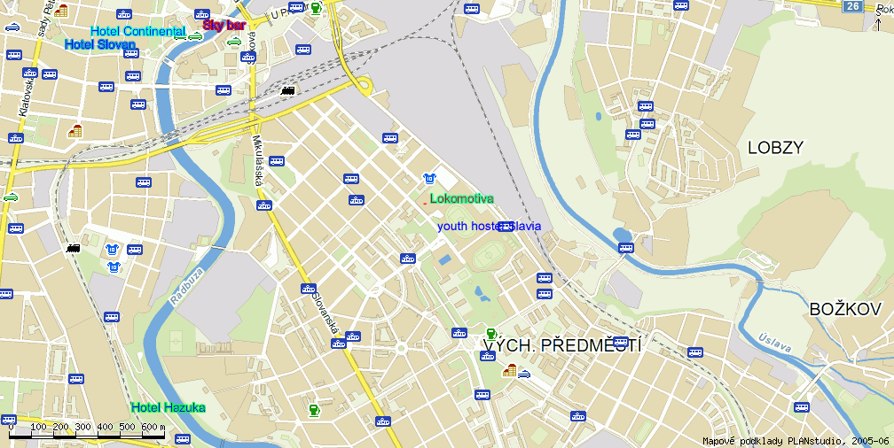

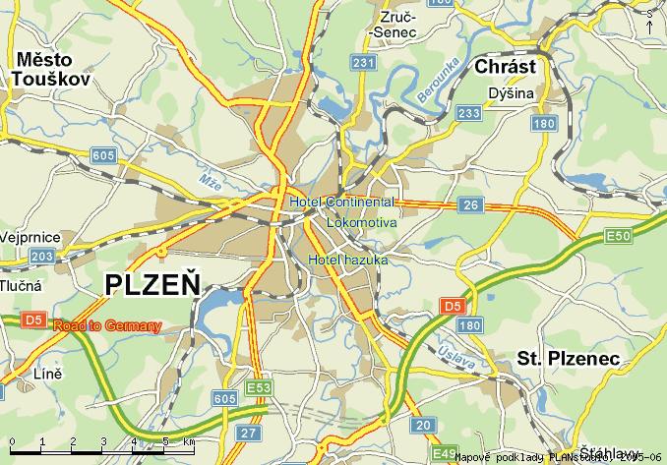

Technical section:

Information for Coaches:
Registration competitors is taking place on 3th October , 2008 from 6.00 to 9.00 pm . Place will be write next bulletin. Weighing of the all categories will be before theTournament Kumite in Saturday or Sunday.

Rules:

New WKF rules:

Kata children 10-13 : Tokui kata Tokui Kata WKF + Heian 1-5, Pinan 1-5, Taikyoku 1-5, Geksai 1-2

Shitei kata cadets, juniors and seniors - Shitei kata WKF, Tokui kata WKF

Kumite rules – All category WKF rules. All category must be protective equipment WKF rules – Hands protectors, gum-shield, foot protector, shin pads and women chest protectors.!!

Referees:
Chief Referee – nominated by Organizing committee. Referees from participating teams are accepted.
OC payed international referees EKF, WKF licence 50 Euro per day and free accommodation. All referees must registration before, deadline is to some than to competitors.

Categories: (min. 5th kyu)
Individual
Kata competition-
Boys – age groups: 10-11, 12-13,
Girls – age groups: 10-11, 12-13, Cadets Male – aged: 14-15
Cadets Female – aged: 14-15
Juniors Male – aged: 16-17
Juniors Female – aged: 16-17
Seniors Male – aged : 16 and older
Seniors Female – aged : 16 and older
Kumite competition-
Boys – age groups: 10-11, 12-13,
Time: 90 sec
10-11: (-30, -35, -41, +41 kg)
12-13: (-39, -45, -52, -60, +60 kg)
Girls – age groups: 10-11, 12-13,
Time: 90 sec
10-11: (-35, +35 kg)
12-13: (-42, -50, +50 kg)
Cadets Male – aged: 14-15
Time: 120 sec
(-52, -57, -63, -70, +70 kg, Open)
Cadets Female – aged: 14-15
Time: 120 sec
(-47, -54, +54 kg, Open)
Juniors Male – aged:16 – 17
Time: 120 sec.
(-55, -61, -68, -76, +76 kg, Open)
Juniors Female – aged: 16 – 17
Time: 120 sec.
(-48, -53, -59, +59 kg, Open)
New Seniors Male – aged : 18 and older
Time: 180 sec.
(-60, -67, -75, -84, +84 kg, Open)
Seniors Female – aged : 18 and older
Time: 120 sec.
(-48, -55, -61, -68,+68 kg, Open)

Kumite team-
Juniors male – aged: 16 – 17
Time: 120 sec. (3+1)
Juniors Female – aged: 16 - 17
Time: 120sec. (3+1)
Seniors male – aged: 18 and older
Time: 120 sec. (3+1)
Seniors Female – aged: 18 and older
Time: 120sec. (3+1)

Category children is nomination tournament for National Championship
Category Youth is nomination tournament for National Championship and Central-European league
Category Seniors is nomination tournament for Central-European league

Information about Central-European league is on web site www.cekl.eu.

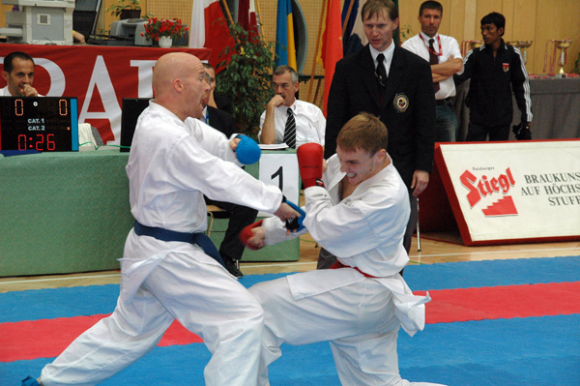

ENTRY FORM

Country ……………………………………
Address ….............……………………….
Club ………………...…………………….
/Phone/Fax/……………………………….
Team leader ………………………………
Referee:...………………………………...
Number of competitors …… Number of referees ……

Competitor's Name | Date of Birth | Category | Kata | Kumite (weight)

Please, send the completed ENTRY FORM to be received no later than 1th OCTOBER, 2008 to:

Pilsen Karate Federation
Linska 18
323 12 Plzeň
Czech Republic

Phone: +420 37 7535493
Mobil: +420 606 963 407
Fax: +420 37 7535493
e-mail: karate@karatecz.cz

Date:……………. Signature: …………….

Best regards,

Marek Kubín Jan Pytlík
Organizing Commission Vicepresident
of The Pilsen Karate Federation
e-mail: kubin@karatecz.cz e-mail: pytlik@karatecz.cz

