
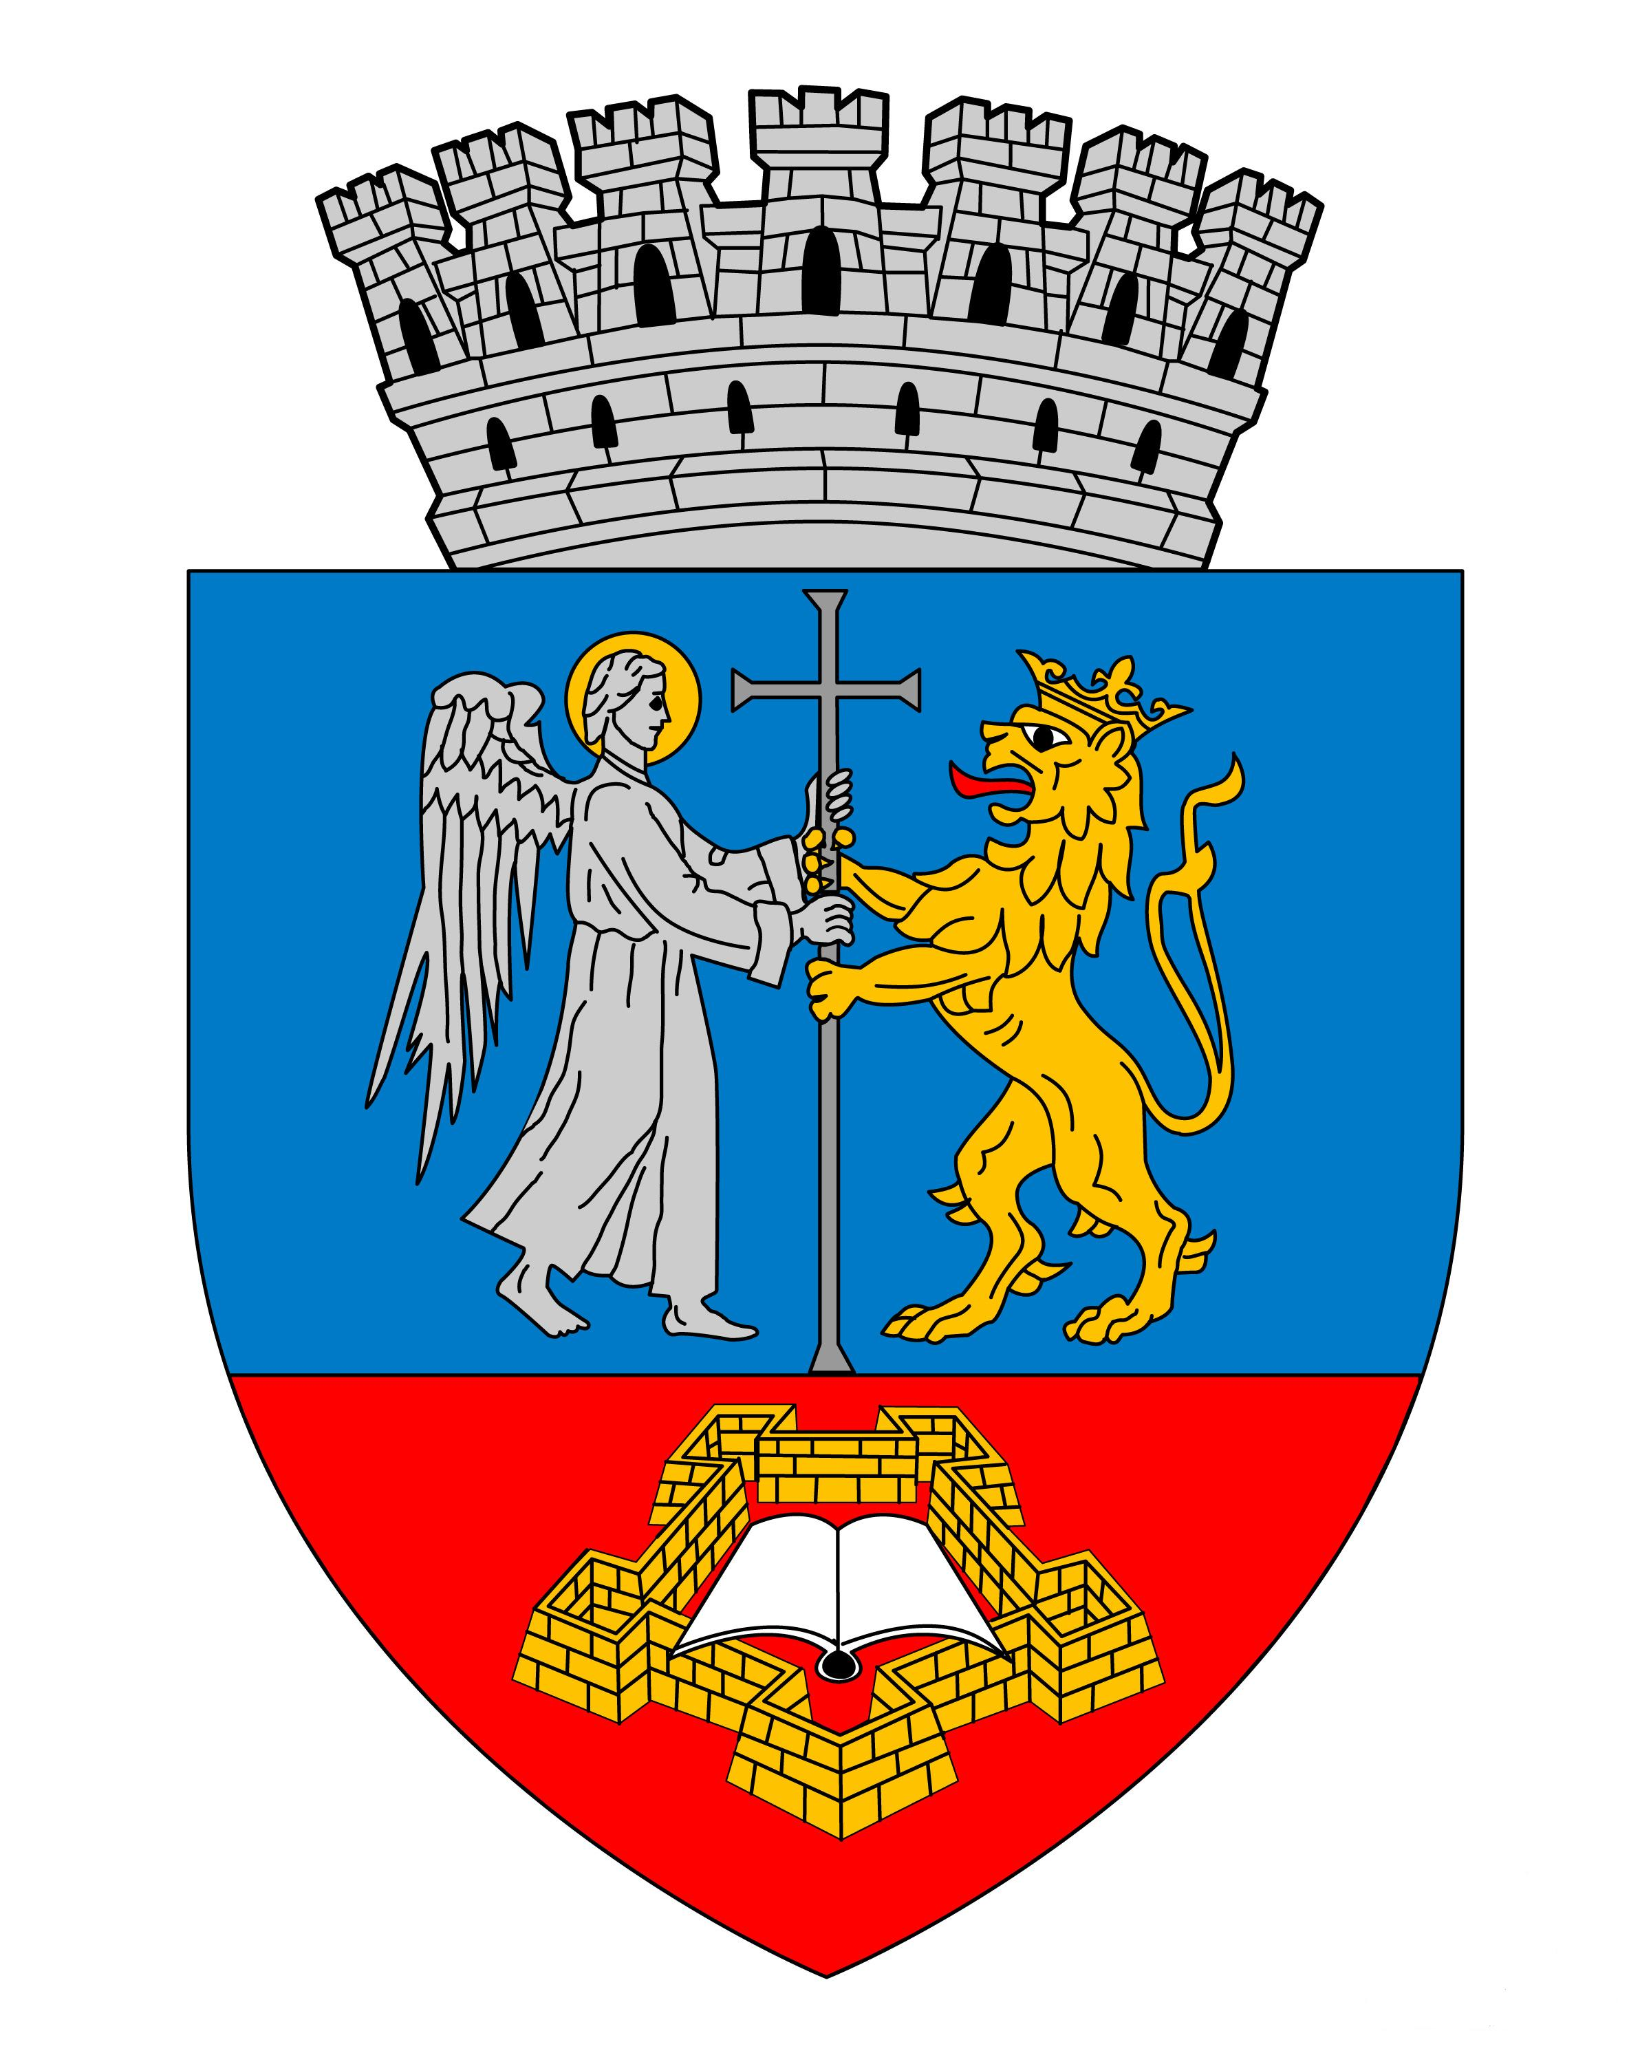

ENTRY FORM: Oradea / Romania 03 th October (Saturday) 2015. | International Open Karate Championship XIV. Bihor Open „CHAMPIONS DAY” Time: 10.00 – 20.00
Name of the Karate Club :  City: | -  -
Country : | -
Telefon / Phone number : | -
E-mail : | -
Website : | -
Responsible person : | -
Coaches / Team leader’sname: | -
Referees : | -
Entries please not later than 30.09.2015. on E-mail: secretariat.shogunul@gmail.com | By sending this Entry from I declare that all above listed competitors are in good health, capable of participating on tournament and in order to the medical conditions. Also we will take full responsibility for any possible injuries. I take responsibility for reality of the datas. I accept the entry conditions and I announce that the nominated competitors fit for the entry conditions.

Nr. | Name is surname of the competitor: | Date of birth | Weight (kg) | after sex  (M/F) | Individual  Kata Categories code: | Individual Kumite Categories code: | Team  Kata Categories code: | Team  Kumite Categories code:
1.
2.
3.
4.
5.
6.
7.
8.
9.
10.
11.
12.
13.
14.
15.
16.
17.
18.
19.
20.
21.
22.
23.
24.
25.

Data: ______________, 2015. _______. ___. ______________________
signature of coach / team leader

INDIVIDUAL KUMITE
BOYS / Male |  |  |  |  | GIRLS / Female
Code | Categories | Age | Weight |  | Code | Categories | Age | Weight
KUB-1 | CHILDREN - BOYS | 5-6-7 years | -20 kg |  | KUF-1 | CHILDREN - GIRLS | 5-6-7 years | -20 kg
KUB-2 | CHILDREN - BOYS | 5-6-7 years | -24 kg |  | KUF-2 | CHILDREN - GIRLS | 5-6-7 years | -24 kg
KUB-3 | CHILDREN - BOYS | 5-6-7 years | -30 kg |  | KUF-3 | CHILDREN - GIRLS | 5-6-7 years | +24 kg
KUB-4 | CHILDREN - BOYS | 5-6-7 years | +30 kg
KUB-5 | CHILDREN - BOYS | 8-9 years | -26 kg |  | KUF-4 | CHILDREN - GIRLS | 8-9 years | -28 kg
KUB-6 | CHILDREN - BOYS | 8-9 years | -30 kg |  | KUF-5 | CHILDREN - GIRLS | 8-9 years | -32 kg
KUB-7 | CHILDREN - BOYS | 8-9 years | -34 kg |  | KUF-6 | CHILDREN - GIRLS | 8-9 years | -36 kg
KUB-8 | CHILDREN - BOYS | 8-9 years | -38 kg |  | KUF-7 | CHILDREN - GIRLS | 8-9 years | +36 kg
KUB-9 | CHILDREN - BOYS | 8-9 years | +38 kg
KUB-10 | CHILDREN - BOYS | 10-11 years | -30 kg |  | KUF-8 | CHILDREN - GIRLS | 10-11 years | -32 kg
KUB-10 | CHILDREN - BOYS | 10-11 years | -34 kg |  | KUF-9 | CHILDREN - GIRLS | 10-11 years | -36 kg
KUB-12 | CHILDREN - BOYS | 10-11 years | -38 kg |  | KUF-10 | CHILDREN - GIRLS | 10-11 years | -40 kg
KUB-13 | CHILDREN - BOYS | 10-11 years | -42 kg |  | KUF-11 | CHILDREN - GIRLS | 10-11 years | -44 kg
KUB-14 | CHILDREN - BOYS | 10-11 years | -46 kg |  | KUF-12 | CHILDREN - GIRLS | 10-11 years | +44 kg
KUB-15 | CHILDREN - BOYS | 10-11 years | +46 kg
KUB-16 | MINICADETS - BOYS | 12-13 years | -36 kg |  | KUF-13 | MINICADETS - GIRLS | 12-13 years | -40 kg
KUB-17 | MINICADETS - BOYS | 12-13 years | -41 kg |  | KUF-14 | MINICADETS - GIRLS | 12-13 years | -45 kg
KUB-18 | MINICADETS - BOYS | 12-13 years | -45 kg |  | KUF-15 | MINICADETS - GIRLS | 12-13 years | -50 kg
KUB-19 | MINICADETS - BOYS | 12-13 years | -48 kg |  | KUF-16 | MINICADETS - GIRLS | 12-13 years | -55 kg
KUB-20 | MINICADETS - BOYS | 12-13 years | -52 kg |  | KUF-17 | MINICADETS - GIRLS | 12-13 years | +55 kg
KUB-21 | MINICADETS - BOYS | 12-13 years | -57 kg
KUB-22 | MINICADETS - BOYS | 12-13 years | +57 kg
KUB-23 | CADETS - Male | 14-15 years | -50 kg |  | KUF-18 | CADETS - Female | 14-15 years | -50 kg
KUB-24 | CADETS - Male | 14-15 years | -55 kg |  | KUF-19 | CADETS - Female | 14-15 years | -55 kg
KUB-25 | CADETS - Male | 14-15 years | -60 kg |  | KUF-20 | CADETS - Female | 14-15 years | +55 kg
KUB-26 | CADETS - Male | 14-15 years | -65 kg
KUB-27 | CADETS - Male | 14-15 years | +65 kg
KUB-28 | JUNIORS - Male | 16-17 years | -55 kg |  | KUF-21 | JUNIORS - Female | 16-17 years | -50 kg
KUB-29 | JUNIORS - Male | 16-17 years | -60 kg |  | KUF-22 | JUNIORS - Female | 16-17 years | -55 kg
KUB-30 | JUNIORS - Male | 16-17 years | -70 kg |  | KUF-23 | JUNIORS - Female | 16-17 years | -60 kg
KUB-31 | JUNIORS - Male | 16-17 years | -75 kg |  | KUF-24 | JUNIORS - Female | 16-17 years | +60 kg
KUB-32 | JUNIORS - Male | 16-17 years | +75 kg
KUB-33 | U21 - YOUTHS - Male | 18-19-20 years | -60 kg |  | KUF-25 | U21 - YOUTHS - Female | 18-19-20 years | -50 kg
KUB-34 | U21 - YOUTHS - Male | 18-19-20 years | -70 kg |  | KUF-26 | U21 - YOUTHS - Female | 18-19-20 years | -55 kg
KUB-35 | U21 - YOUTHS - Male | 18-19-20 years | -80 kg |  | KUF-27 | U21 - YOUTHS - Female | 18-19-20 years | -60 kg
KUB-36 | U21 - YOUTHS - Male | 18-19-20 years | -85 kg |  | KUF-28 | U21 - YOUTHS - Female | 18-19-20 years | -70 kg
KUB-37 | U21 - YOUTHS - Male | 18-19-20 years | +85 kg |  | KUF-29 | U21 - YOUTHS - Female | 18-19-20 years | +70 kg
KUB-38 | SENIORS - Male | +21 years | -60 kg |  | KUF-30 | SENIORS - Female | +21 years | -50 kg
KUB-39 | SENIORS - Male | +21 years | -70 kg |  | KUF-31 | SENIORS - Female | +21 years | -55 kg
KUB-40 | SENIORS - Male | +21 years | -80 kg |  | KUF-32 | SENIORS - Female | +21 years | -60 kg
KUB-41 | SENIORS - Male | +21 years | -85 kg |  | KUF-33 | SENIORS - Female | +21 years | -70 kg
KUB-42 | SENIORS - Male | +21 years | +85 kg |  | KUF-34 | SENIORS - Female | +21 years | +70 kg
KUB-43 | VETERANS - Male | +35 years | -80 kg |  | KUF-35 | VETERANS - Female | +35 years | -58 kg
KUB-44 | VETERANS - Male | +35 years | +80 kg |  | KUF-36 | VETERANS - Female | +35 years | +58 kg

TEAM KUMITE
BOYS / Male |  |  |  |  | GIRLS / Female
Code | Categories | Age | Weight |  | Code | Categories | Age | Weight
KUEB-1 | CHILDREN - BOYS | 5-6-7 years | open |  | KUEF-1 | CHILDREN - GIRLS | 5-6-7 years | open
KUEB-2 | CHILDREN - BOYS | 8-9 years | open |  | KUEF-2 | CHILDREN - GIRLS | 8-9 years | open
KUEB-3 | CHILDREN - BOYS | 10-11 years | open |  | KUEF-3 | CHILDREN - GIRLS | 10-11 years | open
KUEB-4 | MINICADETS - BOYS | 12-13 years | open |  | KUEF-4 | MINICADETS - GIRLS | 12-13 years | open
KUEB-5 | CADETS - Male | 14-15 years | open |  | KUEF-5 | CADETS - Female | 14-15 years | open
KUEB-6 | JUNIORS - Male | 16-17 years | open |  | KUEF-6 | JUNIORS - Female | 16-17 years | open
KUEB-7 | U21 - YOUTHS - Male | 18-19-20 years | open |  | KUEF-7 | U21 - YOUTHS - Female | 18-19-20 years | open
KUEB-8 | SENIORS - Male | +21 years | open |  | KUEF-8 | SENIORS - Female | +21 years | open
KUEB-9 | VETERANS - Male | +35 years | open |  | KUEF-9 | VETERANS - Female | +35 years | open

KATA GROUP: IMPOSED! | In rounds there are the following Kata:  Rules for Kata samples! Competitors are not allowed to perform alternative Kata from other karate schools. Example: in round one running Shotokan Kata, Wado-ryu Kata then run in round two. This situation is only possible to category to (Open-Free Kata).
A / Aspirants 10.9.8. Kyu | (1 Kata) same Kata can be repeated.
Shotokan Kata | Taikyoku Shodan or Heian Shodan.
Shito-Ryu Kata | Pinan Nidan.
Wado-Ryu Kata | Pinan Nidan.
Goju-Ryu Kata | Taikyoku Jodan or Taikyoku Chudan.
All schools style Kata | or equivalent school style to which they belong!
B / Hopes 7.6.5. Kyu | (2 Katas) minimum two Katas chosen imposed list can be repeated by turns, in rotation.
Shotokan Kata | Taikyoku 1-5 or Heian Shodan (1), Heian Nidan (2), Heian Sandan (3), Heian Yondan (4), Heian Godan (5).
Shito-Ryu Kata | Pinan Nidan (1), Pinan Shodan (2), Pinan Sandan (3), Pinan Yondan (4), Pinan Godan (5).
Wado-Ryu Kata | Pinan Nidan (1), Pinan Shodan (2), Pinan Sandan (3), Pinan Yondan (4), Pinan Godan (5).
Goju-Ryu Kata | Taikyoku Jodan (1), Taikyoku Chudan (2), Takioku Kake-uke (3), Takioku Gedan (4), Takioku Mawashi-uke (5).
All schools style Kata | or equivalent school style to which they belong!
C / Advanced 4.3.2. Kyu | (3 Katas) minimum three Katas chosen imposed list can be repeated by turns, in rotation.
Shotokan Kata | Heian Shodan (1), Heian Nidan (2), Heian Sandan (3), Heian Yondan (4), Heian Godan (5), Bassai Dai, Kanku Dai.
Shito-Ryu Kata | Pinan Nidan (1), Pinan Shodan (2), Pinan Sandan (3), Pinan Yondan (4), Pinan Godan (5), Basai Dai, Jion.
Wado-Ryu Kata | Pinan Nidan (1), Pinan Shodan (2), Pinan Sandan (3), Pinan Yondan (4), Pinan Godan (5), Naihanshi, Seishan.
Goju-Ryu Kata | Taikyoku Jodan (1), Taikyoku Chudan (2), Gekisai Dai Ichi (3), Gekisai Dai Ni (4), Sanchin (5), Tensho, Saifa.
All schools style Kata | or equivalent school style to which they belong!
D / Consecrated 1. Kyu-Dan | (4 Katas) minimum four Katas chosen imposed list can be repeated by turns, in rotation.
Shotokan Kata | Bassai Dai, Kanku Dai, Jion, Empi, Hangetsu.
Shito-Ryu Kata | Basai Dai, Jion, Seinchin, Naifanchin Shodan, Seipai.
Wado-Ryu Kata | Naihanshi, Seishan, Chinto, Ku Shanku, Bassai.
Goju-Ryu Kata | Seinchin, Sanseiru, Seipai, Shisochin, Seisan.
All schools style Kata | or equivalent school style to which they belong!
E / High Performance | To absolute category (Open-Free Kata) Can’t repeat kata. All Belts

INDIVIDUAL KATA / LEGENDA KATA
BOYS / Male |  |  |  |  | GIRLS / Female
Age-group : A / Aspirants (10.9.8. Kyu) |  |  |  |  | Age-group : A / Aspirants (10.9.8. Kyu)
Age-group : B / Hopes (7.6.5. Kyu) |  |  |  |  | Age-group : B / Hopes (7.6.5. Kyu)
Age-group : C / Advanced (4.3.2. Kyu) |  |  |  |  | Age-group : C / Advanced (4.3.2. Kyu)
Age-group : D / Consecrated (1. Kyu-Dan) |  |  |  |  | Age-group : D / Consecrated (1. Kyu-Dan)
Age-group : E / High Performance (All Belts) |  |  |  |  | Age-group : E / High Performance (All Belts)
Code | Categories | Age | Belts |  | Code | Categories | Age | Belts
KAB-1 | CHILDREN - BOYS | 5-6-7 years | A |  | KAF-1 | CHILDREN - GIRLS | 5-6-7 years | A
KAB-2 | CHILDREN - BOYS | 8-9 years | A |  | KAF-2 | CHILDREN - GIRLS | 8-9 years | A
KAB-3 | CHILDREN - BOYS | 8-9 years | B |  | KAF-3 | CHILDREN - GIRLS | 8-9 years | B
KAB-4 | CHILDREN - BOYS | 10-11 years | A |  | KAF-4 | CHILDREN - GIRLS | 10-11 years | A
KAB-5 | CHILDREN - BOYS | 10-11 years | B |  | KAF-5 | CHILDREN - GIRLS | 10-11 years | B
KAB-6 | CHILDREN - BOYS | 10-11 years | C |  | KAF-6 | CHILDREN - GIRLS | 10-11 years | C
KAB-7 | MINICADETS - BOYS | 12-13 years | B |  | KAF-7 | MINICADETS - GIRLS | 12-13 years | B
KAB-8 | MINICADETS - BOYS | 12-13 years | C |  | KAF-8 | MINICADETS - GIRLS | 12-13 years | C
KAB-9 | MINICADETS - BOYS | 12-13 years | D |  | KAF-9 | MINICADETS - GIRLS | 12-13 years | D
KAB-10 | MINICADETS - BOYS | 12-13 years | E |  | KAF-10 | MINICADETS - GIRLS | 12-13 years | E
KAB-11 | CADETS - Male | 14-15 years | B |  | KAF-11 | CADETS - Female | 14-15 years | B
KAB-12 | CADETS - Male | 14-15 years | C |  | KAF-12 | CADETS - Female | 14-15 years | C
KAB-13 | CADETS - Male | 14-15 years | D |  | KAF-13 | CADETS - Female | 14-15 years | D
KAB-14 | CADETS - Male | 14-15 years | E |  | KAF-14 | CADETS - Female | 14-15 years | E
KAB-15 | JUNIORS - Male | 16-17 years | C |  | KAF-15 | JUNIORS - Female | 16-17 years | C
KAB-16 | JUNIORS - Male | 16-17 years | D |  | KAF-16 | JUNIORS - Female | 16-17 years | D
KAB-17 | JUNIORS - Male | 16-17 years | E |  | KAF-17 | JUNIORS - Female | 16-17 years | E
KAB-18 | U21 - YOUTHS - Male | 18-19-20 years | E |  | KAF-18 | U21 - YOUTHS - Female | 18-19-20 years | E
KAB-19 | SENIORS - Male | +21 years | E |  | KAF-19 | SENIORS - Female | +21 years | E
KAB-20 | VETERANS - Male | +35 years | E |  | KAF-20 | VETERANS - Female | +35 years | E

TEAM KATA
We accept MIXED TEAM KATA, ie each mixed team may include:
2 girls +1 boys = girls team or 2 boys + 1 girls = boys team.
BOYS / Male- All Belts |  |  |  |  | GIRLS / Female- All Belts
Code | Categories | Age | Kata Group |  | Code | Categories | Age | Kata Group
KAEB-1 | CHILDREN - BOYS | 5-6-7 years | Group-A |  | KAEF-1 | CHILDREN - GIRLS | 5-6-7 years | Group-A
KAEB-2 | CHILDREN - BOYS | 8-9 years | Group-B |  | KAEF-2 | CHILDREN - GIRLS | 8-9 years | Group-B
KAEB-3 | CHILDREN - BOYS | 10-11 years | Group-C |  | KAEF-3 | CHILDREN - GIRLS | 10-11 years | Group-C
KAEB-4 | MINICADETS - BOYS | 12-13 years | Group-D |  | KAEF-4 | MINICADETS - GIRLS | 12-13 years | Group-D
KAEB-5 | CADETS - Male | 14-15 years | Group-E |  | KAEF-5 | CADETS - Female | 14-15 years | Group-E
KAEB-6 | JUNIORS - Male | 16-17 years | Group-E |  | KAEF-6 | JUNIORS - Female | 16-17 years | Group-E
KAEB-7 | U21 - YOUTHS - Male | 18-19-20 years | Group-E |  | KAEF-7 | U21 - YOUTHS - Female | 18-19-20 years | Group-E
KAEB-8 | SENIORS - Male | +21 years | Group-E |  | KAEF-8 | SENIORS - Female | +21 years | Group-E
KAEB-9 | VETERANS - Male | +35 years | Group-E |  | KAEF-9 | VETERANS - Female | +35 years | Group-E

