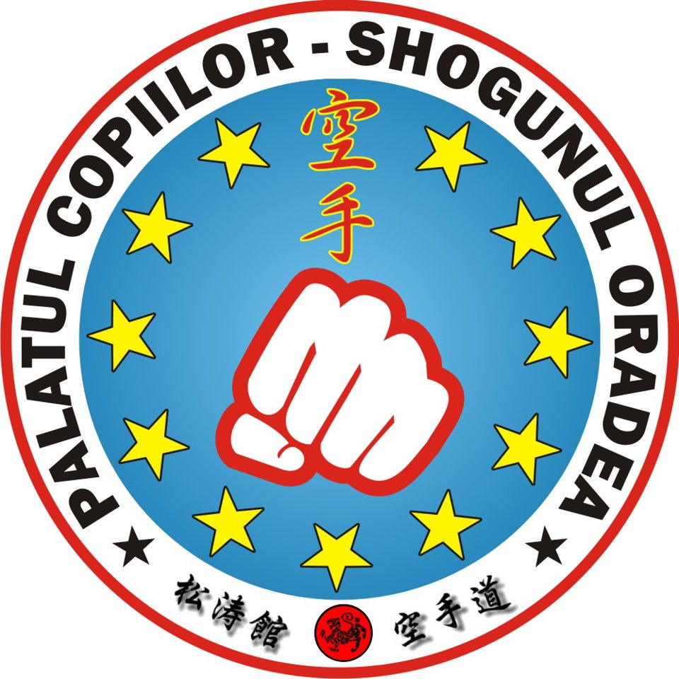
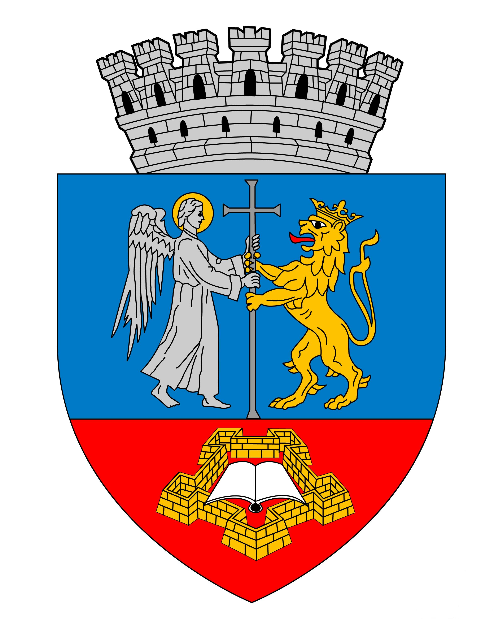
International Open Karate Championship

XII.Bihor Open-„CHAMPIONS DAY”

12 th October (Saturday) 2013.

Time: 10.00 – 20.00

Name of the club: ___________________________________________________________________________

City​​:______________________________Country:_________________________________________________

Coach / Team leader’s name: __________________________________________________________________

Gsm-tel___________________________________________ Website:_________________________________

E-mail address: ______________________________________________________________________

Nr. | Name is surname of the competitor: | Date of birth  (e.g. 15.08.2005) | after sex  (M/F) | Individual Kata code: | Individual Kumite code: | Team  Kata code: | Team Kumite code:
1.
2.
3.
4.
5.
6.
7.
8.
9.
10.
11.
12.
13.
14.
15.
16.
17.
18.
19.
20.
I take responsibility for reality of the datas. I accept the entry conditions
and I announce that the nominated competitors fit for the entry conditions.

Data: ______________, 2013. _______. ___. _____________________
signature of coach / team leader

