Czech Karate Federation
Pilsen Karate Federation





The 14th
Czech Karate Open
Euro Grand Prix
Visegrad four series

For Children, Youth and Seniors

28th – 29th September, 2013
Pilsen (Plzeň)
Czech Republic
City Sports Hall, Úslavská street

Dear Friends,

We have the pleasure to invite you to participate in our karate competition

The 14th International Karate Cup Open – Foundation for youth
For Children, Youth and Seniors

28th – 29th September, 2013

Information about the tournament:

Organiser:
Pilsen Karate Federation
Club karate Pilsen
Place:
Plzeň (Pilsen), Lokomotiva Sports Hall, Úslavská street

Date of competition:
Saturday, 28th September, 2013 - category cadets, seniors, U21
Sunday, 29th September 2013 – category children, juniors,

Time of Competition
9:00

Registration fee:
20 Euros per person per category

Sale for payment by bank transfer 1 Euro per entry
Sale for ID cards WKF 1 Euro per entry
Bank account: CSOB Plzen, Americka street, 30100 Plzen, Czech rep.
Name account: Club karate Plzen, Linska 18, Plzen
IBAN: CZ54 0300 0000 0002 3797 3484
BIC (SWIFT) CEKOCZPP
Or paypal directly from website www.sportdata.org

Closing date:
no later than 24th September, 2013. on-line registration on www.sportdata.org , maximum is 1000 entries.
Payment of the fee may be directly transferred to the following bank account before or on the Apply for transfer no later than September 26, 2013, and in this case, simply register just hours before the start in that category according to schedule. For payment in cash paid on the spot on Saturday respectively. Sunday before the tournament, and no later than 11.00 (min. hour before the start of category in the case earlier start than at 11 pm) or on technical conference in Friday. If this time is not paid the entry fee will be removed from the race start list, though will have draw.
Please inform us about the time of your arrival/departure to/from Pilsen and the means of transport.This information are very important for transport.
Invited:
European and World Teams, Clubs and Schools

Closing date:
no later than 24th September, 2013. on-line registration on www.sportdata.org , maximum is 1000 entries competitors
Please inform us about the time of your arrival/departure to/from Pilsen and the means of transport.This information are very important for transport.

Technical conference:
Friday, 27th September, 2013

Transport:
Transport Airport Prague- Pilsen- Prague ensure
Travel Agency Seko bus per person 25 Euro
Transport official hotel – sporthall – official hotel is free.

Banquet: For official all international teams will be prepare small refreshment. Start timer is 9.00 p.m. in Saturday.

Acommodation:

Official hotels and accomodation with special prices list here.(www.karatecup.cz) or on web sites www.sportadata.org (here)

Maps road to sport hall

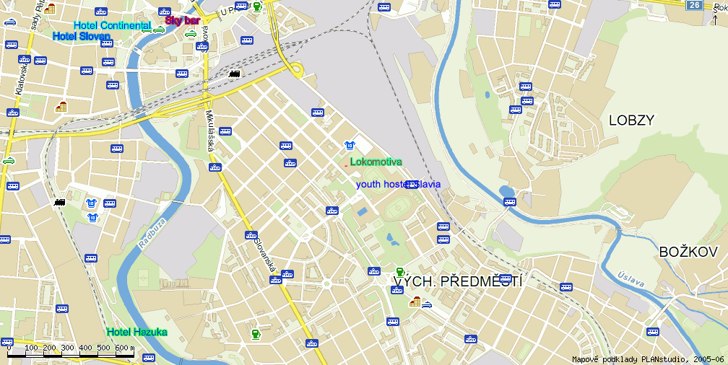

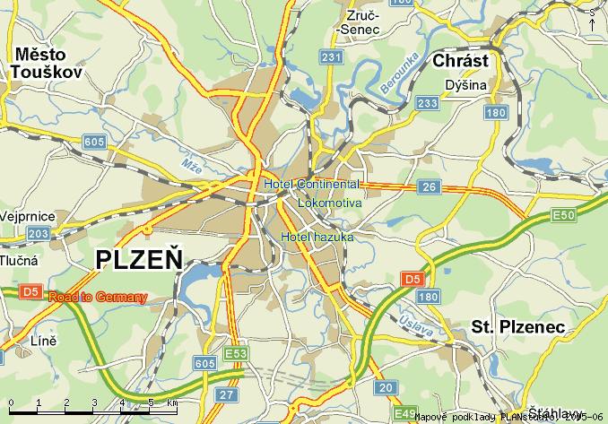

Technical section:

Information for Coaches:
Registration competitors is taking place on 27th September , 2013 from 6.00 to 8.00 pm in hotel Hazuka. Weighing of the all categories will be before theTournament Kumite in Saturday or Sunday one hour before start category on the time schedule.

Rules:

New WKF rules:

Kata all categories WKF kata rules. 7-11 years one time repeated. Another categories not repeated.

Kata children can be practicing competitors together in time. Only semifinal and match to medails by one.

Kumite rules – All category WKF rules

All category must be protective equipment WKF rules – Hands protectors, gum-shield, foot protector, shin pads,body protector and women chest protectors.!!

Face mask for cadets obligatory.

Children body protector obligatory and face mask not obligatory.
Referees:
Chief Referee – nominated by Organizing committee. Referees from participating teams are accepted.
All referees must registration before, deadline is to some than to competitors.

Categories: (min. 5th kyu) Individual
Kata competition-
Boys – age groups: 7-11, 12-13,
Girls – age groups: 7-11, 12-13, Cadets Male – aged: 14-15
Cadets Female – aged: 14-15
Juniors Male – aged: 16-17
Juniors Female – aged: 16-17
U21 male – aged: 18-20
U21 female – aged: 18-20
Seniors Male – aged : 16 and older
Seniors Female – aged : 16 and older

Kumite competition-
Boys – age groups: 7-11, 12-13,
Time: 90 sec
7-11: (-32, -40, +40 kg)
12-13: (-45, -55, +55 kg)
Girls – age groups: 10-11, 12-13,
Time: 90 sec
7-11: (-35, +35 kg)
12-13: ( -50, +50 kg)
Cadets Male – aged: 14-15
Time: 120 sec
(-52, -57, -63, -70, +70 kg, )
Cadets Female – aged: 14-15
Time: 120 sec
(-47, -54, +54 kg,)
Juniors Male – aged:16 – 17
Time: 120 sec.
(-55, -61, -68, -76, +76 kg,)
Juniors Female – aged: 16 – 17
Time: 120 sec.
(-48, -53, -59, +59 kg,)
U21 Male – aged: 18-20
Time: 180 sec.
(-68, -78, +78kg)
U21 Female – aged: 18-20
Time: 120 sec.
(-53, -60, +60kg)
Seniors Male – aged : 18 and older
Time: 180 sec.
(-60, -67, -75, -84, +84 kg, Open)
Seniors Female – aged : 18 and older
Time: 120 sec.
(-48, -55, -61, -68,+68 kg, Open)

Category Seniors, Youth are qualifikations tournament for National Championship.

Specification: It is possible participate in two age categories, but we must accepted this rules. Possible start:
U 12 ---- U14 only kata
U14 ---- Cadets kata and kumite
Cadet ---- Junior kata and kumite
Junior ---- U21 kata and kumite
U21 ---- Senior kata and kumite

Not possible start kata senior over 16 years! Not possible start junior to senior categories.
This all will registrate online to www.sportdata.org. Any manipulation of date of birthday is prohibited. If it is found to be disqualified before, during or after the tournament. Including the possibility of futher sanctions in future editions tournament.

On-line www.sportdata.org

Best regards,

Marek Kubín Jan Pytlík
Organizing Commission Vicepresident
of The Pilsen Karate Federation
e-mail: kubin@karatecz.cz e-mail: pytlik@karatecz.cz

