REGULATIONS
CUP „GÓR OPAWSKICH” KARATE wkf

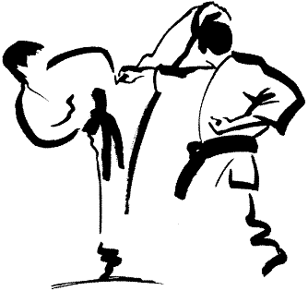

prudnik 3 November 2012 r.

1. Organizer
- Ludowy Klub Sportowy „Zarzewie” in Prudnik.
- Wojewódzkie Zrzeszenie Ludowe Zespoły Sportowe in Opole.

2. Purpose

- Popularization karate
- Showing of fairest sportsman in individual competition

3. Deadline (date) and place

- Deadline (date)
Cup „Gór Opawskich” it will proceed in day 03.11.2012 r.
– Beginning hour 10⁰⁰
- Place
Sports Hall OSiR in Prudnik Łucznicza 1.
- Weryfikacja zawodników
- Payments, verification of document 03.11.2012 r. hour 8³⁰ - 9³⁰ office of sports profession
Sports Hall OSiR in Prudnik Łucznicza 1.

4. Opłata startowa

- Start charge will be accepted - cash In office of sports profession 03.11.2012 r. hour 9³⁰.

- Individual competition: 40,00 zł (participation in two individual competition
2 x 30 zł = 60,00 zł)
- Team competition: 60,00 zł

5. Manner of conducting of sports profession

- Artistry will be carried according to currently obligatory regulations of Polish Federation Karate (WKF)
- Daytime date of birth decide about aged category.

COMPETITION :

kata INDIVIDUAL :
Competition: 1, 2, 8, 9 - in each round optional executioner kata
Competition: 3, 10 - in each round other executioner kata (alternately 2 kata)
Competition: 4, 11 – in each round other executioner from H 1
Competition: 5, 12 – in each round other executioner from H 2
Competition: 6, 7, 13, 14, – regulations WKF

1. | girls | - 8 years |  | 8. | boys | - 8 years
2. | girls | 9 years |  | 9. | boys | 9 years
3. | girls | 10 - 11 years |  | 10. | boys | 10 - 11 years
4. | girls | 12 - 13 years |  | 11. | boys | 12 - 13 years
5. | girls | 14 - 15 years |  | 12. | boys | 14 - 15 years
6. | girls | 16 - 17 years |  | 13. | boys | 16 - 17 years
7. | girls | + 18 years |  | 14. | boys | + 18 years

KATA TEAM
15. | girls | - 9 years |  | 19. | boys | - 9 years
16. | girls | 10 – 12 years |  | 20. | boys | 10 – 12 years
17. | girls | 13 - 15 years |  | 21. | boys | 13 - 15 years
18. | girls | + 16 years |  | 22. | boys | + 16 years

kumite INDIVIDUAL :
At application ask serve current weight sportsman !!!!
23. | girls | - 8 years - phantom | 38. | boys | - 8 years - phantom
24. | girls | 9 years - phantom | 39. | boys | 9 years - phantom
25. | girls | 10 - 11 years - phantom | 40. | boys | 10 - 11 years - phantom
26. | girls | 10 - 11 years - open | 41. boys 10 - 11 years - 40 kg
27. | girls | 12 -13 years - 50 kg | 42. | boys | 10 -11 years + 40 kg
28. | girls | 12 -13 years +50 kg | 43. | boys | 12 -13 years - 50 kg
29. | girls | 14 -15 years - 47 kg | 44. | boys | 12 -13 years +50 kg
30. | girls | 14 -15 years - 54 kg | 45. | boys | 14 -15 years - 57 kg
31. | girls | 14 -15 years +54 kg | 46. | boys | 14 -15 years - 63 kg
32. | girls | 16 -17 years - 53 kg | 47. | boys | 14 -15 years +63 kg
33. | girls | 16 -17 years - 59 kg | 48. | boys | 16 -17 years - 61 kg
34. | girls | 16 -17 years +59 kg | 49. | boys | 16 -17 years - 76 kg
35. | girls | +18 years - 61 kg | 50. | boys | 16 -17 years +76 kg
36. | girls | +18 years - 68 kg | 51. | boys | +18 years – 67 kg
37. | girls | +18 years + 68 kg | 52. | boys | +18 years – 75 kg
 |  |  | 53. | boys | +18 years - 84 kg
 |  |  | 54. | boys | +18 years + 84 kg
For competition case of application less than connection will follow 4 sportsmen .
Time of battle: phantom – 20 seconds, 10–11 years - 60 seconds, 12-13 years – 1,5 minutes, According to regulations remaining WKF.

6. Conditions of participation in karate sports profession
- To executioner starting kata and kumite phantom - minimum 9.1 kyu,
Kumite minimum 7.1 kyu.
It belongs to send application correspondence or on address fax

Ludowy Klub Sportowy „Zarzewie”
48 – 200 Prudnik ul. Parkowa 4 tel. 077 / 436 45 05 lub fax. 077 / 436 25 63
In deadline for day 30.10.2012 r.
or on address e-mail: zarzewie@poczta.onet.pl
- Sportsmen should own:
- Supplied documentary evidence for degree karate
- Proof of identity with photo
- Current medical research

8. Awards  - First three places will be in individual competition handed too commemorative medals busy and diplomas.  - Cup for scoring the first win in individual competition with commemorative printed inscription. | 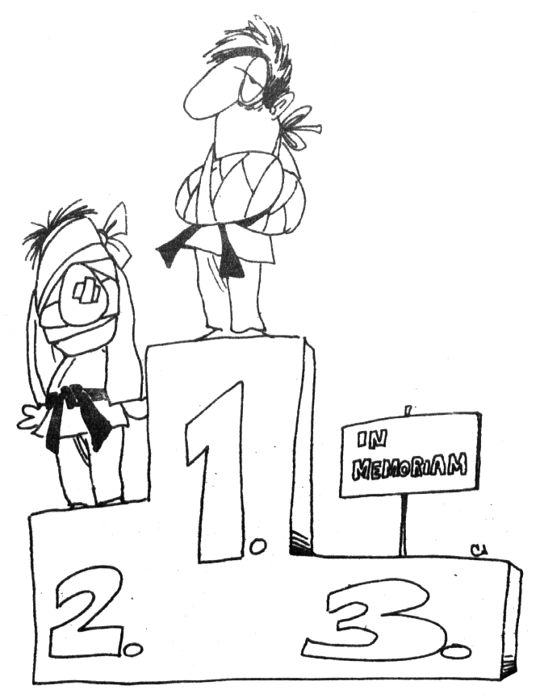

LIST OF APPLICATION
NAME OF CLUB

CUP „GÓR OPAWSKICH” KARATE wkf – Prudnik 2012
Lp. | Surname and name | Date of birth | Degree | Number of competition |  |  | Weight
1
2
3
4
5
6
7
8
9
10
11
12
13
14
15
16
17
18
19
20
21
22
23
24
25

Entering (report)

