Czech Karate Federation
Pilsen Karate Federation



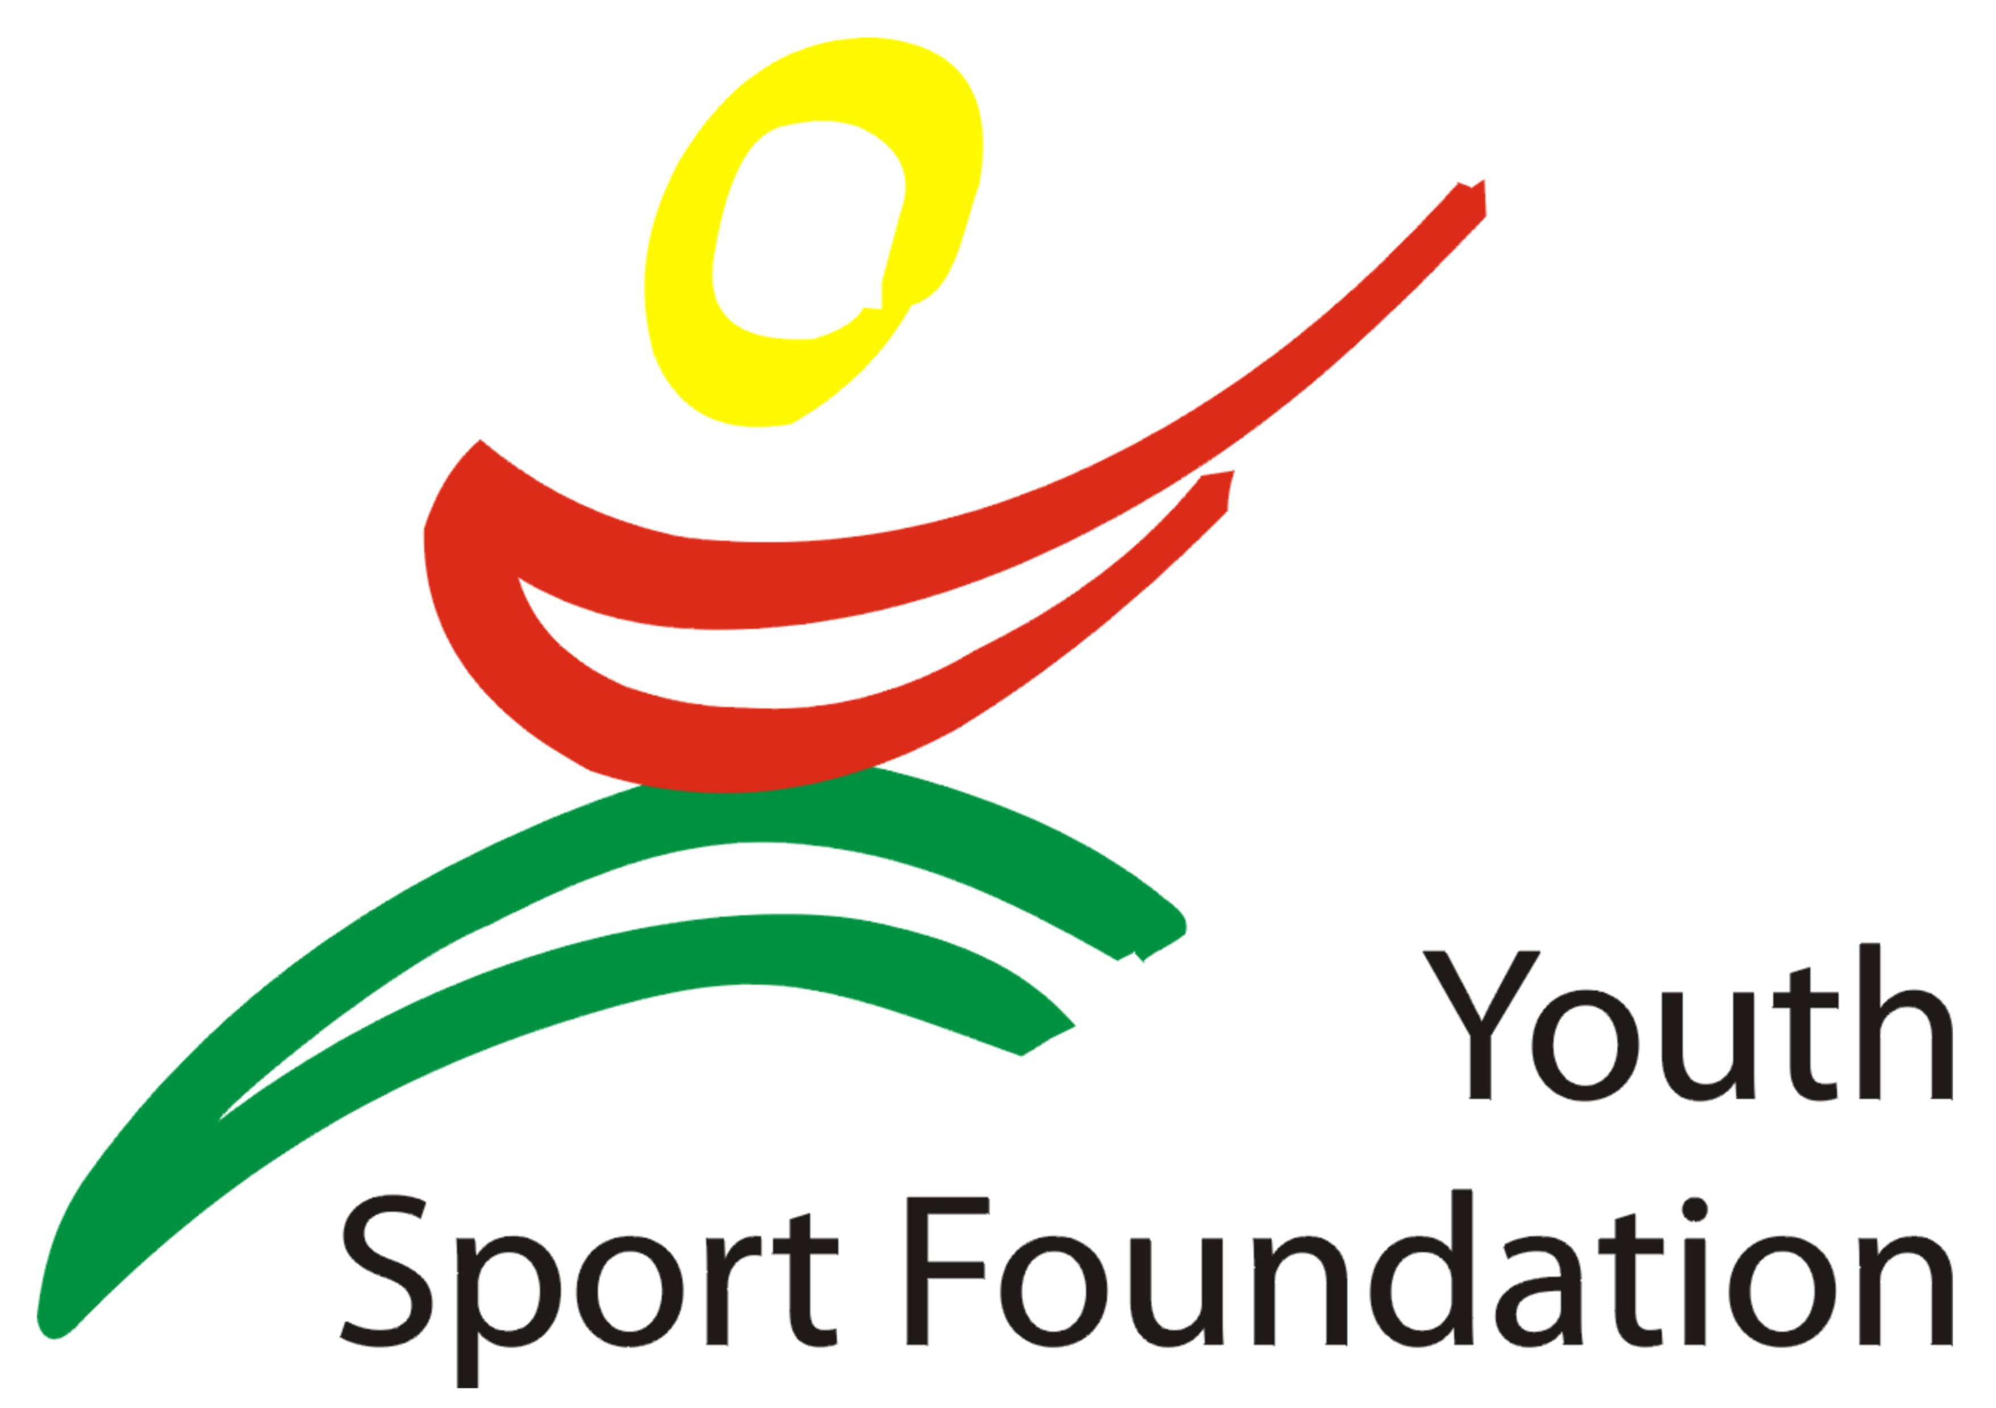

The 13th
Czech Karate Open
Euro Grand Prix
Central-European league

For Children, Youth and Seniors

27th – 28th October, 2012
Pilsen (Plzeň)
Czech Republic
City Sports Hall, Úslavská street

Dear Friends,

We have the pleasure to invite you to participate in our karate competition

The 13th International Karate Cup Open – Foundation for youth
For Children, Youth and Seniors

27th – 28th October, 2012

Information about the tournament:

Organiser:
Central European karate federation
Czech Karate Federation
Pilsen Karate Federation
Club karate Pilsen
Place:
Plzeň (Pilsen), Lokomotiva Sports Hall, Úslavská street

Date of competition:
Saturday, 27th October, 2012 - category cadets, seniors, U21
Sunday, 28th October 2012 – category children, juniors,

Time of Competition
9:00

Registration fee:
16 Euros per person per category

30 Euros per team
Bank account: CSOB Plzen, Americka street, 30100 Plzen, Czech rep.
Name account: Club karate Plzen, Linska 18, Plzen
IBAN: CZ54 0300 0000 0002 3797 3484
BIC (SWIFT) CEKOCZPP
Or paypal directly from website www.sportdata.org
Invited:
European and World Teams, Clubs and Schools

Closing date:
no later than 24th October, 2012. on-line registration on www.sportdata.org , maximum is 1000 entries
Payment of the fee may be directly transferred to the following bank account before or on the Apply for transfer no later than October 25, 2012, and in this case, simply register just hours before the start in that category according to schedule.For payment in cash paid on the spot on Saturday respectively. Sunday before the tournament, and no later than 11.00 (min.však hour before the start of category in the case earlier start than at 11 pm) or on technical conference in Friday. If this time is not paid the entry fee will be removed from the race start list, though will have draw.
Please inform us about the time of your arrival/departure to/from Pilsen and the means of transport.This information are very important for transport.
Invited:
European and World Teams, Clubs and Schools

Closing date:
no later than 24th October, 2012. on-line registration on www.sportdata.org , maximum is 1000 entries competitors
Please inform us about the time of your arrival/departure to/from Pilsen and the means of transport.This information are very important for transport.

Technical conference:
Friday, 26th October, 2012

Transport:
Transport Airport Prague- Pilsen- Prague ensure
Travel Agency Seko bus per person 25 Euro
Transport official hotel – sporthall – official hotel is free.

Banquet: For official all international teams will be prepare small refreshment in Restaurant Rozmaryn on the Americka street in central Pilsen. Start timer is 9.00 p.m. in Saturday.

Accommodation:

Official hotels and accomodation with special prices list here.(www.karatecup.cz)

Maps road to sport hall

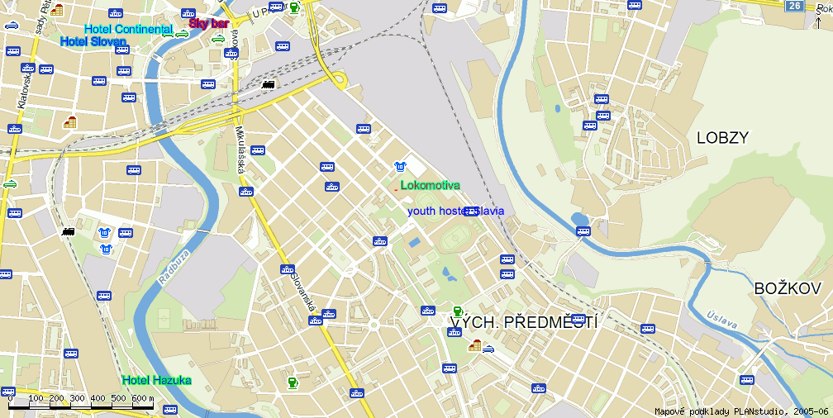

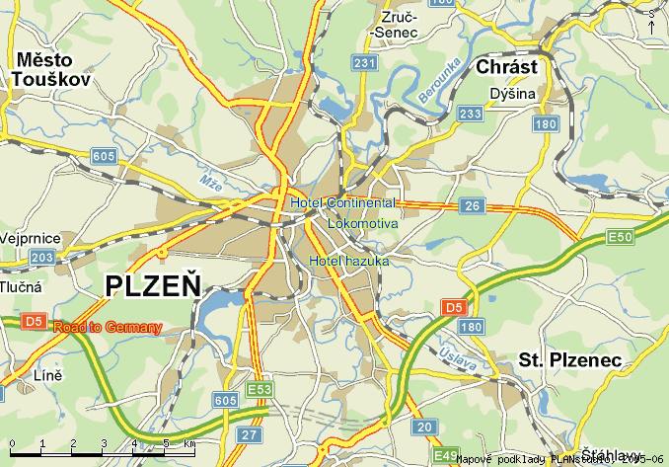

Technical section:

Information for Coaches:
Registration competitors is taking place on 26th October , 2012 from 5.00 to 8.00 pm in hotel Hazuka. Weighing of the all categories will be before theTournament Kumite in Saturday or Sunday.

Rules:

New WKF rules:

Kata children 7-13 : Tokui kata Tokui Kata WKF + Heian 1-5, Pinan 1-5, Taikyoku 1-5, Geksai 1-2

Shitei kata cadets, juniors and seniors - Shitei kata WKF, Tokui kata WKF

Kumite rules – All category WKF rules. All category must be protective equipment WKF rules – Hands protectors, gum-shield, foot protector, shin pads,body protector and women chest protectors.!! Face mask no obligatory.

Referees:
Chief Referee – nominated by Organizing committee. Referees from participating teams are accepted.
OC payed international referees EKF, WKF licence 1250 Euro per day and free accommodation. All referees must registration before, deadline is to some than to competitors.

Categories: (min. 5th kyu) Individual
Kata competition-
Boys – age groups: 7-11, 12-13,
Girls – age groups: 7-11, 12-13, Cadets Male – aged: 14-15
Cadets Female – aged: 14-15
Juniors Male – aged: 16-17
Juniors Female – aged: 16-17
U21 male – aged: 18-20
U21 female – aged: 18-20
Seniors Male – aged : 16 and older
Seniors Female – aged : 16 and older
Kumite competition-
Boys – age groups: 7-11, 12-13,
Time: 90 sec
7-11: (-32, -40, +40 kg)
12-13: (-45, -55, +55 kg)
Girls – age groups: 10-11, 12-13,
Time: 90 sec
7-11: (-35, +35 kg)
12-13: ( -50, +50 kg)
Cadets Male – aged: 14-15
Time: 120 sec
(-52, -57, -63, -70, +70 kg, )
Cadets Female – aged: 14-15
Time: 120 sec
(-47, -54, +54 kg,)
Juniors Male – aged:16 – 17
Time: 120 sec.
(-55, -61, -68, -76, +76 kg,)
Juniors Female – aged: 16 – 17
Time: 120 sec.
(-48, -53, -59, +59 kg,)
U21 Male – aged: 18-20
Time: 180 sec.
(-68, -78, +78kg)
U21 Female – aged: 18-20
Time: 120 sec.
(-53, -60, +60kg)
Seniors Male – aged : 18 and older
Time: 180 sec.
(-60, -67, -75, -84, +84 kg, Open)
Seniors Female – aged : 18 and older
Time: 120 sec.
(-48, -55, -61, -68,+68 kg, Open)

Kumite team-

Seniors male – aged: 18 and older
Time: 120 sec. (3+1)
Seniors Female – aged: 18 and older
Time: 120sec. (3+1)

Category U21 are qualifikations tournament for Central-European league
Category Seniors, Youth are qualifikations tournament for National Championship and Central-European league

Information about Central-European league is on web site www.cekl.eu.

On-line www.sportdata.org

Best regards,

Marek Kubín Jan Pytlík
Organizing Commission Vicepresident
of The Pilsen Karate Federation
e-mail: kubin@karatecz.cz e-mail: pytlik@karatecz.cz

