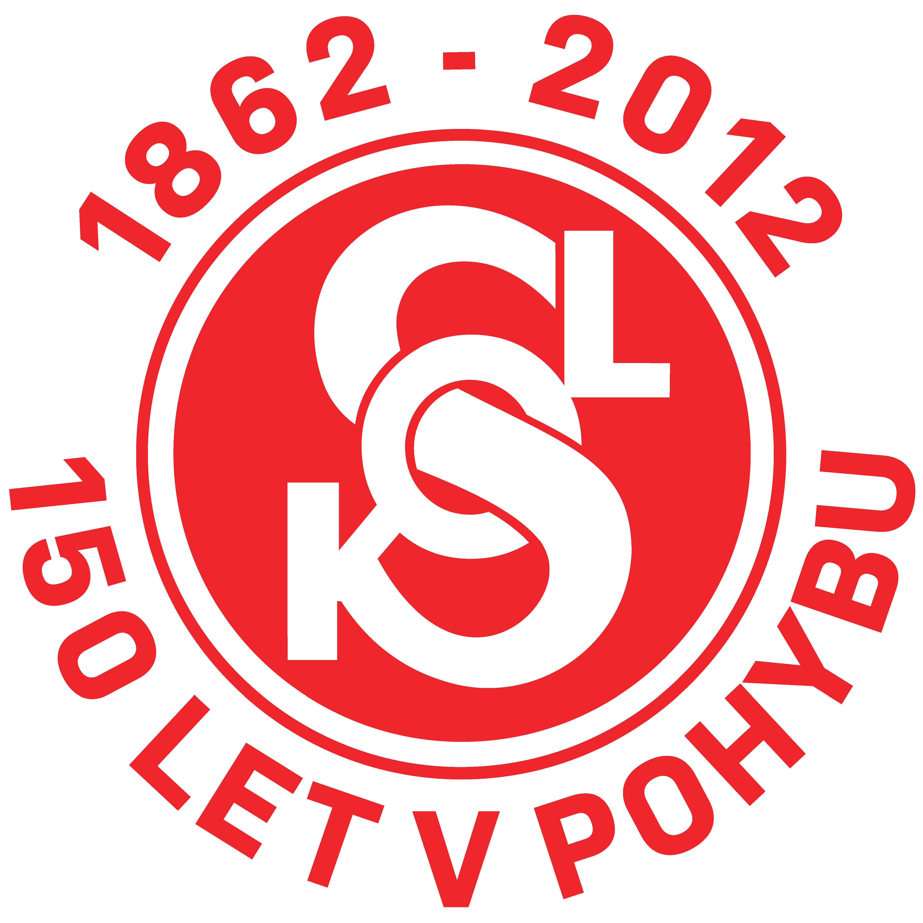
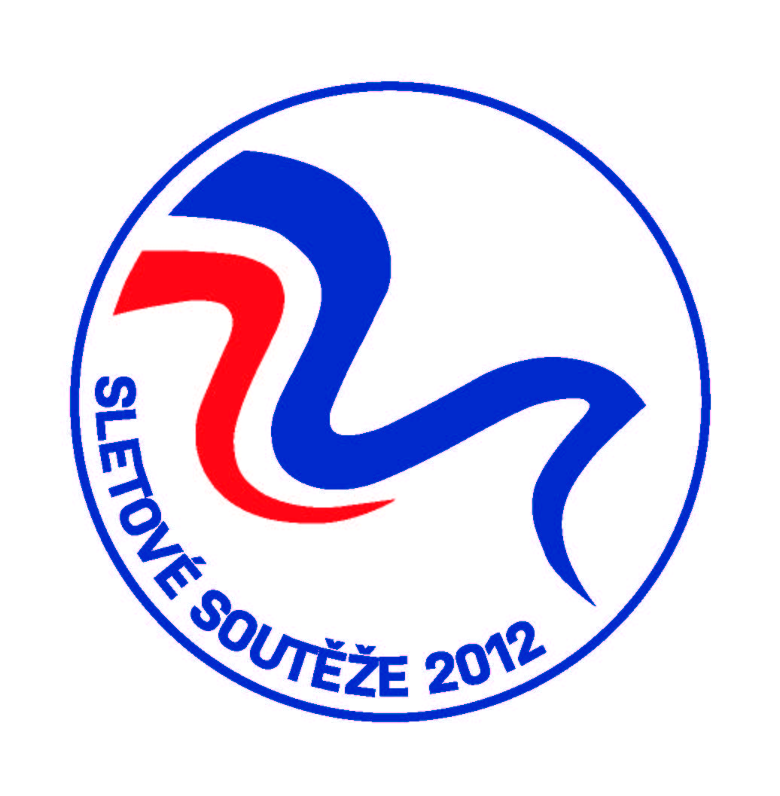
International open cup of Sokol Vamberk karate
WFK and ČOS
Choceň – 6. 10. 2012
ENTRY FORM
Club name:
Country:
Coach:
Adress:
Phone: Fax:
E-mail:

INDIVIDUAL
No. | Name | Birth date | Sex | Grade | Kata | Kumite | Weight
TEAM
No | Name | Birth date | Sex | Kata | Kumite
REFEREES
SIGNATURE
This entry form must arrive at our office at the latest by 5. 10. 2012 till 18:00
For Hotel bookings: yes – no

Adress: Ladislav Lux
Polská 722
517 54 Vamberk
Czech republic
Phone: +420 739 998 425

E-mail: info@karate-vamberk.com, ladislavlux@seznam.cz

