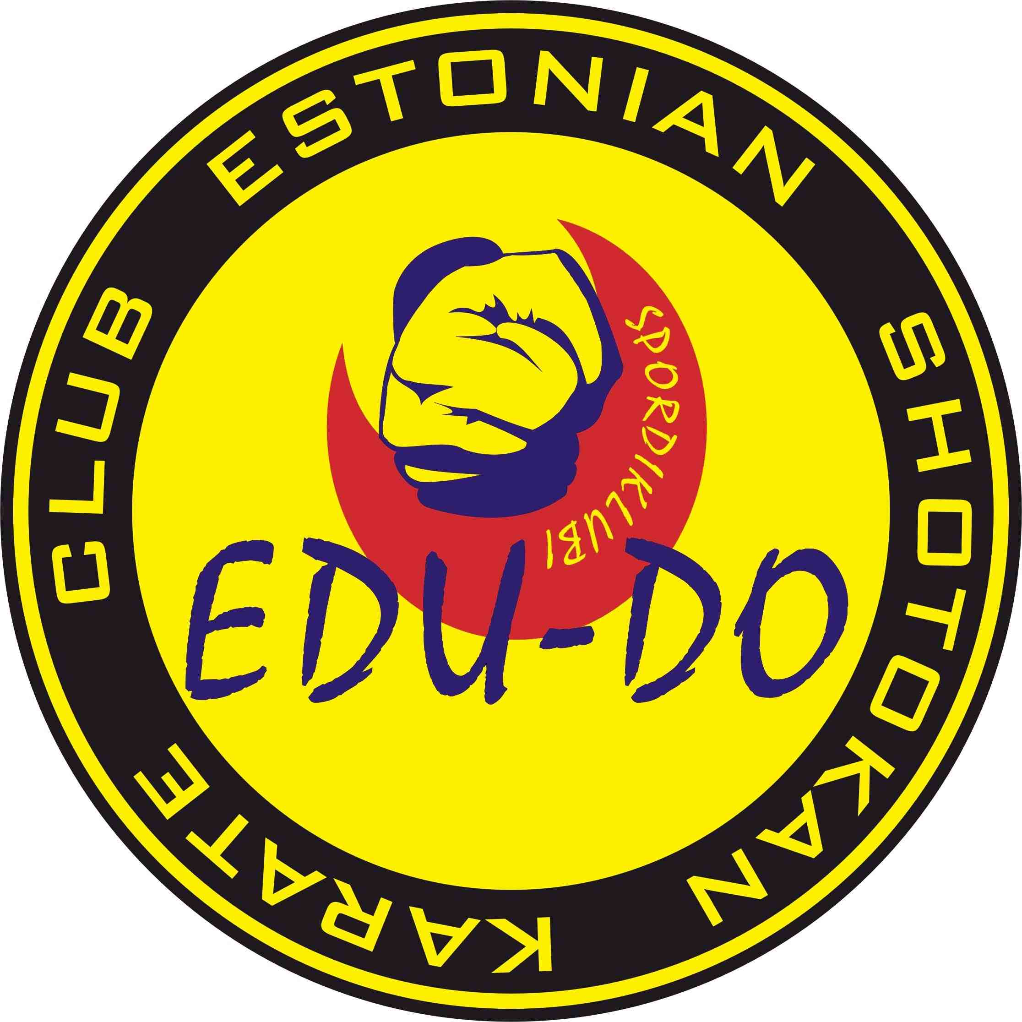

Sportclub EDU-DO

Invites!

V INTERNATIONAL KARATE TOURNAMENT FOR CHILDREN, CADETS, JUNIORS AND SENIORS

04.02.2012

EDU-DO CUP 2012

Organizer: Sportclub EDU-DO

Date : 04 February 2012 Tallinn at 10.30

Place : Estonia, Tallinna Spordihall, Staadioni 8/Herne 30

Chief referee: Dmitri Lahtikov Tel. +37255553963

Chief secretary : Rando Sirak, tel.+37256677225

Registration: 04.02.2011 at 9.00. - 10.00, Tallinna Spordihall, Staadioni 8/Herne 30

Deadline for entries:
Reservation: 30.01.2012
rando@ekf.ee
edu_do@hotmail.com
info@edu-do.ee
Registration fee : kata 15 eur.
kumite 15 eur.
kata and kumite 25 eur.
team kumite 30 eur.
team kata 30 eur.

Categories : KATA:
Children
Boys: -9 y. (can compete with 1 kata)
Girls: -9 y. (can compete with 1 kata)
Boys: 10-11 y.
Girls: 10-11 y.
Boys: 12-13 y.
Girls: 12-13 y.
Cadets
Boys: 14-15 y.
Girls: 14-15 y.
Juniors
Boys: 16-17 y.
Girls: 16-17 y.
TEAM KATA (boys and girls are together): (-9 y., 10-13 y., 14-17 y.)

KUMITE:
Children
Boys and girls are together: -7 y. ABS (1 min, till 3 points)
Boys: 8-9 y. -28 kg, +28 kg (1 min, till 3 points),
Girls: 8-9 y. ABS (1 min, till 3 points)
Boys: 10-11 y. -35 kg, -40 kg, +40 kg
Girls: 10-11 y. -40 kg, +40 kg
Boys: 12-13 y. -45 kg, -50 kg, +50 kg.
Girls: 12-13 y. -50 kg, +50 kg
Cadets
Boys: 14-15 y. - 52 kg, -57 kg, -63 kg, + 63 kg.
girls: 14-15 y. - 54 kg, +54 kg.
Juniors
Boys: 16-17 y. - 61 kg, -68, -76 kg, +76 kg.
Girls: 16-17 y. - 59 kg, +59 kg.
Seniors (with money prize)
Men: 18+ ABS. (with written consent of the coach can compete 16+ )
Women: 18+ ABS. (with written consent of the coach can compete 16+ )
TEAM KUMITE
BOYS:
-9 y: 3+1
10-11 y: 3+1
12-13 y: 3+1
14-15 y: 3+1
16-17 y: 3+1
GIRLS:
-9 y: 1 sporsman
10-11 y: 1 sportsman
12-13 y: 1 sportsman
14-15 y: 1 sportsman
16-17 y: 1 spotsman

All sportsmen proceeding registration have to show the identification document.

The number of participants is not limited.

Competition rules : WKF rules

Competence : All questions not included in this restriction are answered according to Organizing and Referee's Committees.

Rewards: Sportclub EDU-DO rewards the 1st place winners with medals, cups and diplomas, 2nd and 3rd place winners with medals and diplomas.

Accommodation: 15 eur and higher per 1 person.

Yours sincerely,
Chairman of Organizing Committee
Konstantin Iljenko
Tel.+372 52 58 372
www.edu-do.ee

EDU-DO CUP 2011
05 February 2011
ESTONIA – TALLINN
Club name:
Club address: Coach name:
Name of representative:
Referees:……………………………………..
Phone:……………….Fax:…………. E-mail:.

ENTRANCE FORM INDIVIDUAL
No | Individual competitor | Age | Male | Female | Individual  Kata | Individual  Kumite | Team  Kata | Team  Kumite | Individual  Men  Kumite | Individual  Women  Kumite | weight
1
2
3
4
5
6
7
8
9
10
11
12
13
14
15
16
17
18
19
20
Guide: In case of individual competitors please fill in the name column legible. Fill in the age column comparing to the date of the competition. Please put an “x” into other columns as appropriate.

