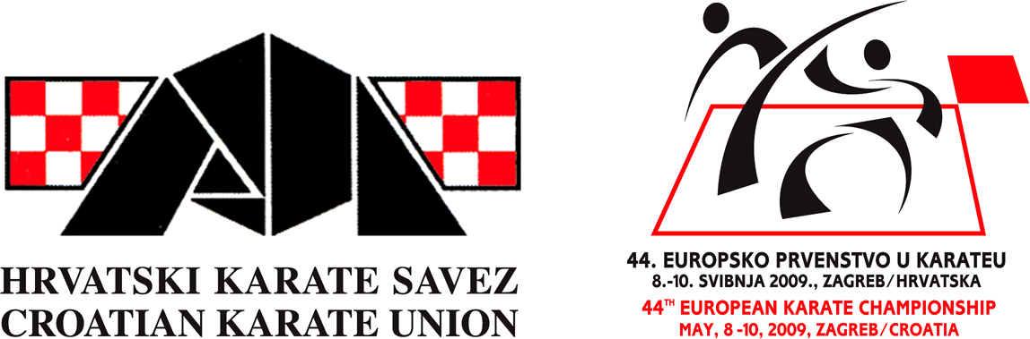
Trg Krešimira Ćosića 11, 10000 Zagreb
Tel:++385 1 3099 071,
Gsm:091/2055 667, 091/5007 851
Fax:++385 1 3011 518,
E-mail:karate.tajnistvo@zg.htnet.hr
darko.simunec@zg.htnet.hr
Web:www.karate.hr
www.hrvatski-karate.hr
Žiro-račun:2484008-1100769406
MB:0242942
___________________________________________________________________________________

I N V I T A T I O N

Referees and Coaches Seminar – NEW RULES
hold by Mr. Con Kassis
Chairman of WKF Referee Commission

Dear friends,

The Croatian Karate Union have the pleasure of hosting Seminar for Referees and Coaches hold by Mr. Con Kassis, Chairman of WKF Referees Commission, which will be held during international karate tournament – „21st GRAND PRIX CROATIA 2012“

Mr Kassis will explain the theoretical and practical implications of the new WKF rules that will come from January 2012. This as a unique opportunity for Referees and Coaches to work with the world`s top Karate Referee. Please be so kind and send this information to your Coaches,Judges and Referees.

INFORMATION

Date: Friday, January 20, 2012.
Venue: City of Samobor (20 km from Capital Zagreb), adress: A.Hebranga 26a
City Sport hall where the competition will be held on January 21 – 22, 2012.
Cost:
Seminar - free of charge
Lunch - 10€ per person

SEMINAR SCHEDULE:
-12,00 – 12,45 Registration, payment vouchers for lunch
-13,00 – 15,30 Theory - NEW RULES-Questions and Answers
-15,30 – 17,00 Lunch & Coffee Break
-17,00 – 20,00 Practice in sports hall

January 21, 2012 –Mr. Kassis will be present in the sports hall during the first day of Competition for Cadets, Juniors, U21 and Seniors.

INFORMATION FOR REFEREES WHO WANT TO JUDGE ON COMPETITION

Referees and judges at the competition are delegated by the Croatian Karate Union Referees' Commitee (CKF). Foreign referees and judges are delegated by their national federations in agreement with the CKF. The organiser will cover the costs to the amount of 80€ per day for foreign referees and judges.

ACCOMMODATION:

 | Bed & breakfast – per person a day | Supplement for dinner | Number of beds | Tourist tax – per person a day*
hostel Samobor  Obrtnička 34, Samobor | 115,00 kn | 35,00 kn | Cca 80 | 7,00 kn
Hostel Samobor is a cozy hostel located in the center of Samobor, near the central square of King Tomislav. Bedrooms are equipped with new, high-quality beds and wardrobes, and have 2, 4, 6 or 10 beds, as well as associated sanitary facilities.
Pension Golubić  Obrtnička 12, Samobor | 144,00 kn | - | Cca 10 | 7,00 kn
Pension Golubić is located in the center of Samobor. This small pension (only 11 beds), is tailored to those who love small and quiet pensions, so it will provide the visitor with true satisfaction that cannot be found in any hotel.
Hostel Arena  Remetinečki gaj 28, Zagreb | 1/2 soba 150,00 kn  1/3 soba 138,00 kn | 46,00 kn | Cca 280 | 7,00 kn
Hostel Arena is located at the southwestern entrance to Zagreb by a bypass road, cca 20 km from Samobor sport hall. Each room has shower, toilets and wardrobes.
hotel Porin 3*  Sarajevska 41, Zagreb | 162,00 kn | 65,00 kn | Cca 100 | 7,00 kn
Hotel Porin is located near the highway and near the airport Pleso separated from the city noise and just minutes from the business and cultural center of Zagreb, with its own parking space.
hotel Lavica 3* Livadićeva 5, Samobor | 1/2 room 175,00 kn  1/3 room 144,00 kn | 46,00 kn | Cca 50 | 7,00 kn
Hotel Lavica is located in the heart of Samobor. All rooms are equipped with new furniture, bathrooms with SOS signs, TV, telephone with direct dialing and minibar.
hotel Holiday 3* Ljubljanska avenija bb, Zagreb | 1/2 room 237,00 kn  1/3 room 220,00 kn | 80,00 kn | Cca 150 | 7,00 kn
Hotel Holiday is situated at the western entrance to Zagreb, cca 15 km from Samobor sport hall. Direct highway access makes it quick journey to Samobor, while excellent connectivity with the center provides a quick arrival at the center of Zagreb.

100 EUR = 750,00 kn

FOR ALL INFORMATIONS AND RESERVATIONS CONTACT :
TRAVEL AGENCY „SAMOBOR RECEPTIVE”
TEL: 00385/1/3366-761
FAX: 00385/1/3366-762
e-mail: samobor.receptive@mail.inet.hr

APPLICATION FORM FOR COACHES AND REFEREES SEMINAR
Samobor, Croatia, January 20, 2012

National Federation:

Karate Club(for Coaches):

No. | Name, Surname | Position  Coach: C  Referee:R  Judge:J | Lunch  Yes / No

Please be so kind and send this Application form no lather than January 15, 2012.

E mail:karate.tajnistvo@zg.t-com.hr
Fax: ++385 1 301 518
Tel. ++385 1 3099 071
Contact person: Mr. Davor Cipek, Tech.Secretary of Croatian Karate Union

