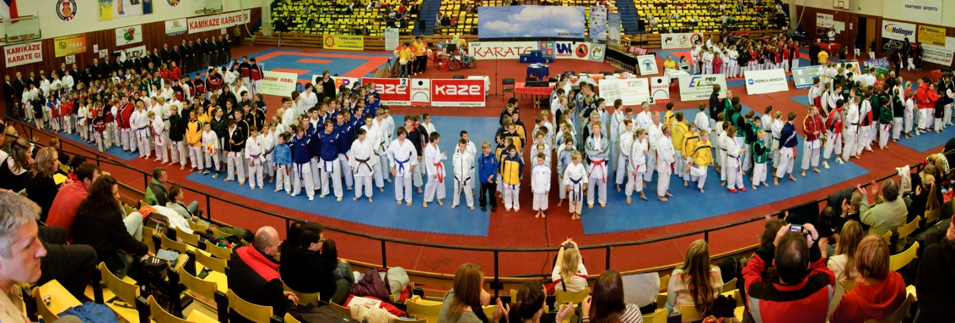
X L III. GRAND PRIX NORTHBOHEMIA
Organizer: S H O T O K A N K L U B R A J C H E R T S P O R T U N I O N o.s.

School of karate Ústí nad Labem
Date: 5th November 2011

Place : Sports hall SLUNETA Klíše – Ústí nad Labem

Contact Adress : Mgr.Bc.Josef Rajchert ,Ve Smyčce 7 , 400 11 Ústí nad Labem,

Czech Republic
Phone/fax +420602 421 764 , 47 271 43 58,
E mail : info@karate-rajchert.cz
Cheff Referee : Mr.Primož Debenak - Referee WKF from Slovenia
Mr.Jaroslav Nekola- Referee WKF from Czech republic

Official hotels : VLADIMÍR tel. 47 523 51 11
BOHEMIA tel. 47 522 08 43
Hostel: Pension Soc.péče ( Mas.Nemocnice) tel.47 711 51 60

The International Referees are very welcome.
The Referees don’t pay for accommodation.
Accommodation for delegated Referees pays the organizer.
Categories:
Kata (from 8th kyu) Individual Boys 7-11 (kata 2x), 12-13 (kata 1x)
Girls 7-11 (kata 2x), 12-13 (kata 1x)
Boys 14-15 (kata 1x)

Gilrs 14-15 (kata 1x)

Cadets (male) 16 – 17 kata WKF rules

Cadets(female) 16 – 17 kata WKF rules

Women + 18 kata WKF rules

Men + 18 kata WKF rules

Masters (+35, 40)

Women category +35 years

Men c ategory + 40 years Tokui Kata

Teams Boys 7 - 13, 14 - 17, +16 years
Girls 7 - 13, 14 - 17 ,+ 16 years
System : Each turn another kata (final Bunkai)
Kumite (from 6th kyu)
Girls 7 - 11 years (-35, +35 kg) / 90 sec.
Boys 7– 11 years (- 30, - 35, - 41, + 41 kg) / 90 sec.
Girls 12 – 13 years (- 42, - 50, + 50 kg) / 120 sec.
Boys 12 – 13 years (- 39, - 45, - 52, - 60, + 60kg ) / 120 sec.
Girls 14 – 15years (- 47, - 54, + 54 kg) / 120 sec.
Boys 14 – 15 years (- 52, - 57, -63, -70, +70kg) / 120 sec.
Girls 16 – 17years (- 48, -53, -59, +59 kg) / 120 sec.
Boys 16 – 17 yers (- 55, - 61, - 68, -76, +76 kg) / 120 sec.
Women + 18 yers -55, -60,+60 Open / 120 sec.
Men + 18 yers -70, -80, +80 Open / 120 sec.

Kumite teams Women 3 +1 / 120 sec.
Men 5 +1 / 120 sec.
Kumite veteran Women + 35 years (Open) / 120 sec.
Men + 40 years (Open) / 120 sec.

Starting fee: Individual 20,- Euros , Teams 50,- Euros ,

BANK: ČSOB a.s. Ústí nad Labem
EURO - 183 093 915 / 0300
CZK - 183 092 154 / 0300
Conditions for start: Medical exam (not older than 1 year)
Minimum is the 6th Kyu (for kumite, for kata 8.kyu)

Rules for the contest of KATA WKF with exception for boys, girls, cadets

Rules for the contest of KUMITE:
The fight lasts 120 seconds / Children 90 sec.), there are two third places with repasage.
In the contest of Teams, there is the system according to the number of teams presented.
Compulsory – red and blue hand protectors, protectors of teeth.
Protectors WKF – shins and waists, for all categories.
No masc and body protectors for boys.
PROTESTS : WKF rules charge 50,-EURO

PROGRAM of the competition - 5 tatami:
Attention:The program can be changed during the competiton.

Saturday 5th November 2011
07,30 - 08,00 specification of competitor lists
08,00 - 08,30 paying fees ; draw
08,30 - 9,00 Referees meeting
09,00 - 11,00 opening elimination kata individuals, teams, – 5 tatami
11,00 Kata final

11,30 Opening ceremony with all competitors
Price-giving ceremony for winners of Kata

12,00 opening elimination kumite kumite team and individuals
Final kumite teams.
Final kumite individuals
Price-giving ceremony for winners of Kumite
20,00 The end of the competition

Referees Referees ČSKe , Referees from abroad .
Rules WKF and correction

Applications for the contest should be sent to the e-mail : karatemb@seznam.cz until the 31 th October 2011 24:00.

AWARDS FOR WINNERS:

For all individual categories:
1st place - gold cup, diploma, sponsor price
2nd place - medal ,diploma, sponsor price
3rd place - medal , diploma, sponsor price
Team women (kumite, min.3 tems !) bonus 1 st place 300 EUROS

Team men (kumite min.4 teams !) bonus 1 st place 1.000 EUROS
Kumite individual Open Men bonus 1 ^{st} place 200 EUROS
Kumite individuals Open Womean bonus 1 ^{st}place 200 EUROS
Kata individual men bonus 1 ^{st}place 100 EUROS
Kata individual women bonus 1stplace 100 EUROS

Special award for best competitor!
Come to do your best with competitors from all around the world in Ústí nad Labem !

From the Shotokan Klub Rajchert Sport Union:

Mgr. Bc.Josef Rajchert
President of the club
Chairman of the Referee committee CZKF
Referee WKF,V.DAN Shotokan

CLUB : ___________________, COACH :_________________

Name compet. |  |  | Categories |  |  |  |  |  |  |  |  |  |  |  |  | kata |  | kumite cat. |  | Open
 |  |  | Children |  |  |  | Cadets |  |  |  |  | Senior |  | Veteran
 |  |  | G |  | B |  | G | B |  |  |  | W | M | W | M
EXAMPLE:  Tonny Castle |  |  |  |  |  |  |  |  |  |  |  |  |  |  | x | X |  | - | X
Teams

Kata | Categories |  |  |  |  |  |  |  |  |  | Kumite |  |  | Category
Kata | Children  B/G | Kadets  B/G |  | F |  | M

