12th BUDAPEST TATAMI CUP

for children, cadets, juniors, U21
26th of February, 2011

BULLETIN

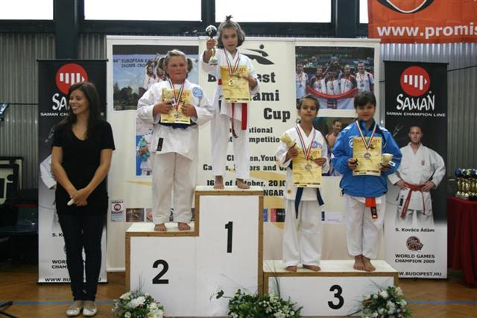
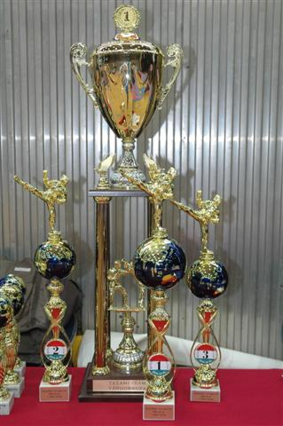
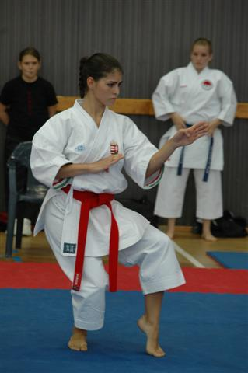

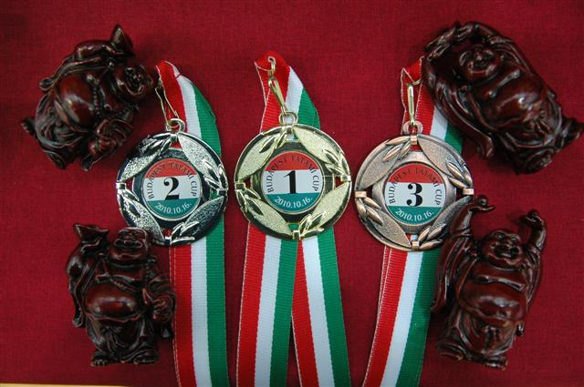
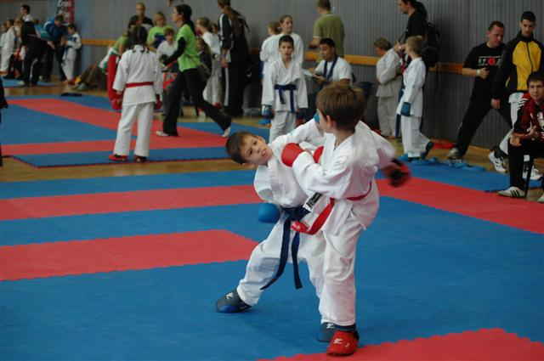
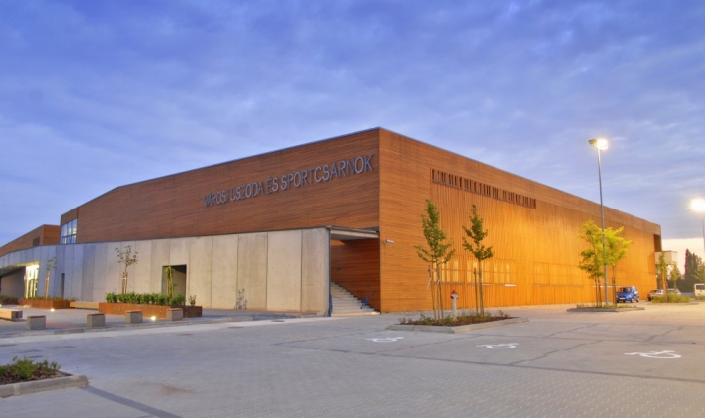
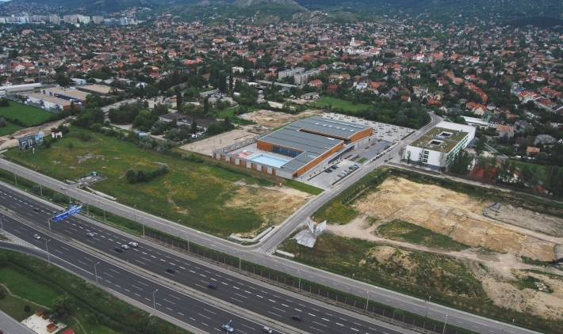

12th Budapest Tatami Cup
for children, cadets, juniors, U21
26th of February, 2011., Budapest, Hungary

Last year: 560 competitors, 43 hungarian clubs, 11 foriegn clubs from Serbia, Slovakia, Croatia, Ukraine, Romania, Germany


Venue: BUDAÖRS CITY SPORTSHALL
2040 Hársfa u. 6., Budaörs,

Starting: at 9.30 on the 26th of February

Order of execution: Competition starts with children. In same age categories we start with kata. Immediately after kata we follow with kumite events. After the junior categories we will start team events and the same time we start U21 individual events. After finishing a category, we will do the medal ceremony. Direct selection, full repechage, two third places.

Programme:
9.30 OPENING CEREMONY
09.45 Competition starts with 6-11 years old kata and kumite
12.00 12-13 years kata and kumite
13.00 14-15 and 16-17 years kata
15.00 14-15 and 16-17 years kumite
16.00 U21 and Team kata and kumite events

Weighing: For Cadets, Juniors and U21: from 9.00-10.00 and from 12.00-15.00

For children and youth we will choose random samples during the competition.

We will not start the events before the above mentioned times, therefore you can organize the arrivals of your competitors considering the starting times!

Entry fee: 15,- Euro for one individual category
15,- Euro for team kata and female team kumite categories
20,-Euro for male team kumite category

Registration: On the day of the competition, from 8.00 to 11.00
ONE PERSON registers ONE SPORTCLUB

Deadline: 22nd February, 2011.

Entries to: Fax: +36-1-787-9368
E-mail: tatamiteam@freemail.hu

Referees: Foreign WKF, EKF and National referees are welcomed!
Please, contact us if you intend to participate as a referee!
40,- Euro compensation for participating foriegn referees.

Head of Referees: Mr. Péter Turák, WKF karate referee
Member of Referee Committee of Hungarian Karate Federation

INDIVIDUAL CATEGORIES
MALE KATA | CODE | RESTRICTION |  | FEMALE KATA | CODE |  | RESTRICTION
6 - 7 years | FKA1 | 1 kata needed |  | 6 - 7 years | LKA1 |  | 1 kata needed
8 - 9 years | FKA2 | 1 kata needed |  | 8 - 9 years | LKA2 |  | 1 kata needed
10 – 11 years | FKA3 | 2 kata needed |  | 10 – 11 years | LKA3 |  | 2 kata needed
12 – 13 years | FKA4 | 3 kata needed |  | 12 – 13 years | LKA4 |  | 3 kata needed
14 – 15 years, kadet | FKA5 | WKF rules |  | 14 – 15 years, kadet | LKA5 |  | WKF rules
16 – 17 years, junior | FKA6 | WKF rules |  | 16 – 17 years, junior | LKA6 |  | WKF rules
18 – 21 years, U21 | FKA7 | WKF rules |  | 18 – 21 years, U21 | LKA7 |  | WKF rules
MALE KUMITE | CODE | BOUT |  | FEMALE KUMITE
6 - 7 years - 25 kg | FKU1 | 1 min, h. 30sec |  | 6 – 7 years - 22 kg | CODE |  | BOUT
6 - 7 years + 25 kg | FKU2 | 1 min, h. 30sec |  | 6 – 7 years + 22 kg | LKU1 |  | 1 min, h. 30sec
8-9 years – 27 kg | FKU3 | 1 min, h. 30sec |  | 8 - 9 years - 25 kg | LKU2 |  | 1 min, h. 30sec
8-9 years + 27 kg | FKU4 | 1 min, h. 30sec |  | 8 - 9 years + 25 kg | LKU3 |  | 1 min, h. 30sec
10-11 years - 35 kg | FKU5 | 1,5 min, h. 30sec |  | 10-11 years - 35 kg | LKU4 |  | 1 min, h. 30sec
10-11 years - 40 kg | FKU6 | 1,5 min, h. 30sec |  | 10-11 years + 35 kg | LKU5 |  | 1,5 min, h. 30sec
10-11 years +40 kg | FKU7 | 1,5 min, h. 30sec |  | 12-13 years - 40 kg | LKU6 |  | 1,5 min, h. 30sec
12-13 years - 40 kg | FKU8 | 2 min, h. 1 min |  | 12-13 years - 50 kg | LKU7 |  | 2 min, h. 1 min
12-13 years - 50 kg | FKU9 | 2 min, h. 1 min |  | 12-13 years + 50 kg | LKU8 |  | 2 min, h. 1 min
12-13 years + 50 kg | FKU10 | 2 min, h. 1 min |  | 14-15 years - 47 kg | LKU9 |  | 2 min, h. 1 min
14-15 years - 52 kg | FKU11 | 2 min, h. 1 min |  | 14-15 years - 54 kg | LKU10 |  | 2 min, h. 1 min
14-15 years - 57 kg | FKU12 | 2 min, h. 1 min |  | 14-15 years + 54 kg | LKU11 |  | 2 min, h. 1 min
14-15 years - 63 kg | FKU13 | 2 min, h. 1 min |  | 16-17 years - 48 kg | LKU12 |  | 2 min, h. 1 min
14-15 years - 70 kg | FKU14 | 2 min, h. 1 min |  | 16-17 years - 53 kg | LKU13 |  | 2 min, h. 1 min
14-15 years + 70 kg | FKU15 | 2 min, h. 1 min |  | 16-17 years - 59 kg | LKU14 |  | 2 min, h. 1 min
16-17 years -55kg | FKU16 | 2 min, h. 1 min |  | 16-17 years + 59 kg | LKU15 |  | 2 min, h. 1 min
16-17 years - 61kg | FKU17 | 2 min, h. 1 min |  | U21 18–20 years – 53 kg | LKU16 |  | 2 min, h. 1 min
16-17 years - 68kg | FKU18 | 2 min, h. 1 min |  | U21 18–20 years - 60 kg | LKU17 |  | 2 min, h. 1 min
16-17 years - 76kg | FKU19 | 2 min, h. 1 min |  | U21 18–20 years + 60kg | LKU18 |  | 2 min, h. 1 min
16-17 years +76kg | FKU20 | 2 min, h. 1 min |  | 
U21 18 – 20 years – 68 kg | FKU21 | 3 min, h. 1 min
U21 18 – 20 years - 78 kg | FKU22 | 3 min, h. 1 min
U21 18 – 20 years + 78 kg | FKU23 | 3 min, h. 1 min
TEAM CATEGORIES |  |  | CODE
GIRLS TEAM KATA 7-13 years |  |  | LKACS1
FEMALE TEAM KATA Cadet, Junior and U21 competitors |  |  | LKACS2
BOYS TEAM KATA 7-13 years |  |  | FKACS1
MALE TEAM KATA Cadet, Junior and U21 competitors |  |  | FKACS2
FEMALE TEAM KUMITE 3 competitors+ 3 reserves |  |  | LKUCS1
1st competitor: 12-13 years, 2nd competitor: cadet, 3rd competitor junior |  |  | LKUCS1
+ 3 reserves, one / age category |  |  | LKUCS1
MALE TEAM KUMITE 5 competitors+ 5 reserves |  |  | FKUCS1
1st competitor: 8-9 years, 2nd: 10-11 years, 3rd: 12-13 years 4th: cadet, 5th: junior |  |  | FKUCS1
+ 5 reserves, one/age category |  |  | FKUCS1

Kata (individual and team) system:
For Children and Youth (7-11, 12-13):
- In the final and for the third place it is possible to demonstrate or repeat any kind of kata.
- FKA1, FKA2, LKA1, LKA2 CATEGORIES: 1 kata, same kata can be repeated (can be more than 1)
- FKA3, LKA3 CATEGORIES: 2 katas, 2 katas in rotation (can be more than 2)
- FKA4, LKA4: 3 katas, different kata in each round, but after the 3rd round possible to repeat (the same kata, or different ones, but in rotation)
For Cadets, Juniors, U21:
- WKF rules

Kumite system:
Contact rules:
- From 6-15 years: WKF Cadet rules
- From 16 – 17 years: WKF Junior rules
- U21: WKF rules
System:
- Direct selection with full repachage, (WKF flag system)
Bouts:
- 6- 9 years 1 minute, +30sec after draw
- 10 – 11 years 1,5 minute , +30sec after draw
- 12 – 13 years, cadets, juniors, U21 (female) 2 minutes +60sec after draw
- U21 males 3 minutes – 60 after draw

Team kumite events:
Bouts: 2 minutes, possible to use younger competitor in the given order

Equipments:
- According to WKF rules
(red and blue mitts, shin and foot protectors and belts of the same colours, teeth protector, brest protector for girls are obligatory, face mask and body protector are optional)

Entry conditions: Every competitor appears at his/her own responsibility, the organizer
doesn’t take responsibility for any eventual injuries. Coaches or team leaders must sign a responsibility statement!
In individual categories we accept only one kata and one kumite entry of the same competitor!
The coaches must have sports equipment or they cannot be in the field.

Protest: At the Head of Referees, in written form, immediately following
the relevant event. Protest fee: 50 Euro.-

Accomodation: We do not organize accomodation!

Reccomended websites for accomodation:
http://www.driveinnhotel.com/
http://www.hibudhotel.hu/

If you prefer smaller pensions, we reccomend you to check „googlemaps” around the adress of the Sporthall: Hársfa u. 6., Budaörs

Rewards: I. place: cup, medal, diploma
II. place: medal, diploma
III. place: medal, diploma
+ gifts and special prizes

We wish you a succesfull and fair competition!

Renáta Szathmáry Zsuzsanna Klima
organizer organizer

