INTERNATIONAL UNION CUP
04.12.2010 LVIV, UKRAINE

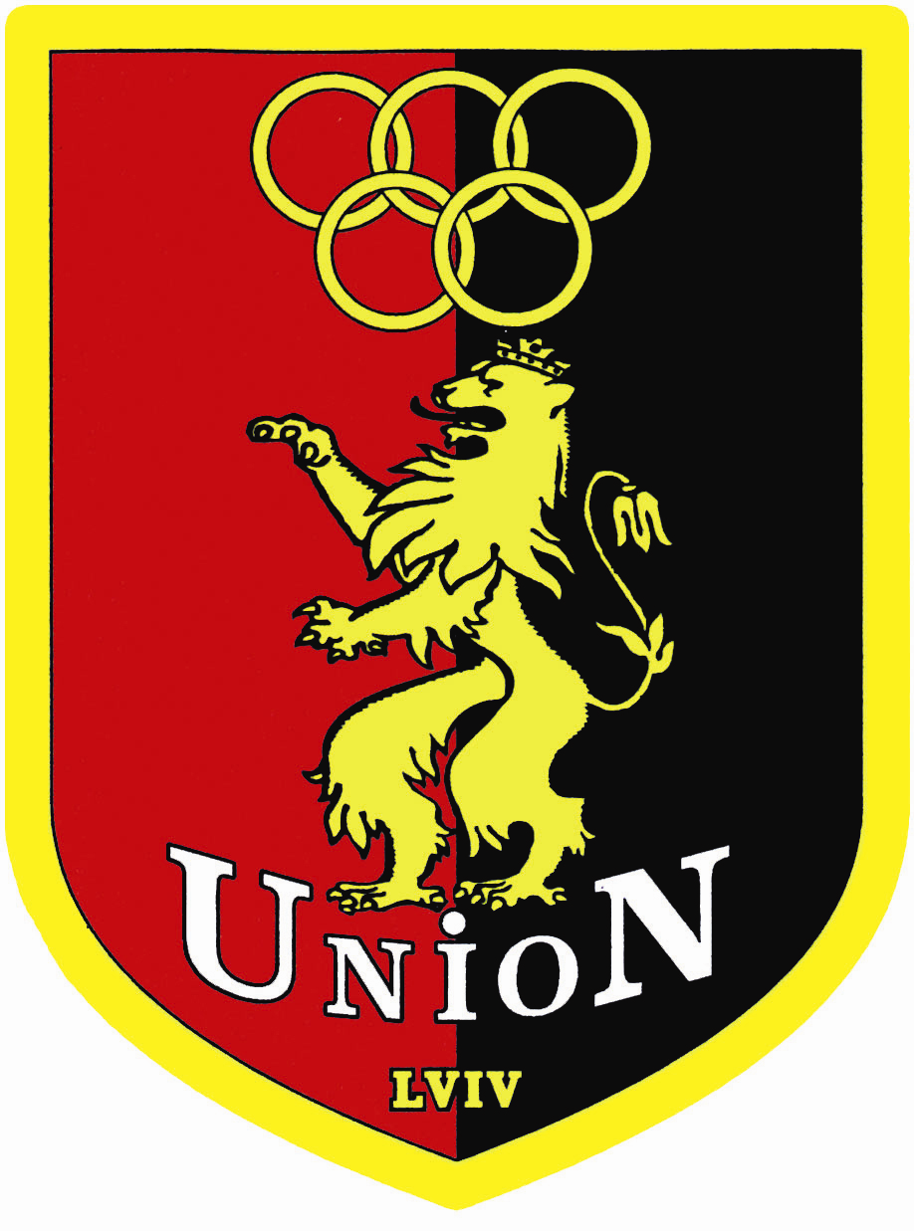

Dear Friends,
We have the pleasure to invite you to participate in our karate competition:
INTERNATIONAL UNION CUP

Information about the tournament: Categories:
Organizer: KATA:
Professional club «Union» Lviv. Ukraine 8 – 9 years old boys 8 – 9 years old girls
Address: 79014 Lviv, G. Grekova str. 1 10 – 11 years old boys 10 – 11 years old girls
12 – 13 years old boys 12 – 13 years old girls
Aim: 14 – 17 years old boys 14 – 17 years old girls
The exteriorization in individual competitions the best
competitors, popularization of spirit and idea of karate KUMITE:
is the aim of championship. 8 – 9 years old boys - 32 kg., + 32 kg.
8 – 9 years old girls - 30 kg., + 30 kg.
Place: 10 – 11 years old boys - 34 kg., - 40 kg., + 40 kg.
The Sport Hall 10 – 11 years old girls - 40 kg., + 40 kg.
Ukraine, Lviv, Cheremshyny str. 31 12 – 13 years old boys - 45 kg., - 52 kg., + 52 kg.
12 – 13 years old girls - 45 kg., + 45 kg.
Time Schedule: 14 – 15 years old boys - 63 kg., + 63 kg.
04.12.2010 (Saturday) 14 – 15 years old girls - 50 kg., + 50 kg.
Referee briefing: 9:00 - in judge’s hall 16 – 17 years old boys - 68 kg., + 68 kg.
Technical briefing: 9:15 16 – 17 years old girls - 55 kg., + 55 kg.
Beginning competition: 9:30 - team kata 18 – 20 years old boys - 75 kg., + 75 kg.
10:00 - individual kata 18 – 20 years old girls open
11:30 - individual kumite TEAM KATA:
19:00 – finals 8 – 13 years old boys
8 – 13 years old girls
Registration: 14 – 20 years old boys
Application by letter, or e-mail on address: 14 – 20 years old girls
e-mail: union_club@ukr.net
Registrations must arrive at the latest by 30.11.2010 Competitions rules:
WKF rules with following changes:
Possession: In category 8 – 13 years in every round different kata (Heian, Pinan)
- up to date medical examination in another category – WKF rules.
- any kind of ID (passport for example) The time of fight 90 sec. (category 8 – 9, 10 – 11, 12 – 13 years).
Another category WKF rules. Repasage and two 3 rd place.
Verification and weighting: If it to weight category will be notified less than 8 competitiors
03.12.2010 (18:00 – 20:00) category be becomes played with another weight category.
04.12.2010 (8:00 – 9:00) The team you would be implement younger competitor.

Registration free: Protests:
- individual competitions – free In writing on the Chief Referee hand after payment of deposit in
- team – free height 50 Euro

Number starting: 500 competitors Accommodation:
The hotel is free for coaches and competitior.
Referees:
Chief Referee – nominated by organizing committee. Any questions considering the way the event will be held should go
Referees from participating teams are accepted directly to Anton Nikulin
Tel. +380676751333
Prize: e-mail: union_club@ukr.net
1-3 placed: medal and certificates, the winner of each category http://www.karateunion.lviv.ua
will receive a cup and special award offered by the sponsor.

