Czech Karate Federation
Pilsen Karate Federation



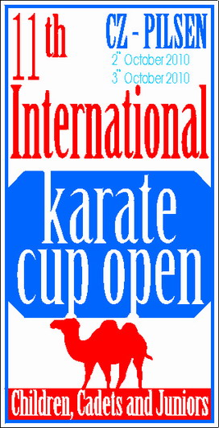

The 11th
Czech Karate Open
Euro Grand Prix
Central-European league

For Children, Youth and Seniors

2rd – 3rd October, 2010
Pilsen (Plzeň)
Czech Republic
Lokomotiva Sports Hall, Úslavská street

Dear Friends,
We have the pleasure to invite you to participate in our karate competition

The 11th International Karate Cup Open – Foundation for youth
For Children, Youth and Seniors

2nd – 3rd October, 2010
Information about the tournament:

Organiser:
Czech Karate Federation
Pilsen Karate Federation
Place:
Plzeň (Pilsen), Lokomotiva Sports Hall, Úslavská street
Date of competition:
Saturday, 2nd October, 2010 - category cadets, seniors
Sunday, 3rd October 2010 – category children, juniors
Time of Competition
9:00
Registration fee:
15 Euros per person per category

20 Euros per team
Bank account: CSOB Plzen, Americka street, 30100 Plzen, Czech rep.
Name account: Club karate Plzen, Linska 18, Plzen
IBAN: CZ54 0300 0000 0002 3797 3484
BIC (SWIFT) CEKOCZPP
Invited:
European and World Teams, Clubs and Schools

Closing date:
no later than 25th September, 2010. on-line registration on www.sportdata.org , maximum is 800 competitors
Payment of the fee may be directly transferred to the following bank account before or on the Apply for transfer no later than September 27, 2010, and in this case, simply register just hours before the start in that category according to schedule.For payment in cash paid on the spot on Saturday respectively. Sunday before the tournament, and no later than 11.00 (min.však hour before the start of category in the case earlier start than at 11 pm) or on technical conference in Friday. If this time is not paid the entry fee will be removed from the race start list, though will have draw.
Please inform us about the time of your arrival/departure to/from Pilsen and the means of transport.This information are very important for transport.
Technical conference:
Friday, 1st October, 2010
Transport:
Transport Airport Prague- Pilsen- Prague ensure
Travel Agency Seko bus per person 15 Euro
Transport official hotel – sporthall – official hotel is free.
Banquet: For official all international teams will be prepare small refreshment in Restaurant Simsalabim on the Americka street in central Pilsen. Start timer is 9.00 p.m. in Saturday.

Accommodation:

Official hotels and accomodation with special prices list here.

Maps road to sport hall

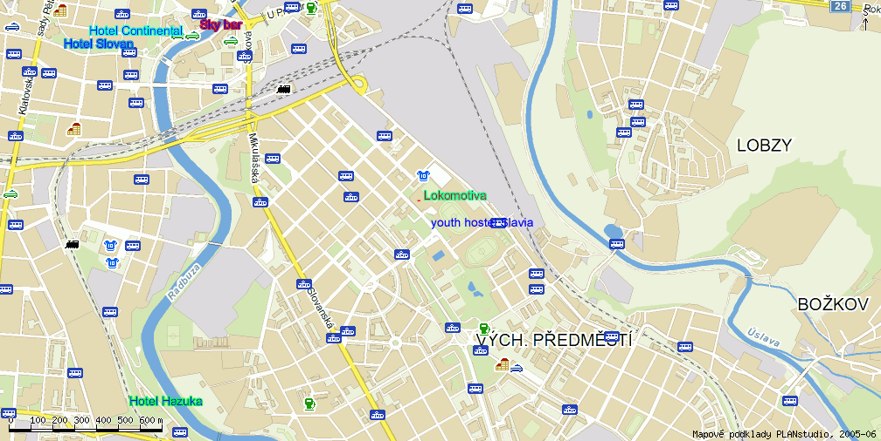

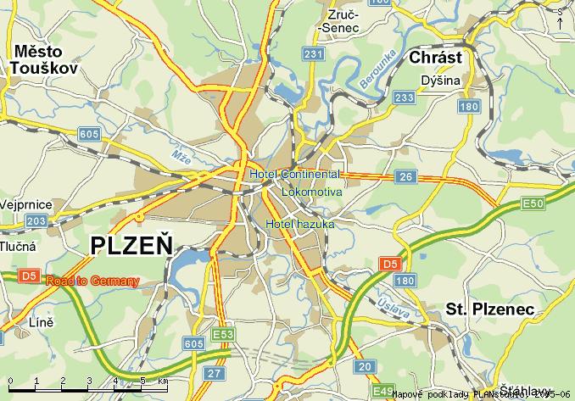

Technical section:

Information for Coaches:
Registration competitors is taking place on 1^{tt} October , 2010 from 5.00 to 8.00 pm . in Hotel Hazuka. Weighing of the all categories will be before theTournament Kumite in Saturday or Sunday.

Rules:

New WKF rules:

Kata children 7-13 : Tokui kata Tokui Kata WKF + Heian 1-5, Pinan 1-5, Taikyoku 1-5, Geksai 1-2

Shitei kata cadets, juniors and seniors - Shitei kata WKF, Tokui kata WKF

Kumite rules – All category WKF rules. All category must be protective equipment WKF rules – Hands protectors, gum-shield, foot protector, shin pads, and women chest protectors.!! Face mask and body protector in category cadets no obligatory.

Referees:
Chief Referee – nominated by Organizing committee. Referees from participating teams are accepted.
OC payed international referees EKF, WKF licence 50 Euro per day and free accommodation. All referees must registration before, deadline is to some than to competitors.

Categories: (min. 5th kyu)
Individual
Kata competition-
Boys – age groups: 7-11, 12-13,
Girls – age groups: 7-11, 12-13, Cadets Male – aged: 14-15
Cadets Female – aged: 14-15
Juniors Male – aged: 16-17
Juniors Female – aged: 16-17
Seniors Male – aged : 16 and older
Seniors Female – aged : 16 and older
Kumite competition-
Boys – age groups: 7-11, 12-13,
Time: 90 sec
7-11: (-30, -35, -41, +41 kg)
12-13: (-39, -45, -52, -60, +60 kg)
Girls – age groups: 7-11, 12-13,
Time: 90 sec
7-11: (-35, +35 kg)
12-13: (-42, -50, +50 kg)
Cadets Male – aged: 14-15
Time: 120 sec
(-52, -57, -63, -70, +70 kg, )
Cadets Female – aged: 14-15
Time: 120 sec
(-47, -54, +54 kg,)
Juniors Male – aged:16 – 17
Time: 120 sec.
(-55, -61, -68, -76, +76 kg,)
Juniors Female – aged: 16 – 17
Time: 120 sec.
(-48, -53, -59, +59 kg,)
Seniors Male – aged : 18 and older
Time: 180 sec.
(-60, -67, -75, -84, +84 kg, Open)
Seniors Female – aged : 18 and older
Time: 120 sec.
(-48, -55, -61, -68,+68 kg, Open)

Kumite team-

Seniors male – aged: 18 and older
Time: 120 sec. (3+1)
Seniors Female – aged: 18 and older
Time: 120sec. (3+1)

Category children is qualifikations tournament for National Championship
Category Youth is qualifikations tournament for Central-European league
Category Seniors is qualifikations tournament for National Championship and Central-European league

Information about Central-European league is on web site www.cekl.eu.

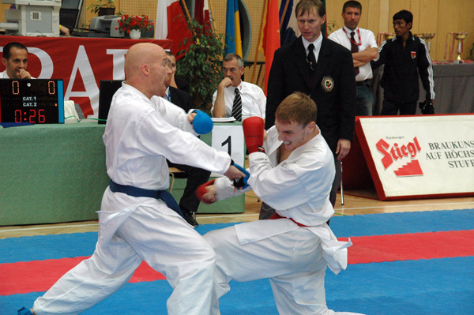

ENTRY FORM

Country ……………………………………
Address ….............……………………….
Club ………………...…………………….
/Phone/Fax/……………………………….
Team leader ………………………………
Referee:...………………………………...
Number of competitors …… Number of referees ……

Competitor's Name | Date of Birth | Category | Kata | Kumite (weight)

Please, send the completed ENTRY FORM to be received no later than 25th SEPTEMBER, 2010 to:

On-line www.sportdata.org

Pilsen Karate Federation
Linska 18
323 12 Plzeň
Czech Republic

Phone: +420 37 7535493
Mobil: +420 606 963 407
Fax: +420 37 7535493
e-mail: karate@karatecz.cz

Date:……………. Signature: …………….

Best regards,

Marek Kubín Jan Pytlík
Organizing Commission Vicepresident
of The Pilsen Karate Federation
e-mail: kubin@karatecz.cz e-mail: pytlik@karatecz.cz

