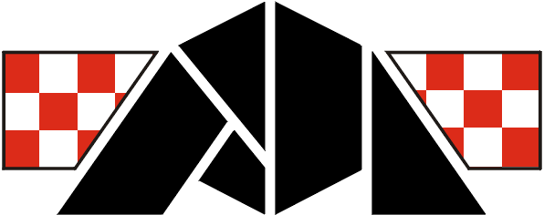

HRVATSKI KARATE SAVEZ
CROATIAN KARATE UNION

8. INTERNATIONAL

KARATE TOURNAMENT
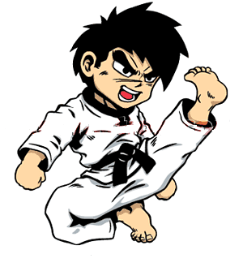
« TROPHY ADRIATIC 2010 »
Pula, CROATIA 23.05.2010.
SPORT CENTRE "MIRNA"( PATTINAGGIO ), Marulićeva 4.



PLACE OF COMPETITION

The competition will take place at the Sport centre "MIRNA" Marulićeva 4. Pula, popular name PATTINAGGIO (Patinađo), which location is in centre of town, 200 m from business building of «Croatia osiguranje» ( Croatia insurance ), 300 m from police station and behind the faculty of economy in one side and business building « Elektroistra»in other side.
44°51´49,21˝ N 13°50´55,16˝ E
For all participiant of karate tournament who come with vehicle recommendation:
Arival with pula bypass to crossway from direction MEDULIN or 300 m farther to crossway from direction PREMANTURA and on one of this tih crossways turn right from direction CENTAR and after cca 1km have parking place behind business building «Croatia osiguranje»
(Croatia insurance) – big black building in glass.

ACCOMODATION AND INFORMATION ABOUT TOURNAMENT
ACCOMODATION
Accomodation for participians of karate tournament deal with "Euro Style“ d.o.o. Pula.
Call from Croatia GSM: 098 / 608 – 495 ( Suzana Stanković )
Fax: 052 / 215 – 167 ; 052 / 216 – 234
Call from foreign country
GSM: **385 98 / 608 – 495 ( Suzana Stanković )
Fax: **385 52 / 215 – 167 ; **385 52 / 216 - 234
E-mail: eurostyle@pu.t-com.hr
karateklub.lav@hi.t-com.hr
ACCOMODATION:

YOUTH ASSOCIATION – Hostel

HOTELS and APARTMENTS
ROOMS

Contact person: Suzana Stanković

INFORMATION ABOUT TOURNAMENT
For all information about tournament all interested can call on
telephon numbers of Karate club "LAV":

Call from Croatia 052/ 216–234, 215–167

GSM 098/ 254–290
Call from foreign country
**385 52/ 216–234, 215–167
GSM **385 98/ 254–290
E-mail: karateklub.lav@hi.t-com.hr
Contact person: Rudolf Oliva


GENERAL CONDITIONS
COMPETITORS
The number of competitors is not limited. All necessary information concerning each competitor is optained from passports. All competitors enter this competition at their own risk and they must be insured. Organisers are absolved of any claims, which may arise however so caused.
REFEREES
EKU and WKF international refrees and national judges are welcome. Judges must wear official uniform.
International refree welcome – 75 €.
RULES
For cadets, juniors and seniors – WKF rules
For children – adjusted WKF rules

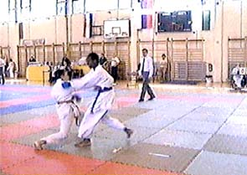

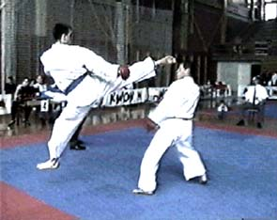

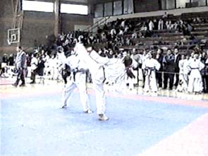

CATEGORY

KUMITE: - INDIVIDUAL AND TEAM
COMPETITORS | CATEGORY |  |  | KG | TEAM
BOYS | C  D | 1 min | 10, 11 years | -30; -34; -38; -42; +42; OPEN | NO
GIRLS | C  D | 1 min | 10, 11 years | -32; -34, -40, +40; OPEN | NO
YOUNG CADETS MALE | E  F | 1 min | 12, 13 years | -36; -41; -45; -48; 52;  -57; +57; OPEN | YES
YOUNG CADETS FEMALE | E  F | 1 min | 12, 13 years | -40; -45; -50; -55; +55; OPEN | YES
CADETS MALE | K | 1,5 min | 14, 15 years | -52; -57; -63; -70; +70; OPEN | YES
CADETS FEMALE | K | 1,5 min | 14, 15 years | -47; -54; +54; OPEN | YES
JUNIORS MALE | J | 2 min | 16, 17 years | -55; -61; -68; - 76; +76; OPEN | YES
JUNIORS FEMALE | J | 2 min | 16, 17 years | -48,-53,-59,+59, OPEN | YES
SENIORS MALE | S | 3 min | 18 years and more | -60,-67,-75,-84,+84, OPEN | YES
SENIORS FEMALE | S | 2 min | 18 years and more | -50,-55,-61,-68,+68, OPEN | YES
VETERANS MALE | z | 2 min | +35 years | OPEN | NO
VETERANS FEMALE | z | 2 min | +35 years | OPEN | NO

KATA: - INDIVIDUAL TEAM
CHILDREN BOYS | A  B | 7, 8, 9 years | NO
CHILDREN GIRLS | A  B | 7, 8, 9 years | NO
BOYS | A  B | 10 – 11 years | YES
GIRLS | A  B | 10 – 11 years | YES
YOUNG CADETS MALE | A  B | 12 – 13 years | YES
YOUNG CADETS FEMALE | A  B | 12 – 13 years | YES
CADETS MALE | X  Y | 14 – 15 years | YES
CADETS FEMALE | X  Y | 14 – 15 years | YES
JUNIORS / SENIORS MALE | X  Y | 16 – 17 and + 18  years | YES
JUNIORS / SENIORS FEMALE | X  Y | 16 – 17 and + 18  years | YES
VETERANS MALE | W | + 35 years | NO
VETERANS FEMALE | W | + 35 years | NO
- Kumite team & kata team: 3 + 1 competitor.
- SENIORS kumite team: male 5 + 1; female 3 + 1

SCHEDULE: (FORESEE)

Confirmation of entries |  | 08,30 – 09,30 hour
KATA individual A – W |  | 10,00 hour
KUMITE individual and teams C – F |  | 11,30 hour
KUMITE individual and teams K – Z |  | 12,30 hour

SPORT HALL:
SPORT CENTRE "MIRNA"( PATINAGGIO ), Marulićeva 4. PULA
ORGANIZER:
KARATE CLUB "LAV" PULA www.karate-kickboxing-lav.com


ENTRY FEE

110,00 kn ( 15 € ) for one category
220,00 kn ( 30 € ) for team




AWARDS

Cups, medals and
transitive big trophy Adriatic (smaller for competitor).
OPEN category – money awards for first place
(Boys/girls & young cadets – return entry fee)
(Cadets & juniors – return dual entry fee)
(Seniors kumite – 100 €)
(Seniors in kata – 50€)
Competitors must take cups and medals in kimono.

ENTRIES
Applications must be sent by :


Fax: **385 (0)52/ 216–234,
**385 (0)52/ 215–167

or on

E-mail: karateklub.lav@hi.t-com.hr
or eurostyle@pu.t-com.hr

not later than 19. may 2010. (19.05.2010.)

See you in Pula - Croatia!

Rudolf Oliva, prezident of Organization committee

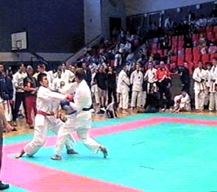

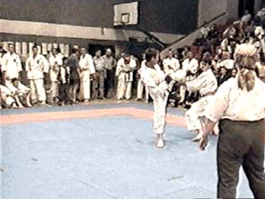

DOBRODOŠLI

WELCOME

WILLKOMMEN

BIENVENUE

BENVENUTO

VITEJTE

