CZECH KARATE OPEN C U P 2010
GRAND PRIX KARATE ÚSTÍ NAD LABEM
European Open karate competition for
childrens,cadets,juniors and seniors-individual+teams

!!! WKF RULES, 5 TATAMI !!!

22. m a y 2010
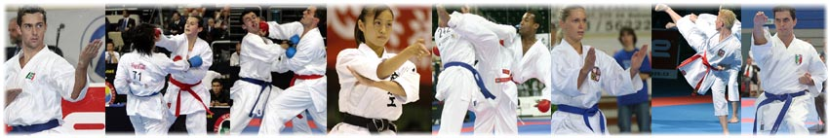

SPORTCENTER SLUNETA– Ústí nad Labem
Czech Republic
Organise: Czech karate federation
Sport karate club Kamura ,Ústí n.L., Internet: www.kamura.cz
Head regional city Ústí nad Labem
Region North Bohemia
Director of competition: Mr. Leška Martin
contact:+420 603 59 57 98, leska@kamura.cz
Information: Internet: www.sportdata.org
e-mail: karate@kamura.cz, info@4karate.net
PROGRAMME | Time | Programme
PROGRAMME | 7:30 – 8:30 | Presentation, payments (KUMITE to 11:30)
PROGRAMME | 9:00 – 11:30 | KATA individual and teams
PROGRAMME | 11.30 -12:00 | Opening Ceremony
PROGRAMME | 12:00 – 18:00 | KUMITE individual and teams, elimination+ finals
PROGRAMME | 18:00 – 19:00 | finals and End of competition
changes in programe are organizer reserved

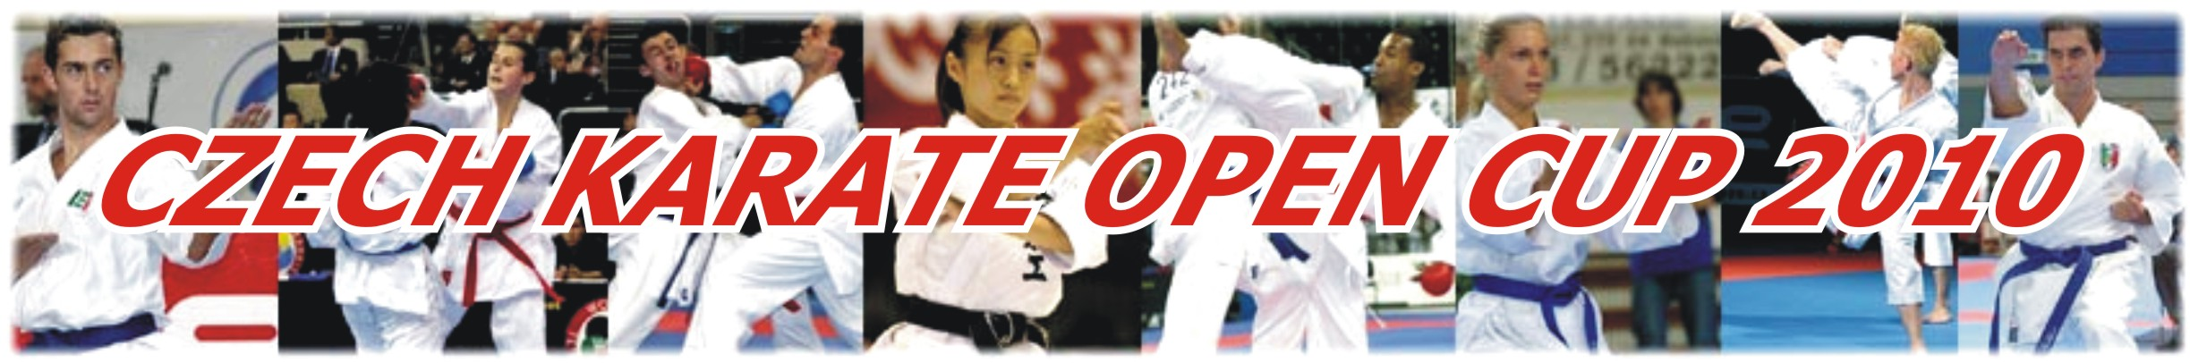

INFORMATION

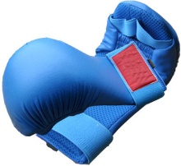

Competitors: from Czech and foreign National teams and clubs

General conditions: official documents – karate passport of national federation
- KATA individual, team - from 8.kyu
- KUMITE individual - min. 6.kyu

!!! Not later than 20.5. 2010 !!!
Entry: must be sent by registration form only
in Sportdata.org
or to e-mail: info@4karate.net

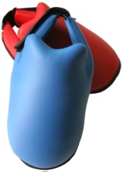
LIMIT OF COMPETITORS – 600 !!!

Entry fee: 15 EUR for every individual category
15 EUR KUMITE OPEN category
20 EUR Team – for kata team or kumite team

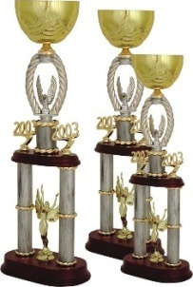
Awards: 1st places – cups, medals and certificates
2nd, 3rd places – medals and certificates
Best team – big cup

Accommodation: each country has to make its own reservation

OFFICIAL HOTELS:BEST WESTERN HOTEL VLADIMIR ****: tel. +420 475 235 111
www.hotelvladimir.cz/
HOTEL BONAPARTE ***: tel. +420 475 224 344
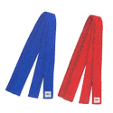
PASSWORD – „KARATE“

OTHER SPORTHOTELS: EKOPROS.: tel. +420 477 115 161
SKP SEVER: tel. +420 472 774 251
TJ SLAVOJ SEVEROTUK: +420 475 531 615
OTHER ACOMMODATION ON WEBSITES: WWW.USTI-NAD-LABEM.CZ

CATEGORIES AND RULES
Categories:

KATA individual
U12 years – CHILDREN boys, girls
U14 years – CHILDREN boys, girls
14-15 years – CADETS -male, female !!! WKF Rules !!!
16-17 years – JUNIORS -male, female !!! WKF Rules !!!
+16 years – SENIORS-male, female !!! WKF Rules !!!
+35 years – MASTERS- female
+40 years - MASTERS-male

KATA team
-13 years – boys, girls
14-17 years – male, female !!! WKF Rules !!!
+16 years – male, female !!! WKF Rules !!!

KUMITE individual
U12 years boys –35, -40,+40
U12 years girls –35, +35
U14 years boys -40, -50, +50
U14 years girls –42, -50, +50
14-15 years CADETS male-52, -57, -63, -70, + 70 kg !!! WKFRules !!!
14-15 years CADETS female -47, -54, +54 kg !!! WKF Rules !!!
16-17 years JUNIORS male-55, -61, -68,-76,+76 kg !!! WKFRules !!!+OPEN
16-17 years JUNIORS female-48, -53, -59, +59 kg !!! WKFRules !!!+OPEN
+18 years SENIORS male -60,-67,-75,-84, +84 kg,OPEN!!! WKFRules !!! +18 years SENIORS female-50,-55,-61,-68,+68kg,OPEN!!!WKF Rules !!!
+35 years – MASTERS- female OPEN
+40 years - MASTERS-male OPEN

KUMITE team +18 years-Seniors- male, female (5/3+1)
Rules:

KATA individual 7-11 years -arbitrary kata, can be repeat same kata one more
12-13 years –arbitrary kata, can not be repeat
14-15 years – !!! WKF rules !!!
+16 years – !!! WKF rules !!!
+35,+40 years –tokui kata WKF
KATA team -13 years - arbitrary kata, can not repeat, with bunkai
14-17 years –!!! WKF rules !!!
+16 years – !!! WKF rules !!!
KUMITE individual -11 years - kumite time 1.30min
12-13 years kumite time 1.30min
14-15, 16-17 years + masters – kumite time 2.min !!! WKF rules !!!
+18 years – kumite time 3/2min (men/women) !!! WKF rules !!!
* for caregory cadets isn't face mask obligatory *
KUMITE team Seniors male,female -5/3+1 members,kumite time 2+1 min WKF rules

ENTRY FORM
CZECH KARATE OPEN CUP 2010

Karate federation/ club:…………………………………………………………………………………………

Coach name:…………………………………………Phone, e-mail:………………………………………

Country:………………..……………………….…………… City:……………………………………………

Entrance form individual
No: | Individual competitor | Age | male / female | Kata | Kumite | Weight | Open  Yes/no
1
2
3
4
5
6
7
8
9
10
11
12
13
14
15
Entrance form team
No: | Team – category | male /female | Kata/kumite team
1
2
3
4
5
Entrance form referees
No: | Name | male /female | Licence – WKF/EKF/Nation
1
2

OFFICIAL PARTNERS:

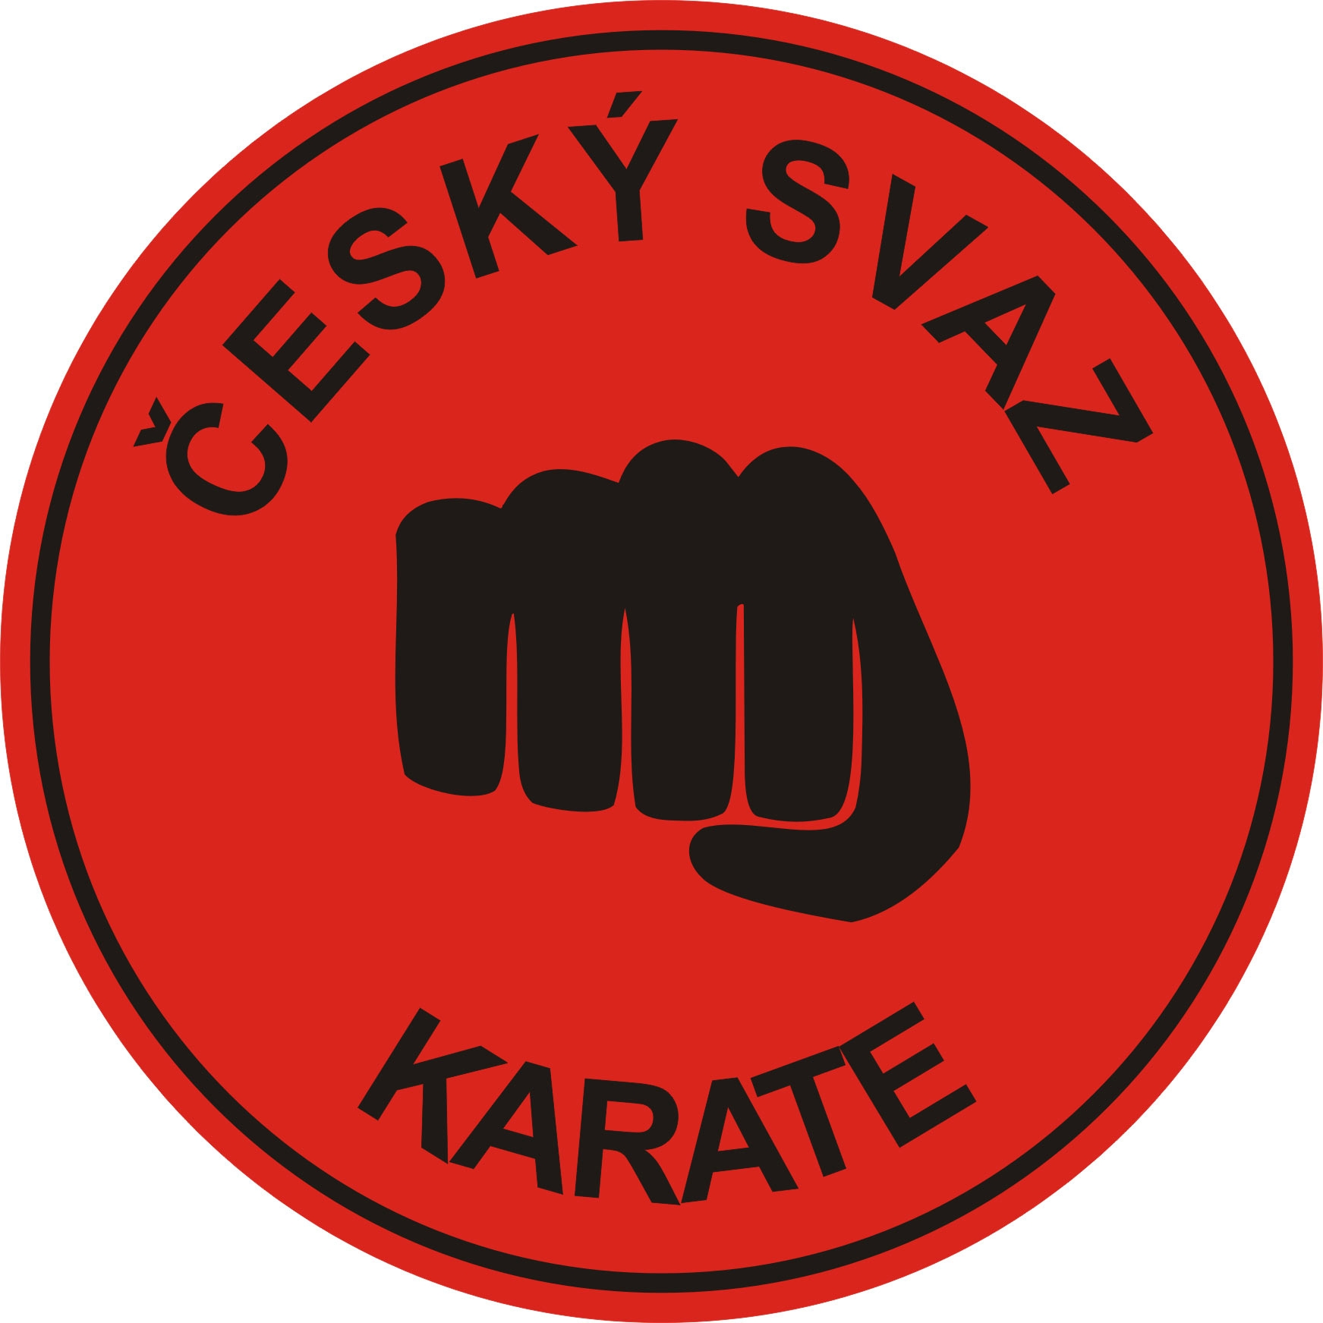



CZECH KARATE FEDERATION HEAD REGIONAL CITY REGION NORTH BOHEMIA









