
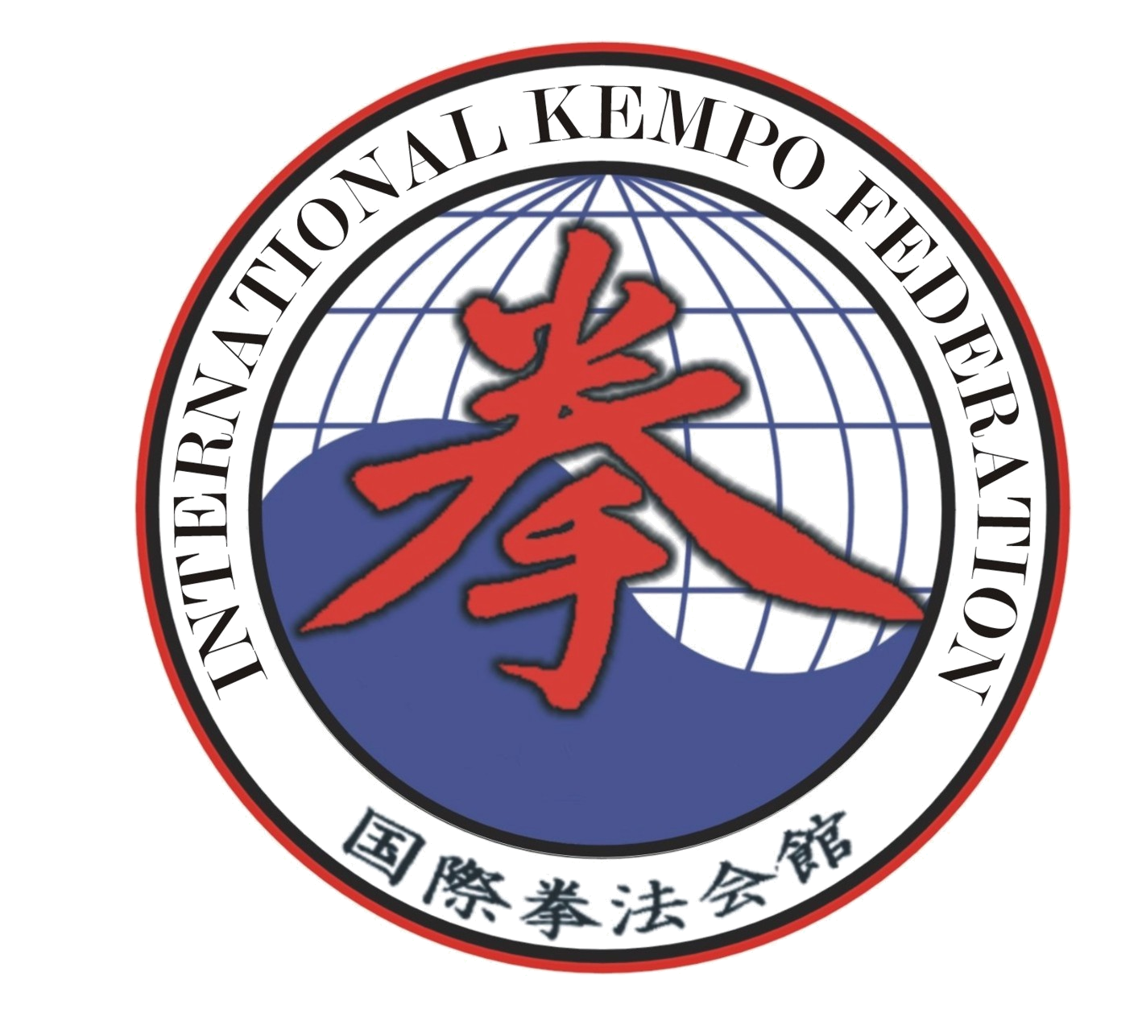
INTERNATIONAL KEMPO FEDERATION WORLD UNIVERSAL KARATE FEDERATION

Presents
Open Europe 2009
among UKADO clubs and national KEMPO organizations

Full-contact, Mix-Contact, Submission grappling

Place and data: Zarasaray, Lithuania, 4-5, December 2009.

Program:

Friday – 16:00-20:00 - Weight and Official Registration; 20:00-21:00 – referees seminar.
Saturday – Official opening, fights, official closing.

Participants:
Members of the International Kempo Federation and the World Universal Karate Federation

Unlimited number of participants from each team on a weight category.

Medical certification: All fighters must have one not older than 3 months.

Liability: All teams must sign a non warranty

Registration fee : 20 EUR / competitor
Weight/Age categories:
Male:
Kids (1996-94): -45, -50, -55, -60, +60 kg;
Juniors I (1993, 1992): – 58, -63, -69, -76, +76 kg;
Seniors (1991 and older): -63, -69, -76, -85, +85 kg.

Female:

Juniors (1994-91): -50, -58, -66 kg. Seniors (1990 and older): -50, -58, -66 kg.

Fighting divisions: Full-contact (Kempo K1), Mix-Contact (kempo full-contact), Grappling (kempo submission).

Accommodation: Hotel "VANDENS LELIJA" – 20 EUR /Person/Day with breakfast.

Each team should have a national flag and a hymn.

Promoter:
Nikolay Gusev: Lithuania, Zarasaray, +37071261898, jolani@one.lt

President WUKF, director IKF:
Shihan Ruslan Akumov: Russia, Saint Petersburg, +79013018146, ukado@yandex.ru

You can see rules of competitions on a site: www.ukado.spb.ru

