Grand Prix Poland
7-8.11.2009 ŁÓDŹ, POLAND

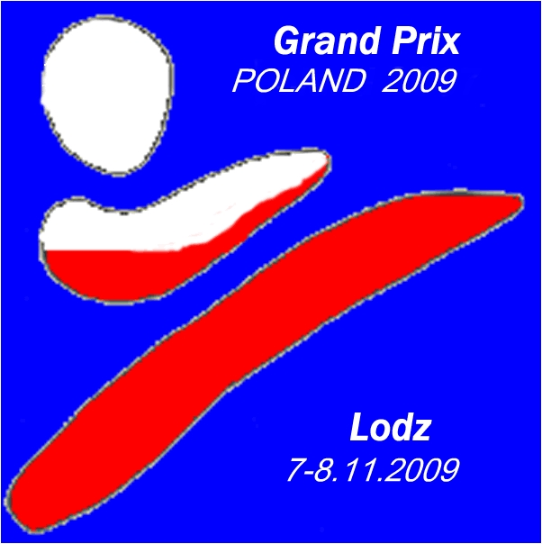

Dear Friends,
We have the pleasure to invite you to participate in our karate competition:
Grand Prix Poland for Children, Cadets, Juniors and Seniors

Information about the tournament:
Organizer
“HARASUTO” Karate Klub Lodz
Address: 92-413 Lodz, H.Brodatego 1/6 POLAND

Aim
The exteriorization in individual competitions the best competitors, popularization of spirit and idea of karate is the aim of championship.

Place:
The Sport Hall
LODZ ul. Małachowskiego 5/7 POLAND

Time Schedule
7.11.2009. (Saturday)
Juniors 16-17 years, Seniors 18 years and older
Referee briefing 9 am in judge's hall
Technical briefing: 9:15 am
Beginning competition: 9:30 am team kata
10:00 individual kata
11:30 individual kumite , team kumite

8.11.2009. (Sunday)
category 9 years and younger, 10-11 years, 12-13 years, cadets 14-5 years
Technical briefing: 9:15 am
Beginning competition: 9:30 am team kata
10:00 individual kata
11:30 individual kumite , team kumite

Registration
Application by letter, or e-mail on address:
92-413 Lodz, H.Brodatego 1/6 POLAND
e-mail: harasutokk@wp.pl
Registrations must arrive at the latest by 30.10.2009

Possession:
- up to date medical examination
- any kind of ID (passport for example)
- confirmation of payment;

Verification and weighting:
6.11.2009 17:00-21:00 and 7.11.2009 8:00-9:00 juniors and seniors
8.11.2009 cadets, boys and girls less than 14 years

Registration fee
- individual competitions 15 €
- team 25 €
Take-off payment will be accepted during registration to 7.11.2009 9am or 8.11.2009 9am

Number starting: 700 competitors

Referees:
Chief Referee – nominated by organizing committee.
Referees from participating teams are accepted

Prizes:
1st place - cup, medal and diploma
2nd place and 2 x 3rd places - medal and diploma

Competitions

Saturday 7.11.2009
Individual kata female – juniors, seniors
Individual kata male - juniors, seniors

Individual kumite juniors (16-17 yrs female): -48kg,-53kg, -59kg, +59kg
Individual kumite juniors (16-17 yrs male): -55kg,-61kg, -68kg, -76 kg,+76kg
Individual kumite seniors (+18 yrs female): -50kg,-55kg, -61kg, -68kg, +68kg
Individual kumite seniors (+18 yrs male): -60kg,-67kg, -75kg, -84 kg, +84kg

Team kata female (juniors + seniors)
Team kata male (juniors + seniors)
Team kumite female (3+1) – juniors, seniors
Team kumite male (3+1) – juniors, seniors

Sunday 8.11.2009
Individual kata girls – 9 years or less, 10-11 years, 12-13 years,
14-15 years
Individual kata boys - 9 years or less, 10-11 years, 12-13 years,
14-15 years

Individual kumite girls fantom -9 years or less, 10-11 years
Individual kumite boys fantom -9 years or less, 10-11 years

Individual kumite girls (12-13 years): -40kg, -50kg, +50kg
Individual kumite girls (14-15 years): -47kg, -54kg, +54kg
Individual kumite boys (12-13 years): -45kg, -50kg, -55kg, +55kg
Individual kumite boys (14-15 years): -52kg, -57kg, -63kg, -70kg, +70kg

Team kata girls – 10 years or less, 11-13 years, 14-15 years
Team kata boys – 10 years or less, 11-13 years, 14-15 years
Team kumite girls (3+1) – 12-13 years, 14-15 years
Team kumite boys (3+1) – 12-13 years, 14-15 years

Competitions rules
WKF rules with following changes:
Category team kata 10 years and younger and 11-13 years in final bunkai kata does not it be required.
In category 9-13 years in every round different kata (Heian, Pinan - acceptable), in another category- WKF rules
The time of fight 90 sec (category 12 -13 years) kumite fantom 45 sec
Another category WKF rules. Repasage and two 3 rd place
If it to weight category will be notified less than 8 competitors category be
becomes played with another weight category.
The team you would be implement younger competitor.

Protection
Fist protection, shin pads, gum shields are compulsory in all kumite competitions
Chest protection for women and crotch protection for men is recommended.
Kumite 12 -13 years and 14- 15 years face masks are obligatory (WKF rules)

Protests
In writing on the Chief Referee hand after payment of deposit in height 50 €

Accommodation
Hotel Focus ** http://www.hotelfocus.com.pl
Hotel Boss* http://www.hotel-boss.pl/

Any questions considering the way the event will be held should go directly to
Dariusz Dąbrowski
Tel. +48 603 385 145
Janusz Harast
Tel. +48 607 803 094
e-mail: harasutokk@wp.pl
http://www.harasuto.pl

