

HRVATSKI KARATE SAVEZ
CROATIAN KARATE UNION

7. INTERNATIONAL

KARATE TOURNAMENT

« TROPHY ADRIATIC 2009 »
Pula, CROATIA 24.05.2009.
SPORT CENTRE "MIRNA" PULA ( PATINAGGIO )



PLACE OF COMPETITION

The competition will take place at the Sport centre "MIRNA" popular name PATINAGGIO (Patinađo), which location is in centre of town, 200 m from business building of «Croatia osiguranje» ( Croatia insurance ), 300 m from police station and behind the faculty of economy in one side and business building « Elektroistra»in other side.

For all participiant of karate tournament who come with vehicle recommendation:
Arival with pula bypass to crossway from direction MEDULIN or 300 m farther to crossway from direction PREMANTURA and on one of this tih crossways turn right from direction CENTAR and after cca 1km have parking place behind business building «Croatia osiguranje»
(Croatia insurance) – big black building in glass.

ACCOMODATION AND INFORMATION ABOUT TOURNAMENT
ACCOMODATION
Accomodation for participians of karate tournament deal with tourist agency "A-TURIZAM" Pula.
Call from Croatia 052/ 212–212, 211–454,
211–394, 215–067
Call from foreign country
**385 52/ 212–212, 211–454,
211–394, 215–067
E-mail: a-turizam@pu.t-com.hr
www.a-turizam.hr
ACCOMODATION:

YOUTH ASSOCIATION – Hostel

HOTELS and APARTMENTS
ROOMS

Contact person: Zlatko Retkovec

INFORMATION ABOUT TOURNAMENT
For all information about tournament all interested can call on
telephon numbers of Karate club "LAV":

Call from Croatia 052/ 216–234, 215–167

GSM 098/ 254–290
Call from foreign country
**385 52/ 216–234, 215–167
GSM **385 98/ 254–290
E-mail: karateklub.lav@hi.htnet.hr
Contact person: Rudolf Oliva


GENERAL CONDITIONS
COMPETITORS
The number of competitors is not limited. All necessary information concerning each competitor is optained from passports. All competitors enter this competition at their own risk and they must be insured. Organisers are absolved of any claims, which may arise however so caused.
REFEREES
EKU and WKF international refrees and national judges are welcome. Judges must wear official uniform.
International refree welcome – 75 €.
RULES
For cadets, juniors and seniors – WKF rules
For children – adjusted WKF rules

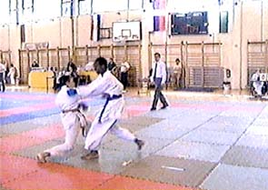

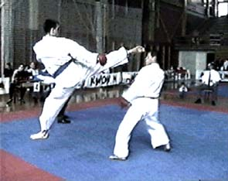

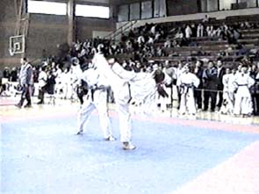

CATEGORY

KUMITE: - INDIVIDUAL AND TEAM
COMPETITORS | CATEGORY |  |  | KG | TEAM
BOYS | C  D | 1 min | 10, 11 years | -30; -34; -38; -42; +42; OPEN | NO
GIRLS | C  D | 1 min | 10, 11 years | -32; -34, -40, +40; OPEN | NO
YOUNG CADETS MALE | E  F | 1 min | 12, 13 years | -36; -41; -45; -48; 52; -57; +57; OPEN | YES
YOUNG CADETS FEMALE | E  F | 1 min | 12, 13 years | -40; -45; -50; -55; +55; OPEN | YES
CADETS MALE | K | 1,5 min | 14, 15 years | -52; -57; -63; -70; +70; OPEN | YES
CADETS FEMALE | K | 1,5 min | 14, 15 years | -47; -54; +54; OPEN | YES
JUNIORS MALE | J | 2 min | 16, 17 years | -55; -61; -68; - 76; +76; OPEN | YES
JUNIORS FEMALE | J | 2 min | 16, 17 years | -48,-53,-59,+59, OPEN | YES
SENIORS MALE | S | 3 min | 18 years and more | -60,-67,-75,-84,+84, OPEN | YES
SENIORS FEMALE | S | 2 min | 18 years and more | -50,-55,-61,-68,+68, OPEN | YES
VETERANS MALE | z | 2 min | +35 years | OPEN | NO
VETERANS FEMALE | z | 2 min | +35 years | OPEN | NO

KATE: - INDIVIDUAL TEAM
CHILDREN BOYS | A  B | 7, 8, 9 years | NO
CHILDREN GIRLS | A  B | 7, 8, 9 years | NO
BOYS | A  B | 10 – 11 years | YES
GIRLS | A  B | 10 – 11 years | YES
YOUNG CADETS MALE | A  B | 12 – 13 years | YES
YOUNG CADETS FEMALE | A  B | 12 – 13 years | YES
CADETS MALE | X  Y | 14 – 15 years | YES
CADETS FEMALE | X  Y | 14 – 15 years | YES
JUNIORS / SENIORS MALE | X  Y | 16 – 17 and + 18  years | YES
JUNIORS / SENIORS FEMALE | X  Y | 16 – 17 and + 18  years | YES
VETERANS MALE | W | + 35 years | NO
VETERANS FEMALE | W | + 35 years | NO
- Kumite team & kata team: 3 + 1 competitor.
- SENIORS kumite team: male 5 + 1; female 3 + 1

SCHEDULE: (FORESEE)

Confirmation of entries |  | 08,30 – 09,30 hour
KATE individual A – W |  | 10,00 hour
KUMITE individual and teams C – F |  | 11,30 hour
KUMITE individual and teams K – Z |  | 12,30 hour

SPORT HALL:
SPORT CENTRE "MIRNA" PULA ( PATINAGGIO )
ORGANIZER:
KARATE CLUB "LAV" PULA www.eurostyle.hr/lav


ENTRY FEE

100,00 kn ( 15 € ) for one category
200,00 kn ( 30 € ) for kumite team




AWARDS

Cups, medals and
transitive big trophy Adriatic (smaller for competitor).
OPEN category – money awards
(Boys/girls & young cadets – return entry fee)
(Cadets & juniors – return dual entry fee)
(Seniors kumite OPEN– 100 €)
(Seniors in kata – 50€)
Competitors must take cups and medals in kimono.

ENTRIES
Applications must be sent by :


Fax: **385 (0)52/ 216–234,
**385 (0)52/ 215–167

or on

E-mail: karateklub.lav@hi.htnet.hr
or eurostyle@pu.t-com.hr

not later than 19. may 2009. (19.05.2009.)

See you in Pula - Croatia!

Rudolf Oliva, prezident of Organization committee

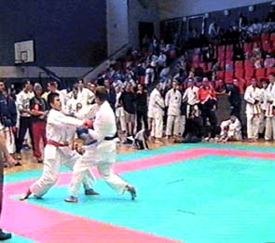

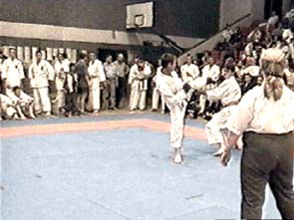

TEAMS

ENTRY FORM

7. Internacional WKF karate tournament « TROPHY ADRIATIC 2009»

Pula, 24.05.2009. CROATIA
COUNTRY:
CLUB:
ADRESS:
TEL: | FAX:
E-mail:
Coach:
Contact person::

TEAMS - KUMITE
CATEGORY | E/F | K | J | S

MALE

FEMALE

TEAMS – KATA
CATEGORY | A/B  7,8,9 | A/B  10,11 | A/B  12,13 | X/Y  14,15 | X/Y  16+
MALE A; X
FEMALE B; Y

President Club / National team declaration:
The undersignened person declares that all competitors are healthy and in order to the medical conditions can fight.

Date:____________ Sign:___________________

APPLICATIONS-Fax: ** 385 52 216 234; E-mail: karateklub.lav@hi.htnet.hr
Or: eurostyle@pu.t-com.hr

