KARATE KLUB POSTOJNA  http://www.karateklub-po.si/,  Planina 62 – 6232 PLANINA – 05 756 52 65  TR: 10100-0034950065  E-pošta: sabina.ilersic@guest.arnes.si |  |  |  |  |  |  |  |  | Pokrovitelj tekmovanja:  Občina Postojna
 |  |  |  |  | Karate klub Postojna  organizira |  |  |  |  |  |  |  |  |  | 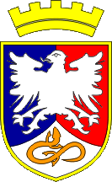

VIII. POSTOJNA OPEN
8th POSTOJNA OPEN
Leta 2008- 4 države, 737 tekmovalcev |  |  |  |  |  |  |  |  | Year 2008 - 4 countries, 737 competitors
Italy, Croatia, Germany, Slovenia
16. maja 2009  Dvorana šolskega centra Postojna |  |  |  |  |  |  |  |  | 16th of May 2009  at Sports Hall of Postojna High School
URNIK : |  |  |  |  |  |  |  |  | SCHEDULE :
potrditev prijav, tehtanje  začetek tekmovanja za mlajše kategorije  začetek tekmovanja za starejše 16+ |  |  |  |  |  |  |  | 07.00 - 08.30 ratification of entries, weighing  09.00 commencement of the competition for younger competitors  14.00 commencement of the competition for 16+
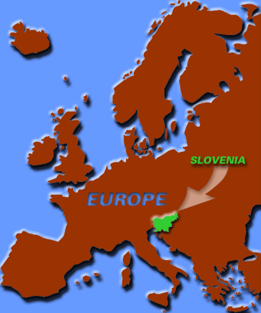 |  |  |  |  |  |  | 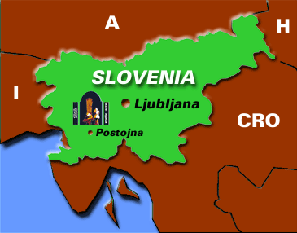 |  |  |  |  |  |  | 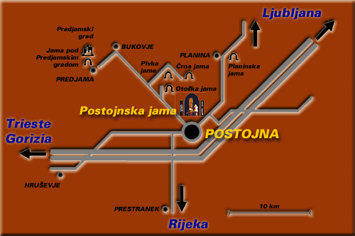
KONTAKTNE OSEBE: |  |  |  |  |  | CONTACTS:
Konrad Jurca |  |  | GSM: +386 (0)40 724 706  E-pošta: k.jurca@ gmail.com |  |  |  |  |  |  |  | Sabina  Ileršič-Kovšca |  | tel.+386 (0)5 756 5265  Fax. .+386 (0)5 756 5265  GSM: +386 (0)40 217 304  E-pošta: sabina.ilersic@guest.arnes.si
SPLOŠNI POGOJI : |  |  |  | GENERAL CONDITIONS:
Tekmovalci nastopajo na lastno odgovornost.  Tekmovalec lahko nastopa v več kategorijah, katerim ustreza po letih in kilogramih. V primeru poškodb na tekmovanju ni mogoče  zahtevati od organizatorja nikakršnega povračila.  Število tekmovalcev ni omejeno. Vsi tekmovalci v borbah bodo tehtani.  Organizator si pridružuje pravico, da spremeni, združi ali odpove, posamezno kategorijo na dan tekmovanja. |  |  |  |  |  |  |  |  |  |  |  | Competitors enter this competition at their own risk and  by doing so agree to absolve the organizers of any  claims which may arise however so caused.  The number of competitors is not limited.  All competitors will be weighed.  The organizers reserve right to change group or omit single category on the day.
 | http://www.karateklub-po.si/,
 | SODNIKI : |  |  |  |  |  |  |  |  | REFEREES:
 | Tekme bodo sodili (WKF) sodniki Karate zveze Slovenije in tujine z ustrezno licenco. |  |  |  |  |  |  |  |  | The WKF and EKF referees licensed by the Slovenian Karate Federation and the referees from abroad with proper licence.
 | PRAVILA : |  |  |  |  |  |  |  |  | RULES:
 | Na turnirju veljajo pravila Karate zveze Slovenije in WKF. |  |  |  |  |  |  |  |  | WKF rules and the Slovenian Karate Federation rules will be applied at the championship.
 | Za vse tekmovalce je obvezna uporaba ščitnikov za zobe, zaščitne rokavice in ščitnikov za nart rdeče in modre barve.  Tekmovalci morajo imeti pasove rdeče in modre barve. |  |  |  |  |  |  |  |  | All competitors are obliged to wear protective gears, such as tooth protection, red and blue gloves and protection for the instep. Head teams should provide red and blue belts.
 | Pravila / Rules KATA |  |  |  |  |  |  |  |  |  |  |  |  |  |  | Pravila / Rules KUMITE
 | 7 in mlajši | Heian (Pinan) 1.-2.  kata se lahko ponavlja tudi v finalu/ kata can bee repeated |  |  |  |  |  |  |  |  |  |  |  |  |  | -
 | 8, 9 | Heian (Pinan) 1.-5.  kata se ponavlja po 3. krogu / kata can bee repeated after third round |  |  |  |  |  |  |  |  |  |  |  |  |  | 1 min
 | 10/11 | 1. in 2. krog Heian (Pinan) 1.-5. 1. and 2. round  Po drugem krogu prosta izbira kate / after second round free kata  Kata se ne sme ponavljati / kata can not bee repeated |  |  |  |  |  |  |  |  |  |  |  |  |  | 1 min
 | 12/13, 14/15 | Prosta izbira kate / free kata  Kata se ne sme ponavljati / kata can not bee repeated |  |  |  |  |  |  |  |  |  |  |  |  |  | 1,5 min
 | KADETI, JUN/SEN, VETERANI |  |  |  |  | WKF |  |  |  |  |  |  |  |  |  | 2 min
 | TEKMOVALNA TAKSA: |  |  |  |  |  |  |  |  |  | ENTRY FEE:
 | 15 € za nastop v posamezni disciplini, |  |  |  |  |  |  |  |  |  | 15 € for each category,
 | 25 € za nastop ekip. |  |  |  |  |  |  |  |  |  | 25 € for kata or kumite team.
 | Klub, kateri prijavi 10 TEKMOVALCEV ima naslednja dva brezplačno (10+2). |  |  |  |  |  |  |  |  |  | If a club enters 10 COMPETITORS, the next 2 competitors pay no entry fee. (10+2)
 | NAGRADE: |  |  |  |  |  |  |  |  |  | PRIZES:
 | Pokal, medalje, diplome ter praktične nagrade. |  |  |  |  |  |  |  |  |  | Cup, medals, diplomas and practical awards
 | NAMESTITEV: |  |  |  |  |  |  |  |  |  | ACOMODATION:
 |    |  |  |  |  |  |  |  |  |  | HOTEL & HOSTEL SPORT  Kolodvorska ul. 1, 6230 Postojna  tel: + 386 5 720 22 44  fax: + 386 5 720 22 40  GSM: + 386 51 630 575  e-pošta: booking@sport-hotel.si  spletna stran: www.sport-hotel.si  APARTHOTEL EPICENTER  Kazarje 10, 6230 Postojna  tel: + 386 5 700 22 00  fax: + 386 5 700 22 44  GSM: + 386 51 680 573  e-pošta: booking@epicenter-on.net  spletna stran: www.epicenter-on.net
Nasvidenje v Postojni!
See you in Postojna!
http://www.karateklub-po.si/,

  KATA
  POSAMEZNO - INDIVIDUAL
  MOŠKI / MALE
  STAROST / AGE | OZNAKA / CODE
  7 in mlajši | K 1
  8, 9 | K 2
  10, 11 | K 3
  12, 13 | K 4
  14, 15 | K 5
  KADETI | K 6
  JUN/SEN | K 7
  VETERANI | K 8
  ŽENSKE / FEMALE
  7 in mlajše | K 21
  8, 9 | K 22
  10, 11 | K 23
  12, 13 | K 24
  14, 15 | K 25
  KADETINJE | K 26
  JUN/SEN | K 27
  VETERANKE | K 28
  EKIPA - MOŠKI / TEAM - MALE
  8, 9, 10 | E 1
  11, 12, 13 | E 2
  14, 15 | E 3
  KAD, JUN, SEN | E 4
  EKIPA - ŽENSKE / TEAM - FEMALE
  8, 9, 10 | E 5
  11, 12, 13 | E 6
  14, 15 | E 7
  KAD, JUN, SEN | E 8
  KUMITE EKIPA/TEAM
  MOŠKI /  MALE  EKIPA/  TEAM  3+1 | 12, 13 | B 28
  MOŠKI /  MALE  EKIPA/  TEAM  3+1 | 14, 15 | B 29
  MOŠKI /  MALE  EKIPA/  TEAM  3+1 | 16, 17 | B 30
  MOŠKI /  MALE  EKIPA/  TEAM  3+1 | JUN/SEN | B 31
  ŽENSKE / FEMALE  EKIPA/  TEAM  3+1 | 12, 13 | G 21
  ŽENSKE / FEMALE  EKIPA/  TEAM  3+1 | 14, 15 | G 22
  ŽENSKE / FEMALE  EKIPA/  TEAM  3+1 | 16, 17 | G 23
  ŽENSKE / FEMALE  EKIPA/  TEAM  3+1 | JUN/SEN | G 24
  KUMITE
  MOŠKI / MALE
  POSAMEZNO - INDIVIDUAL | STAROST /  AGE | TEŽA / | OZNAKA /
  POSAMEZNO - INDIVIDUAL | STAROST /  AGE | WEIGHT | CODE
  POSAMEZNO - INDIVIDUAL | 8, 9 | -30 | B 1
  POSAMEZNO - INDIVIDUAL | 8, 9 | +30 | B 2
  POSAMEZNO - INDIVIDUAL | 10, 11 | - 30 | B 3
  POSAMEZNO - INDIVIDUAL | 10, 11 | - 35 | B 4
  POSAMEZNO - INDIVIDUAL | 10, 11 | - 40 | B 5
  POSAMEZNO - INDIVIDUAL | 10, 11 | + 40 | B 6
  POSAMEZNO - INDIVIDUAL | 12, 13 | - 40 | B 7
  POSAMEZNO - INDIVIDUAL | 12, 13 | - 45 | B 8
  POSAMEZNO - INDIVIDUAL | 12, 13 | - 50 | B 9
  POSAMEZNO - INDIVIDUAL | 12, 13 | + 50 | B 10
  POSAMEZNO - INDIVIDUAL | 14, 15 | - 52 | B 11
  POSAMEZNO - INDIVIDUAL | 14, 15 | - 57 | B 12
  POSAMEZNO - INDIVIDUAL | 14, 15 | - 63 | B 13
  POSAMEZNO - INDIVIDUAL | 14, 15 | - 70 | B 14
  POSAMEZNO - INDIVIDUAL | 14, 15 | + 70 | B 15
  POSAMEZNO - INDIVIDUAL | 16, 17 | - 55 | B 16
  POSAMEZNO - INDIVIDUAL | 16, 17 | - 61 | B 17
  POSAMEZNO - INDIVIDUAL | 16, 17 | - 68 | B 18
  POSAMEZNO - INDIVIDUAL | 16, 17 | - 76 | B 19
  POSAMEZNO - INDIVIDUAL | 16, 17 | + 76 | B 20
  POSAMEZNO - INDIVIDUAL | JUNIOR  SENIOR | - 60 | B 21
  POSAMEZNO - INDIVIDUAL | JUNIOR  SENIOR | - 67 | B 22
  POSAMEZNO - INDIVIDUAL | JUNIOR  SENIOR | - 75 | B 23
  POSAMEZNO - INDIVIDUAL | JUNIOR  SENIOR | - 84 | B 24
  POSAMEZNO - INDIVIDUAL | JUNIOR  SENIOR | + 84 | B 25
  POSAMEZNO - INDIVIDUAL | JUNIOR  SENIOR | ABS | B 26
  POSAMEZNO - INDIVIDUAL | VETERANI | ABS | B 27
  ŽENSKE / FEMALE
  POSAMEZNO - INDIVIDUAL | AGE / STAROST | WEIGHT /  TEŽA | CODE / OZNAKA
  POSAMEZNO - INDIVIDUAL | 8, 9 | - 30 | G 1
  POSAMEZNO - INDIVIDUAL |  | + 30 | G 2
  POSAMEZNO - INDIVIDUAL | 10, 11 | - 35 | G 3
  POSAMEZNO - INDIVIDUAL | 10, 11 | - 40 | G 4
  POSAMEZNO - INDIVIDUAL | 10, 11 | +40 | G 5
  POSAMEZNO - INDIVIDUAL | 12, 13 | -40 | G 6
  POSAMEZNO - INDIVIDUAL | 12, 13 | - 45 | G 7
  POSAMEZNO - INDIVIDUAL | 12, 13 | - 50 | G 8
  POSAMEZNO - INDIVIDUAL | 12, 13 | + 50 | G 9
  POSAMEZNO - INDIVIDUAL | 14, 15 | - 47 | G 10
  POSAMEZNO - INDIVIDUAL | 14, 15 | - 54 | G 11
  POSAMEZNO - INDIVIDUAL | 14, 15 | + 54 | G 12
  POSAMEZNO - INDIVIDUAL | 16, 17 | - 48 | G 13
  POSAMEZNO - INDIVIDUAL | 16, 17 | - 53 | G 14
  POSAMEZNO - INDIVIDUAL | 16, 17 | - 59 | G 15
  POSAMEZNO - INDIVIDUAL | 16, 17 | +59 | G 16
  POSAMEZNO - INDIVIDUAL | JUNIORKE  SENIORKE | - 53 | G 17
  POSAMEZNO - INDIVIDUAL | JUNIORKE  SENIORKE | - 60 | G 18
  POSAMEZNO - INDIVIDUAL | JUNIORKE  SENIORKE | + 60 | G 19
  POSAMEZNO - INDIVIDUAL | JUNIORKE  SENIORKE | ABS | G 20
http://www.karateklub-po.si/,

POSLATI NA NASLOV/  SEND TO ADRESS  Karate klub Postojna  Planina 62,  6232 Planina, Slovenija  e-mail: : k.jurca@ gmail.com  fax :+386/5 756 52 65 |  |  | klub / club
 |  |  | naslov / address
 |  |  | tel - fax
 |  |  | e-mail
 |  |  | trener / coach
 | Priimek in ime Surname and name |  |  | datum rojstva date of birth |  | oznaka code
 | Janez Novak 21.06.1996 |  |  |  |  | K3, B4, E2, B28

Prijave pošljite najkasneje do 13. maja 2009

Applications must be sent not later than May 13th 2009

