GRAND PRIX POLAND

ŁÓDŹ 8-9.11.2008

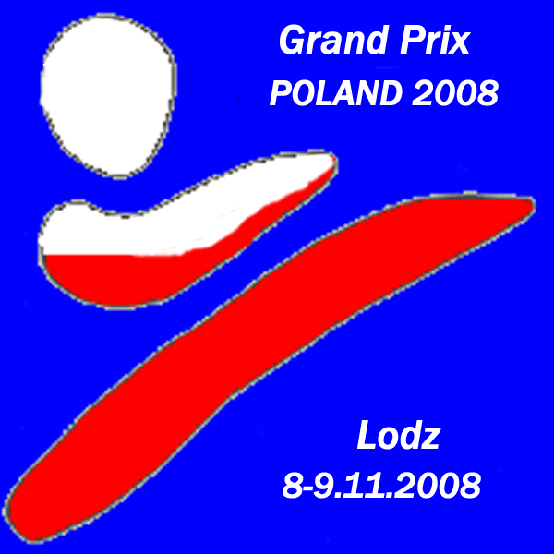

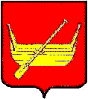

Sport Hall
Lodz
ul.Małachowskiego 7 (park 3 Maja)
POLAND

Dear Friends,
We have the pleasure to invite you to participate in our karate
competition
GRAND PRIX POLAND
For Children, Cadets, Juniors and Seniors

Information about the tournament:
Organizer
“HARASUTO” Karate Klub
Lodz Address: 92-414 Lodz, Bolka Świdnickiego 27/31 POLAND

Aim
The exteriorization in individual competitions the best competitors, popularization of spirit and idea of karate is the aim of championship.
Place: The Sport Hall LODZ Małachowskiego ul. 5/7 POLAND

Time Schedule
8.11.2008. (Saturday)
category 14-15 years, 16-17 years, 18 years and older
Referee briefing 9 am in judge's hall
Technical briefing: 9:15 am
Beginning competition: 9:30 am team kata
10:00 individual kata
11:30 individual kumite , team kumite
9.11.2008. (Saturday)
category 9 years and younger, 10-11 years, 12-13 years and older
Technical briefing: 9:15 am
Beginning competition: 9:30 am team kata
10:00 individual kata
11:30 individual kumite , team kumite

Registration
Application by letter, or e-mail on address:
92-414 Lodz, Bolka Świdnickiego 27/31 POLAND
e-mail: harasutokk@wp.pl

Registrations must arrive at the latest by 02.11.2008
Possession:
1. Current physical examination;
2. Confirmation of degree (BUDO - PASS or the diploma);
3. Confirmation of payment;
4. Identity card;
Degree
Executioner from 9 (9.1) kyu
Kumite min. 6 kyu

Referees:
Chief Referee – nominated by organizing committee.
Referees from participating teams are accepted

More info http://www.harasuto.prv.pl/
Rules Competitions:
KATA INDIVIDUAL |  | KATA TEAM
FEMALE | MALE | FEMALE | MALE
YEARS | YEARS | YEARS | YEARS
SATURDAY 8.11.2008
14-15 years | 14-15 years | 14-17 years | 14-17 years
16-17 years | 16-17 years | 18 years and older | 18 years and older
18 years and older | 18 years and older
SUNDAY 9.11.2008
9 years and younger | 9 years and younger | 10 years and younger | 10 years and younger
10-11 years | 10-11 years | 11-13 years | 11-13 years
12-13 years | 12-13 years

WKF rules
Category team kata 10 years and younger and 11-13 years in final bunkai kata does not it be required.
In category 9-13 years in every round different kata (Heian, Pinan - acceptable), in another category- WKF rules

KUMITE
Individual
FEMALE |  |  | MALE
YEARS | WEIGHT |  | YEARS | WEIGHT
SATURDAY 8.11.2008
14-15 years | -54, +54 kg |  | 14-15 years | -57, -70, +70 kg
16-17 years | -59, +59 kg |  | 16-17 years | -61, -76, +76 kg
18 years and older | -55, -61, -68, +68kg, open |  | 18 years and older | -67,-75, -84, +84 kg, open
TEAM
14-15 years (3+1) |  |  | 14-15 years (3+1)
16-17 years (3+1) |  |  | 16-17 years (3+1)
18 years and older (3+1) |  |  | 18 years and older (3+1)
SUNDAY 9.11.2008
9 years and younger |  | fantom | 9 years and younger | fantom
10-11 years |  | fantom | 10-11 years | fantom
12-13 years |  | -45, +45 kg | 12-13 years | -45, -55, +55 kg
TEAM
12-13 years (3+1) |  |  | 12-13 years (3+1)

According to WKF obligatory guards on teeth and bracers.
The time of fight 90 sec (category 12 -13 years) kumite fantom 45 sec
Another category WKF rules. Repasage and two 3 rd place
If it to aged category will be notified less than 12 competitors category be becomes played without division on weight categories -open.
The team you would be implement younger competitor.
Prizes:
1st place - cup, medal and diploma
2nd place and 2 x 3rd places - medal and diploma
Protests
In writing on the Chief Referee hand after payment of deposit in height 30 €

Take-off payment will be accepted during registration to 8.11.2008 9am

GRAND PRIX POLAND
8-9.11.2008 Lodz

ENTRY FORM
Club:
Country __________________________________
Coach:
Address:
Tel / fax: E-mail:
Individual:
No | Name | Sex | Bitrh date | Grade | Kata | Kumite | Weight
Team:
No | Name | Sex | Bitrh date | Kata | Kumite
Referees

Signature

