V INTERNACIONALNI
KARATE TURNIR
″PLJEVLJA OPEN 2008″
01.11.2008.god.
Organizuje

KARATE KLUB “POTOCI”

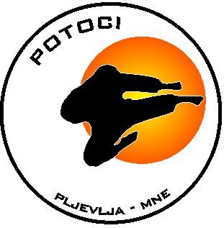
www.pljevlja-open.tk

P LJ E V LJ A
C R N A G O R A – M O N T E N E G R O

Telefon & e-mail:

Slavka Maksimovic +382/0/67-546-151 slavka@cg.yu, Fax: +382/0/89-301-284,
+382/0/68685565
Slavisa Papić +382/0/67-400-468 pslavisa@cg.yu Fax: +382/0/89-300-263,

http://www.pljevlja-open.tk http://www.karatepotoci.com

Poštovani prijatelji, Dear friends,
Pozivamo vas na 5.jubilarni Međunarodni We invite yur on a 5 th international
Karate tirnir “PLJEVLJA OPEN 2008”, Karate tournament “ PLJEVLJA OPEN 2008”,
Najkvalitetniji I najmasovniji karate turnir the best and the most visisted karate tournament
U Crnoj Gori,uz učešće takmičara iz: in Montenegro,wit participation of competitors
Slovenije,Federacije Bosne i Hercegovine, from Slovenia, Croatia,Romania,Makedonia,
Makedonije,Srbjie,Rumunije,C.Gore Federation Bosnia and Herzegovina,Serbia and
Montenegro.
Dobrodošli i Vi ! You are Welkome !

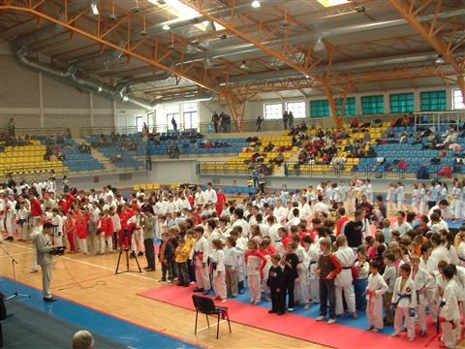

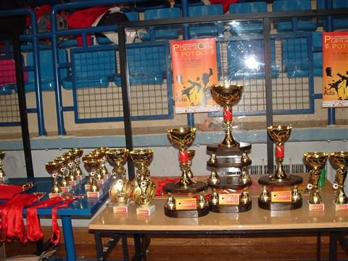

MJESTO: Pljevlja, Sportski centar *ADA* PLACE : Pljevlja, Sport Center *ADA*

DATUM: 01.11. 2007. god. /subota/, DATE: November 01 th ,2008. /saturday/

ORGANIZATOR:Karate klub *POTOCI* ORGANIZER: Karate Club *POTOCI*,
Pljevlja,Crna Gora Pljevlja, Montenegro

POKROVITELJ: Skupština opštine Pljevlja, PATRON: Pljevlja, Municipality
Uprava za sport Vlade Crne Gore, Ministry of sport of the Government of Montenegro

PRIJAVE: APPLICATIONS:
Najkasnije do: 30.0. 2008.god. do 20:00 h At the latest till 30 th October,till 20:00 h
Žrebanje: 31.10.2007 (petak) od 18:00 h. The lot 31 th October,from 18:00 h /Friday/
Fax: +382/0/89-301-284, 300-263, +382/0/89-301-284, 300-263,
E-mail: slavka@cg.yu, pslavisa@cg.yu

NAGRADE: PRIZES:
Za prva tri mjesta medalje i diplome /dva treća mjesta/, For the first three places medals and diplomas /two third places/
Pehari: Cups:
- a sve ekipne pobjednike u katama i borbama, -for all team winners , kate and kumite
- za najuspješnijeg takmicara i takmicarku u ml.kategorijama - for the most successful male and female competitor at yo.categories - za najbolju ekipu u katama i borbama - for the best team, kate and kumite
-za najušpješnije tri ekipe u generalnom plasmanu, -for the three most successful teams in the general final

Novčane nagrade: Money prizes:-
- za pobjednike u katama u kat. juniori/ke-seniori/ke -100 € -for the winners ,kate, juniors and seniors 100 €
- za najatraktvinijeg juniora/ka-senira/ka u fin. borbi -100 € -for the most attractive junior-senior in the final kumite, 100 €
Za individualne pobjednike nagrade iznenađenja, - For the individual winners surprise prizes.

Organizator turnira ne ulazi u izbor

KOTIZACIJA: ENTRY FEE:
Individualni nastup 10.oo €, for each category 10.oo E
Ekipni nastup 15.oo €, For the team 15.oo E
Za ekipe preko 30 takmicara 10% od kotizacije. /The organizer of the tournament isn t included in the choice/

SATNICA: SCHEDULE:
08:00 – 09:15 h - prijava ekipa,korekcija žreba, 08:00 – 09:15 h – applications of the teams, correction of the lot

09:30 –pocetak takmicenja u katama i 12:00 u borbama 09:30 -the beginning of the competitions in kate and 12:00 in kumite
za mlđje kategorije od 93-2002.g. i mlađe, for younger categories,1993-2002.and younger
14:15 -postrojavanje, svečano otvaranje, 14:15 h -lining of the teams and opening

14:30 h - pocetak takmicenja u katama i borbama 15:30 h -the beginning of competitions in kate and 15:30 in kumite
za starije kategorije ml.kadeti-kadeti-jun/seniori for older categories kadets- juniors and seniors

18:30 18:30 h
- sva pojed. Fin. u kat. juniori/ke-seniori/ke-kate-borbe, -all ind.finals in cat. of juniors and seniors ,kate and kumite

SMJEŠTAJ:
H - *Pljevlja* +382/0/89-323-140
H - *GOLD* +382/0/69-048-362, 089-323-102,
H - *Mileševo* - Prijepolje +38133/711-078, 033/712-350,
H - *Jabuka* - /16 km od Pljevalja/ +38133/75-201
Hotelski kompleksi *Zabljak*

Kontaktirati organizatora oko smjestaja

