42nd European Karate
Championships
4th – 6th May 2007
Bratislava, Slovakia

BULLETIN N° 1
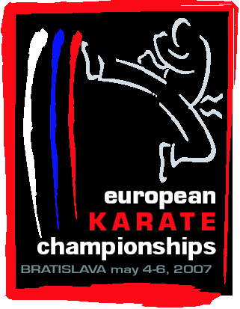

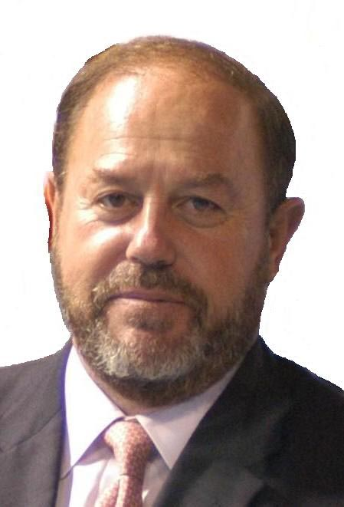

We wait with great expectation and encouragement the arrival of these 42nd European Senior Championships 2007 in Bratislava. The Slovakian Karate Union has already hosted the EKF Cadet & Juniors in 1995 and the EKF Regions in 2003, both in Bratislava. Now, it is the right time to host the top European event.

I would like to take this opportunity to recognize the work developed by the Slovakian Karate Union during these last years. For me it is a model of efficiency, responsibility, quality and well doing. It has always been a pleasure to work with the SKU, and in all the before mentioned I want to make a special mention to President Daniel Liska, that has always made things easy inside a positive atmosphere of help and collaboration.

The celebration of this big event in Slovakia is something well deserved by the SKU and I can say, without any doubt, that these 42nd European Senior Championships are going to be a new success of our sport in the Continent, a new success of the European Karate Federation thanks to the inestimable contribution of one of its outstanding members as it is the Slovakian Karate Union.

Antonio Espinós
The President of
European Karate Federation

BRATISLAVA CITY

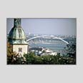
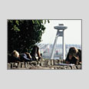
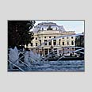
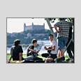
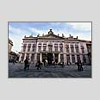
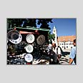
Bratislava is one of the youngest capitals in Europe and few people know that during the time it was called Pressburg or Pozsony it was one of the most important cities in the Austro-Hungarian Empire. It was a mixing pot of various nations and nationalities who lived together in peace and harmony. There is a saying that a true ‘Pressburgian’ speaks four languages: Slovak, German, Hungarian and Mishmash. Even as recently as the 1980s you might hear how older Pressburgians in the street would say two words in German, two in Hungarian and two in Slovak all in the space of one sentence. That is what we mean by “mishmash”.
Bratislava’s location on the banks of the River Danube and at the crossroads of ancient trading routes right at the heart of Europe predestined it to become a meeting point of various cultures. It was the home of the Celts, the Romans, and the Slavs ... The reign of Maria Theresa is regarded as a golden era in the city’s history. She was crowned Queen of Hungary in St. Martin’s cathedral in Pressburg, just like the 10 other kings and 8 royal partners over the course of 300 years when Pressburg was in fact the capital of the Kingdom of Hungary.
The rich mix of cultures and nations not only left its mark in the language spoken here, but also in the customs, cuisine and lifestyle. Just like the Viennese, the people of Bratislava also enjoy promenading through the streets of the city centre, taking time out for a coffee in any of the many cafes. This part of the city is referred to as the Korzo and combines elegance with charm. Visitors say that the city has a relaxed Mediterranean type atmosphere. Bratislava is a seaside city without the sea.
Nowadays Bratislava is experiencing a boom once more. Buildings are popping up, deals being made, people studying, and everything is on the move. Experts regard it as one of the most dynamically developing and most prospective regions in Europe. It welcomes tourists, business people, and investors, who are attracted to this bloom city and its lively atmosphere.
There are many cities in Europe that can boast their own special unique charm, and Bratislava is definitely one of them.
GENERAL INFORMATION ABOUT SLOVAKIA

The capital
Bratislava (451.616 inhabitants) http://www.bratislava.sk/en

Time Zone
1 hr ahead of GMT, the summer time which lasts from March to December is 2 hrs ahead of GMT.

Climate
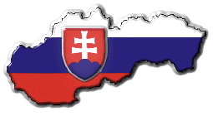
Slovakia has a moderate climate, with cold and rigid winters, and with moderate and rainy summers. The average weather conditions for Bratislava in May (Time Period: 01.05 - 08.05) - the average daily maximum temperature is between 18°C and 25°C. At night it cooled down to temperatures between 8°C and 12°C
http://www.weatheronline.co.uk/Slovakia.htm

bank holidays IN MAY
1st and 8th May

Currency
The National Currency of Slovak Rebublic is 1 Slovak crown (Sk) = 100 halier (h), bank notes with a value of 20, 50, 100, 200, 500, 1000, 5000 Sk, coins with a value of 1, 2, 5, 10 Sk, coins with a value of 50 halier.
1 Euro = approximately 34,00 SKK http://www.slovakia.org/currency2.htm
Most banks are open from 9:00-18:00 on weekdays, and many are open on Saturday mornings. All banks offer currency exchange and cash advances on major credit cards.
Exchange offices are also found in shopping centers and large hotels, as well as in the airports and railway stations. Currency exchange is available in all exchange offices.
Most hotels, shops and restaurants accept Visa, Mastercard, Eurocard, Diner's Club and American Express. Traveler’s cheques can be exchanged in most banks, but are not always accepted in shops. All major credit cards are accepted in the country.

Voltage & Adaptors
220 volts / 50 Hz, Slovakia uses the standard continental European "europlug", with 2 round pins, socket and plug system also found in Germany, France, etc.

Traffic regulation:
On the main roads the speed limit is 90 km/h. On the highway the speed limit is 130 km/h, in the cities and villages it is 60 km/h. Children until 12 years of age must not be seated on front seat. The safety belts have to be fastened on the front seat and back-seat also in towns. To the requisite equipment of vehicle belong a medicine-chest, towing-rope, accident triangle, spare tire. The blood-alcohol level allowed in Slovakia is 0.0.
Shopping hours
Slovakia and Bratislava are really a shopping paradise. Stores have long opening hours and shopping malls are also open over weekends on Saturdays and Sundays as well as over holidays. Most establishments are open between 9 a.m. to 6 p.m., but some take lunch breaks. Many banks close at 3:30 p.m. Bratislava’s top shopping destinations are its shiny new malls – Polus City Centre, AuPark, Avion, Palace City centre.

COMMUNICATIONS
To call Bratislava from abroad, dial your international access code (+421) for Slovakia, then the city code (2) for Bratislava and telephone number (seven-digit)
Within Slovakia you can make local and international calls from card-operated public telephones, located on streets, in hotels, restaurants and other public buildings. Cards are sold at newsstands, post offices or shopping centers.

Mobile operators

GSM cellular mobile phones service is also available – check with your national cellular operator for roaming.
Orange – info line 905 T-Mobile – info line 12345
+421 905 905 905 +421 903 903 903

Emergency calls

Fire Department: 150 Rescue Service-ambulance: 155 Police: 158
Municipal Police: 159 Foreign Police: 0961031265

LOCAL HOSPITALS

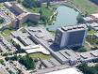
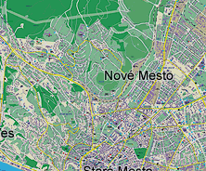
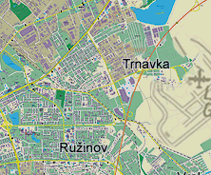
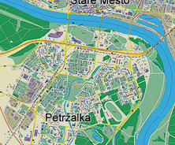
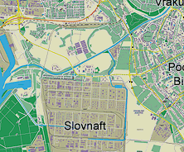
HOSPITAL Ružinov (HQ)
Ružinovská 6,
Sibamac Arena
HOSPITAL L.Dérera
HOSPITAL Ružinov
HOSPITAL Staré Mesto
826 06 Bratislava
Tel.: +421-(0)2-48 234 111
Fax: +421-(0)2-43 336 433
E-mail: nsprriad@nspr.sk

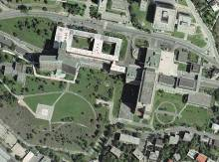
HOSPITAL L. Dérera
Limbová 5, KRAMÁRE
833 05 Bratislava,
Tel.: +421-(0)2-59 541 111
Fax: +421-(0)2-59 543 191
E-mail: fnderera@fnderera.sk

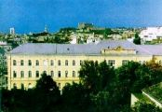
HOSPITAL Staré Mesto
Mickiewiczova 13,
813 69 Bratislava
Tel.: +421-(0)2-52 923 480
Fax: +421-(0)2-52 963 126
E-mail: faneba@faneba.sk
Visa requirements

Visas are not required by most European and U.S. citizens. Canadian, British and Irish nationals can stay up to 180 days visa-free and US citizens can stay up to 30 days.

Citizens of the following European countries do not need a Slovak entry visa:
All EU member states, Andorra, Bulgaria, Croatia, Israel, Monaco, Romania, San Marino, Switzerland, Vatican.

Citizens of other European countries must apply for a Slovak visa:
Belarus, Russia, Ukraine, Moldavia, Serbia, Montenegro, Bosnia and Herzegovina, Fyrom, Albania, Turkey and Georgia

In order to be granted one they have to submit:
- A passport (not a copy) valid for at least next 8 months
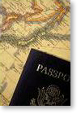
- A completed application form (original only). The forms in Slovak, English and several other foreign languages can be downloaded from the website of the Ministry of Foreign Affairs http://www.mzv.sk or http://www.minv.sk/uhcp/new/tlaciva.htm and are available at Slovak diplomatic and consular missions and at certain travel agencies
- Two photos max. 3.5cm x 4 cm
- Visa fee (check fee with local Embassy)
- Either self-addressed prepaid envelope or * 5 cash. For courier service send prepaid courier envelope.

Apply at Slovak Embassies and Consulates in your local country (or nearest geographic location). Allow 5 weekdays for processing visa by mail.

To obtain initial visa support documents (an official invitation for your delegation) please contact:

Slovak Karate Union:

Contact person: Leopold ROMAN - secretary general

Address: Junácka 6, 832 80 Bratislava, Slovakia
Tel: ++421-2-49 249 132 Fax: ++421-2-49 249 539
E-mail: bratislava@karate-euro2007.sk Web: www.karate-euro2007.sk

SPORTSHALL - SIBAMAC ARENA

The Sibamac Arena was a stage for many sports, cultural and social events, such as elite Davis Cup matches with the USA, Germany, Spain, the Netherlands, Argentina and Croatia (final of Davis Cup). Lord of the Dance, Scooter, Natasha Beningfield or Natalia Inbruglia and many others are cultural events, which were presented in the Sibamac arena of the National tennis centre.
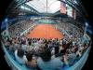
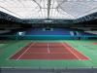
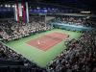
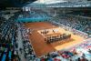

The Sibamac Arena is an ideal place, where you can sport at a high professional level in the nice environment. Eight tennis courts with the Premier surface, 4 squash courts with the ASB surface and 8 badminton courts are prepared for you. Besides top sport happenings it has housed numerous other spectacular activities, from concerts, contests, corporate evenings, presentations to congresses and exhibitions.
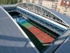
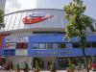
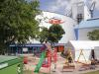
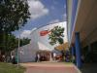

In addition to sports activities, Sibamac Arena also offers services in the area of hairdresser´s and cosmetics, sale of sports utensils and service repair of rackets. It offers additional nutrition, services of the Fitness Centre, restaurant and accommodation services.
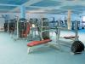
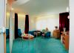
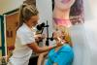
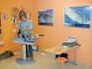

National Tennis Centre, a.s., Príkopova 6, 831 03 Bratislava, Slovak Republic
tel. +421/2/492 09 890, fax. +421/2/492 09 878
mail: ntc@stz.sk, web: www.ntc.sk

Transportation by air

- Airport M.R.Štefánika
823 11 Bratislava 21
tel: +421 2 33 03 33 53, fax: +421 2 43 42 58 29
web site: www.letiskobratislava.sk e-mail: information@airportbratislava.sk

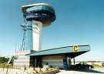
The M.R Štefánika Airport is the principal international airport of the Slovak Republic with day-and-night (24 hour) operation. It is situated 9 km to the north-east from the inner city, in the area with the elevation above sea-level of 132 m, spreading on the area of 477 hectares. The climatic conditions of the airport are particularly good and the location within Central European region is favourable. It serves scheduled and non-scheduled air services on domestic as well as international flights.

Regular Airlines: Aeroflot, Aero most, Air Slovakia BWJ, Czech airlines, Ryan air, Easy Jet, Seagle air, Slovak airlines, Sky Europe, Vip Air, Lufthansa, Austrian

- Vienna International Airport
PO Box 1, A-1300 Wien Flughafen, Austria
tel: +43 (0)1 70070, fax: +43 (0)1 7007 23805, Information 24 hours: tel. 7007–222 31

e-mail: m@viennaairport.com , web site: www.viennaairport.com

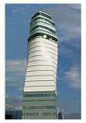
Located at the heart of Europe and on the threshold to Eastern Europe, Vienna International Airport is the most easterly "western airport".
A key feature of Vienna International Airport is simple and uncomplicated entry to markets in the East. For the best connection with most of the cities all around the world, the international Vienna Airport in Schwechat (only 65 km from City Hotel Bratislava) is available in addition to Bratislava Airport.

Transfer to Bratislava

The organization, when requested, will provide transfers from the airports Bratislava or Vienna to the hotels to those delegations that contract this service through the Official Agency – ASSP s.r.o. in accordance with the EKF regulations.

Transfer prices: Vienna Airport – Official Hotels - Vienna Airport (50-60 min)

Price per person for transfers from the Vienna Airport to Official hotels and back, if arranged throught the Official Travel Agency, is 15 € per person.

Transfers prices: Bratislava Airport – Official Hotels - Bratislava Airport (15 min)

Price per person for transfers from the Bratislava Airport to Official hotels and back, if arranged throught the Official Travel Agency, is 5 € per person.

The participating countries have to book this service two weeks in advance (Transfer order Form – see attached Transfer order form or web address – www.karate-euro2007.sk). Reservation will take an effect after receiving of full payment. Payment should be made by money transfer to Official Agency – ASSP s.r.o. to the account (Account info - page 12). No given below.
If cancellation is made in less than 7 (seven) days before ordered service, participants will be charged to pay fee in amount of 100% of ordered service cost.
Without this booking any transfers are not possible and the participants will have to make their own arrangements.

Transport to/from Hotels – SportsHALL

Shuttle between the official hotels and the sport pavilion will be given according to EKFs rules (this service will be free o charge). Information will be given in the official hotels lobbies and in the registration hall during registration. A shuttle bus will be provided from all official hotels.

CITY TRANSPORTATION
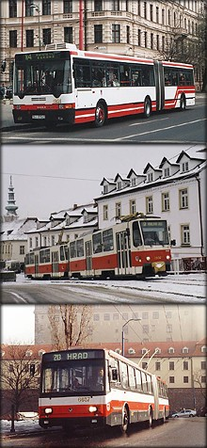
Buses, trolleys and trams operate regularly from 5:00 to 23:00.

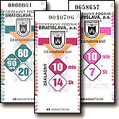
In public transport, you can use your ticket for more transfers. The validity of basic ticket, which costs 14 SKK, is 10 minutes. There are 30/45-minutes (18 SKK), 60/90-minutes (22 SKK) and reduced-fare tickets (for children from 6 up to 15 years old and for retired). You can also buy 24-hours, 48-hours and 7-days tickets in DPB shops and in the most of ticket machines and 1-month, 3-months and 1-year tickets only in DPB shops. You have to validate your ticket in 15 seconds after closing doors of the vehicle or you risk a fine for traveling without valid ticket which is 1400 SKK.

Registration of delegations

Registration will take place in Headquarter Hotel on 3th of May from 10h to 16h.
Each delegation should bring their national anthem and two national flags!
Registration will be carried in the :
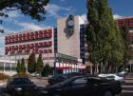
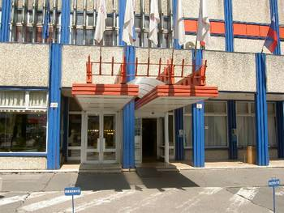

CITY HOTEL BRATISLAVA
Seberíniho 9, 821 03 Bratislava
Registration site: 1st floor in Room “R3”

Thursday, 3th May 2007: from 10.00 a.m. to 16.00 p.m.

Sibamac Arena
CITY HOTEL BRATISLAVA
- Advantageous hotel location in a quiet
district of the city
- Ružinov – only 15 minutes drive to city
centre and airport,
- international highway E75/D61 only 1 km
- exit Bratislava–Ružinov
- Ideal accommodation for transit
Triangel Bratislava - Vienna /60 km/
Budapest /200 km/
- nearby shopping centres - Polus City Center,
Avion Shopping Park Bratislava

SECRETARIAT
All delegations are kindly requested to fill in the attached Registration and Competition Entry forms and return them to the Organizing Committee within the set time frames.
The Secretariat will be located in one of the conference halls at 1st Floor – Room “R3” at the Headquarter hotel “City Hotel Bratislava”. Each participating country is requested to provide 2 national flags and an audiocassette or CD with the national anthem. During the registration there is the possibility to accredit the representatives of official press/media.

PRESS ACCREDITATION
Press accreditation can only be given to persons who apply for such in advance and who are able to prove they are journalists.
The press center is adjacent to the stands and seats allocated to journalists. Accredited journalists will have access to working seats, telephone and fax. A press conference will be organized with the prizewinners. Photographers and TV or video cameraman will have access to their allocated seats only upon presenting their special cards, given at the accreditation. The journalists and photographers will not have access to the competition area. Permits for video recording will be issued by EKF against payment to be settled on spot at the accreditation.
Details on public TV broadcasting should preferably be discussed in advance with the official Public Relations Service of Slovak Karate Union:
E-mail: bratislava@karate-euro2007.sk

Official hotels

Official hotels | Hotel standard | Accodomation in SKK *  (per person/ per night) |  |  | Price of additional meal in SKK
Official hotels | Hotel standard | 1/1 | 1/2 | 3/3 | Price of additional meal in SKK
CITY HOTEL BRATISLAVA  (HEADQUARTER) |  | 2.550,-^{S}  75 € | 1.530,-^{S}  45 € | 1.150,-^{S}  34 € | 420,-  12 €
CITY HOTEL BRATISLAVA  (HEADQUARTER) |  | 3.750,-^{B}  110 € | 2.200,-^{B}  65 € |  | 420,-  12 €
HOLIDAY INN |  | 4.600,-  135 € | 2.350,-  69 € | --- | 630,-  18 €
HOTEL PREMIUM |  | 3.280,-  96 € | 1.780,-  52 € | --- | 630,-  18 €
HOTEL SET |  | 3.035,-  89 € | 1.750,-  51 € | 1.520,-  45 € | 420,-  12 €
HOTEL ECHO |  | 1.850,-  54 € | 1.050,-  31 € | --- | 420,-  12 €
HOTEL JUNIOR |  | 1.810,-  53 € | 1.030,-  30 € | 900,-  26 € | 420,-  12 €
HOTEL TURIST |  | 1.250,-  37 € | 750,-  22 € | 600,-  18 € | 280,-  8 €

- Hotel prices are indicated in SKK and (EUR) per person / per night and include breakfast, VAT. The Local tax should be added to the invoice
- Local tax or “City tax” per person and per day of stay is 30 SKK
- ^{S},^{B} – ROOMS - Standard and Business category

Rooms in hotels of several categories have been reserved for the Championships participants and guests. Please, complete the enclosed Accommodation form (see attached Accommodation Form or web address www.karate-euro2007.sk) and indicate your choice for the members of your delegations

RESERVATIONS: The reservations in the official hotels designated by the organizations must be done through the Official Agency
no later than 15th March 2007.

Payment conditions: full payment for the accommodation and additional
has to be made by 1st April 2007.

The number of rooms available is limited and the policy of first come/first paid/first serve will be followed.

Cancellation conditions by travel agency:

Cancellation 32 and more days prior to arrival: cancellation free of charge
Cancellation 31-21 days prior to arrival: apply cancellation fee 25% of the total price for booking
Cancellation 20-12 days prior to arrival: apply cancellation fee 40% of the total price for booking
Cancellation 11-2 days prior to arrival: apply cancellation fee 75% of the total price for booking
Cancellation 1- 0 days prior to arrival: apply cancellation fee 100% the total price for booking

Payment should be made to Official Agency - ASSP s.r.o. by mean of bank transfer from the account of the Federation (Company) to:
ACCOUNT (EUR): 29 2378 2257 / 1100
IBAN: SK 92 1100 0000 0029 2378 2257
SWIFT: TATR SK BX
ADDRESS: Tatra Banka, Einsteinova, 851 01 Bratislava (SC AUPARK)
TEL: +421 /2/ 6866 1000, +421 /2/ 5919 1000 FAX: +421 /2/ 6345 4060

FOR INFORMATION DETAILS YOU CAN CONTACT
ALSO OFFICAL TRAVEL AGENCY

Name: CK PRESSBURG Bratislava a.s.
Address: Priekopy 20, 821 08 Bratislava, SLOVAKIA
Tel.: ++421 2 446 405 81 Fax: ++421 2 444 554 58
E-mail: bratislava@karate-euro2007.sk

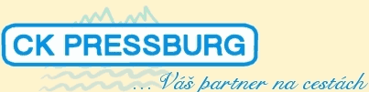


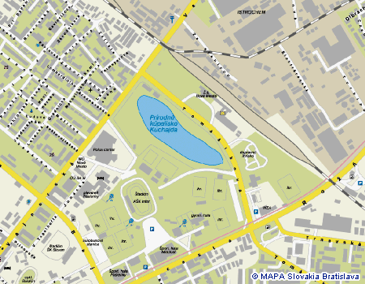
Bottom of Form

detailed map of official hotels
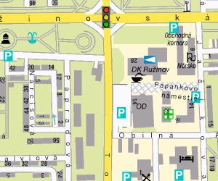
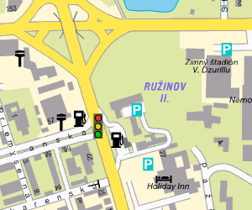
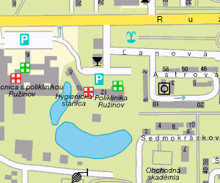
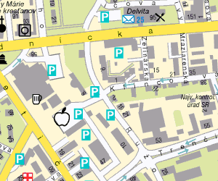
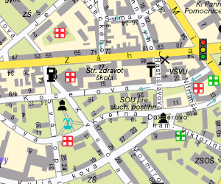
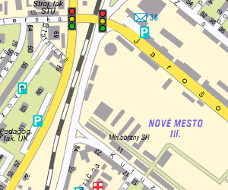
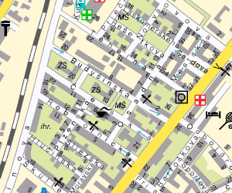
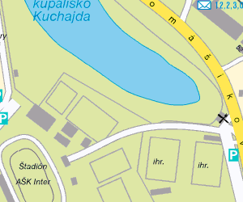
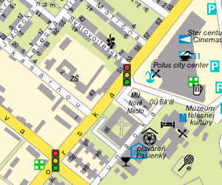
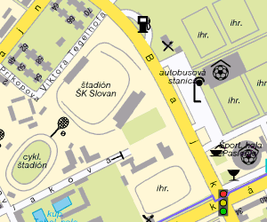
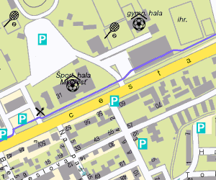
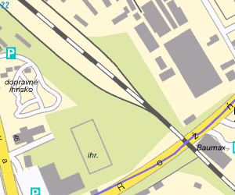
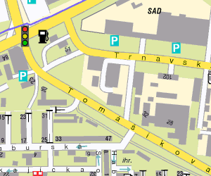
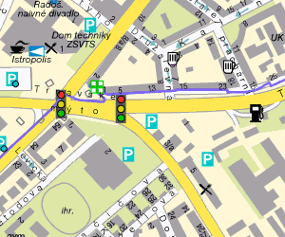
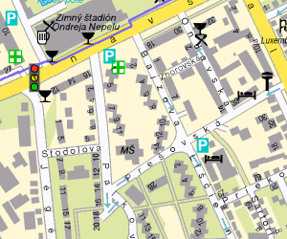
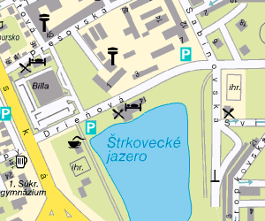
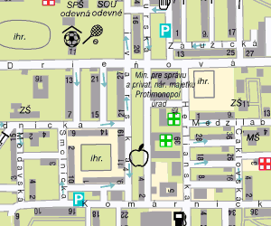
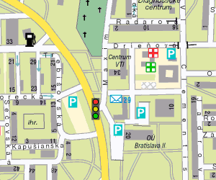
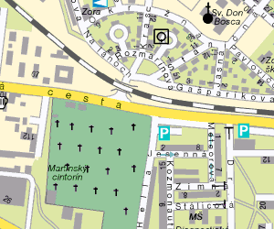
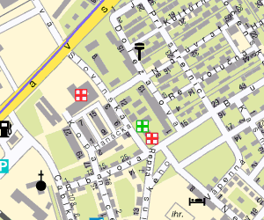
Hotel Set
Sibamac Arena
Hotel Turist
Holiday Inn
Hotel Junior
HQ - City Hotel BA
Hotel Premium
Hotel Echo

Self-consuming possibilities

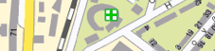
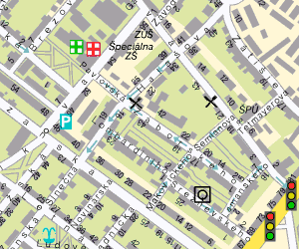

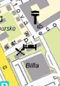
SIBAMAC Arena
STEAM & COFFEE
HYSTERIA PUB
PRI JAZERE
SPORT PUB
MOLO
STEAK HOUSE
PIZZERIA CIAO
U ZLATEHO ORLA
LA MAMMA
ESTREMO
VAJNORSKA 44
VAJNORSKA VIECHA
POLUS CITY
STEAK HOUSE, www.steak-house.sk
HYSTERIA PUB, www.hysteria-pub.sk
STEAM & COFFEE, www.steamcoffee.sk
MÓLO RESTAURANT , www.molorestaurant.sk
ESTREMO, PASTA & CAFFE, www.estremo.sk
POLUS CITY CENTER, www.poluscitycenter.sk
- L.A.Restaurant, Long Benn, Pizza Pazza,
- Slovak-Czech Kitchen,
- Fast foods – McDonald´s, Thai food…
PIZZERIA CIAO
PIZZERIA LA MAMMA,
CHINESE RESTAURANT – PRI JAZERE
VAJNORSKA 44, restaurant
U ZLATÉHO ORLA, www.uzlatehoorla.sk
SPORT PUB, resturant
VAJNORSKÁ VIECHA, www.vajnorska.sk

Referee course activities

The referee course will take place from Monday April 30th to Thursday May 3rd.

All activities will be inside HQ-hotel:
- in Congress Hall, Small Lounge, Foyer 2, Reštaurácia 1, Primátorský salónik

We recommend all referees/judges to book room at HQ-hotel City Hotel Bratislava due to the luncheon.
DATE | SCHEDULE | ACTIVITY
Sunday, 29th of April | 17.00 – 19.00 | EKF referee commission meeting
Monday, 30th of April | 08.30 – 10.00 | Kumite registration
 | 10.15 – 11.45 | Kumite theory
 | 11.45 - 12. 45 | Kumite theory examination
 | 12.45 – 14.30 | Lunch
 | 14.30 – 17.30 | Kumite practical examination Group-1
Tuesday, 1st of May | 09.30 – 12.30 | Kumite practical examination Group-2
 | 12.30 – 14.00 | Lunch
 | 14.00 - 17.30 | Kumite practical examination Group-3
Wednesday, 2nd of May | 08.00 - 9.00 | Kata registration
 | 09.30 – 10.00 | Kata theory
 | 10.00 – 10.30 | Kata theory examination
 | 11.00 - 13.00 | Kata practical examination Group-1
 | 13.00 – 14.00 | Lunch
 | 14.00 – 17.30 | Kata practical examination Group-2
Thursday, 3rd of May | 09.30 – 12.30 | Kata practical examination Group-3
 | 12.30 – 13.30 | Lunch
 | 14.00 – 16.00 | RC + MAC Workshop  (HQ FOYER 2 – “F2”)
 | 16.30 – 17.30 | Examination result Kata & Kumite (HQ FOYER 2 – “F2”)
 | 17.30 – 18.00 | Licence renewal theory examination  (HQ FOYER 2 – “F2”)
 | 20. 00 – 21.00 | Referees and judges briefing  (HQ Congress Hall)
Referee course registration fees and conditions

The deadline for registration is 2 weeks before the 1st day of the referee course. For late registration cases, acceptance will be subject to places being available and a surcharge of 100 € for each single late registration (kata or kumite) and of 150 € for each double late registration (kata and kumite) will be applied.

The registration of qualified referees for officiating in European Championships will be free of charge when done 2 weeks before the first day of competition in the Cadet & Junior Championships and 2 weeks before the 1st day of the referee course in the Senior Championships. For late registration a surcharge of 100 € will be applied.

For late registration (the deadline for registration is 2 weeks before the 1st day of the competition) a surcharge of 20 € will be applied for each individual entry and of 40 € for each team. The same surcharge will have to be paid for entry changes even if they were registered on time, including delegations members other then competitors.

Thursday May 3rd - Schedule of pre-competition activities

ACTIVITY | SCHEDULE | PLACE
EKF executive committee meeting | 09.00 – 11.00 | HQ room “Primatorský salónik”
EKF medical commission meeting | 10.00 – 11.00 | HQ room “Small Lounge”
EKF technical commission meeting | 12.00 – 14.00 | HQ room “Small Lounge”
Coaches meeting | 14.00 – 15.00 | Room Reštaurácia 1 - “R1”
EKF congress | 16.00 – 19.00 | Congress Hall
Results of referee examinations | 19.00 | HQ FOYER 2 – “F2”
EKF referees briefing | 20.00 – 21.00 | HQ Congress Hall
EKF referee commission meeting | 21.00 | HQ Congress Hall

Weighing

Weighing will take place in the sporthall “Sibamac Arena” on Friday, May 6^{th.}

Time | Men * | Women **
09.00 – 09.10h | +80 kg | +60 kg
09.10 – 09.20h | -80 kg | -60 kg
09.20 – 09.30h | -75 kg | -53 kg
09.30 – 09.40h | -70 kg
09.40 – 09.50h | -65 kg
09.50 – 10.00h | -60 kg
* Men – “Warm-up Area” – 1st floor
**Women – “Salon 1” - Coach Meeting Room

Important! According to the Committees Working Rules of European Karate Federation only exclusively EKF/WKF approved protective equipment must be used at the Championships.
COMPETITION PROGRAM

The competition will take place in the Sporthall “Sibamac Arena”.

Friday, May 4th
Schedule:
10.00 – 11.30 Elimination and repechages, individual Kata male and female.
11.30 – 13.10 Elimination and repechages, male Kumite -80kg & +80kg.
13.10 – 14.40 Elimination and repechages, female kumite -60kg & +60kg.
14.40 – 16.25 Elimination and repechages, male Kumite -70kg & -75kg.
16.30 – 17.30 Opening Ceremony
17.30 – 17.40 Finals, individual Kata; male & female
17.40 – 17.50 Medals presentation
17.50 – 18.00 Finals, male Kumite -80kg & +80kg.
18.00 – 18.10 Medals presentation
18.10 – 18.20 Finals, female Kumite -60kg & +60kg.
18.20 – 18.30 Medals presentation
18.30 – 18.40 Finals, male Kumite -70kg & +75kg.
18.40 – 18.50 Medals presentation

Saturday, May 5th
Schedule:
10.00 – 11.30 Elimination and repechages, male Kumite -60kg & -65kg.
11.30 – 12.30 Elimination and repechages, female kumite -53kg.
12.30 – 14.20 Elimination and repechages, male and female Kumite, Open
14.20 – 15.20 Elimination and repechages, male and female Kata Teams.
15.20 - 15.30 Finals, male Kumite -60kg & -65kg.
15.30 – 15.40 Medals presentation
15.40 – 15.55 Finals, male and female Kumite Open
Finals, female Kumite -53kg.
15.55 – 16.15 Medals presentation
16.15 – 16.35 Finals, male and female Kata Teams
16.35 – 16.45 Medals presentation

Sunday, May 6th
Schedule:
10.00 – 15.00 Elimination and repechages, Kumite Team, male.
12.30 – 15.00 Elimination and repechages, Kumite Team, female.
15.00 – 15.15 Final, Kumite Team, female.
15.15 – 15.25 Medals presentation.
15.25 – 15.55 Final, Kumite Team, male.
15.55 – 16.10 Medals presentation.
16.10 Closing Ceremony

ACCOMODATION & TRANSFER FORM
Please, return this entry forms (incl. term of responsibility) until March, 15th 2007 by mail, fax or e-mail to the:
Slovak Karate Union Agency - ASSP s.r.o.
Junácka 6, 832 80 Bratislava, SLOVAKIA
Tel: ++421-2-49 249 132 Fax: ++421-2-49 249 539
E-mail: bratislava@karate-euro2007.sk
Nation/country
Responsible leader of delegation person to contact
Address
Tel.-no.:
Fax.-no.
E-mail address
Hotel wanted
Arrival at Vienna (delegation)
Flight No.:
Departure from Vienna
Flight No.:
Total number of delegations participants: (we need details on a separate list – like next)

Surname | Given  name | Date of birth | No of passport | Position¹ | Arrival  date | Depart. date | Type of room | Price per night | Meal | Loc al Tax | Total
 |  |  |  |  |  |  | TOTAL
¹ Position: C=Competitor; Co=Coaches; E=EKF Committees members; P=Presidents of National Federations; R=Referees/Judges; D=Doctors; V=VIPs; M=Managers; A=Administratk>n; Pr=Press; 0=0thers

Payment conditions: full payment for the accommodation and additional meal has to be made by 15 of April 2007
Cancellation conditions by Travel Agency:
Cancellation 32 and more days prior to arrival: cancellation free of charge
Cancellation 31-21 days prior to arrival: apply cancellation fee 25% of the total price for booking
Cancellation 20-12 days prior to arrival: apply cancellation fee 40% of the total price for booking
Cancellation 11-2 days prior to arrival: apply cancellation fee 75% of the total price for booking
Cancellation 1- 0 days prior to arrival: apply cancellation fee 100% the total price for booking
RESERVATION OF ACCOMMODATION

Federation Details
Name of Federation:
Address:
ZIP Code: |  |  |  | City: |  |  | Country:
Telephone: |  |  |  | Mobile: |  |  | Fax:
Name of Federation Representative:
Passport No.: |  |  |  |  |  |  | Position:
E-mail:
Invoice Details
Organization Name:
Address:
ZIP Code: |  |  | City: |  |  |  | Country:
C.I.F. |  |  | Telephone: |  |  |  | Fax:
E-mail:

TRIP DETAILS

Hotel Name:
Check-in Date: |  |  | Check-out Date:
No. of Single Rooms: |  | No. of Double/Twin Rooms: |  | No. of Triple Rooms:
No. Persons Ordering  Breakfast: |  | No. Persons Ordering  Half Board: |  | No. Persons Ordering  Full Board:

FORM OF PAYMENT

Bank Transfer | Credit Card
Bank Transfer | Card Number:
Bank Name: TATRA Banka a.s. | Card Holder Name:
Address: Einsteinova, (SC Aupark)  851 01 Bratislava, Slovakia | Card Expiry Date:
 | VISA | MASTERCARD |  |  | AMERICAN EXPRESS
Account No.: 29 2378 2257  Account Holder Name: ASSP s.r.o,  Obchodná 15, 911 01 Trenčín, Slovakia | I authorize the official agent ASSP s.r.o.to charge on the credit card indicated above the amount of (Euro):
Bank Code: 1100
SWIFT / BIC Code: TATR SK BX
IBAN: SK 92 1100 0000 0029 2378 2257
Reference: Invoice Number | Signature:

TRANSFER ORDER FORM
To be sent back two weeks before service to:

1. Slovak Karate Union Agency - ASSP s.r.o.,
Junácka 6, 832 80 Bratislava , SLOVAKIA
Phone: ++421 2 492 491 32 Fax: ++421 2 492 495 39
E-mail: bratislava@karate-euro2007.sk

Contact person
Federation | Country
Last name | First name
Address | City
Telephone | Fax
E-maile

Travel information:
Flight Number,  Time of arrival/departure | Destination  (airport – hotel / hotel – airport) | Number of  persons | Quantity and type of buses | Price per bus | Total

Payment conditions: full payment for the transfer has to be made by 15 of April 2007
If cancellation is made in less than 7 (seven) days before ordered service, participants will be charged to pay fee in amount of 100% of ordered service cost.

Name of contact person: Signature
Date: Official stamp

TERM OF RESPONSIBILITY:
To be filled, signed sent back before by 15th April 2007
I, ________________________________ the undersigned, as the Chief of Delegation of my country, duly enrolled to participate in the 42th European Karate Championships, which will be held in Bratislava, Slovakia, from the 4th to the 6th of May 2007, with fully knowledge of the Statutes, the Rules and the Norms of The EUROPEAN KARATE FEDERATION, pledge myself to faithfully accomplish the regulations of this before mentioned entity, and I take any and all administrative, civil and criminal responsibilities of whatever happens to our athletes, coaches and other members of our delegation participating in this championship, before, during and after the competition, such as physical injuries, personal expenses, or monetary debts and casual material damages to the hotels, the venue, means of transportation etc.
Furthermore, I exempt from any legal, civil or criminal responsibilities the organizers of the Championships, the EKF and the Slovak Karate Union, its directors, as well as any person, company, or entity related to the event (sponsors, public and private entities).
I authorize the organizers of the event to use images, photos and the names of our competitors and other members of our delegation (since it is considered necessary) for the sport activities and publications of karate, related to the event, without any monetary compensation.

Country/Nation:
Surname, First name:
Passport number
& expiry date:
Credit Card details
& expiry date:
Position in the federation:
Address:
Tel.-no.:
Fax & email:

Fill in, stamp, sign and send to:
Slovak Karate Union Agency - ASSP s.r.o.
Junácka 6, 832 80 Bratislava , SLOVAKIA ____________________________
Phone: ++421 2 492 491 32 Fax: ++421 2 492 495 39 Signature
E-mail: bratislava@karate-euro2007.sk

