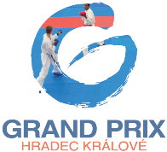
AFFIRMATION OF THE HEAD OF THE DELEGATION

I, the undersigned,

Name:
Surname:
Date of birth:
Passport number:
Residence:
Club/federation:
Position:
E-mail:
Phone number:

as the Head of the delegation of the club/federation mentioned above, with regard to our wish to participate on karate tournament Grand Prix Hradec Králové which will be held in Hradec Králové, Czech Republic on 30th April and 1st May 2016,
with fully knowledge of all norms of World Karate Federation (WKF) and bulletin of the competition,
I confirm that I respect all these norms and bulletin and I also confirm that all our athletes are physically and mentally fit for the participation on this tournament.
I authorize the organizers of this tournament to use images, photos, videos and names of our athletes and other members of our delegation for the sport activities, publication of results of this tournament, promotion of this tournament and karate itself, without monetary compensation. I also confirm that with this authorization agree all members of our delegation or their legal representatives.

Date: .................................................

______________________________
signature (& stamp)

